Task - 1
Setup Jenkins CICD pipeline using freestyle job using Docker containers using below code. https://github.com/betawins/hiring-app.git Stages:
- Git Clone
- SonarQube Integration
- Maven Compilation
- Nexus Artifactory
- Slack Notification
- Deploy On tomcat

- Git Clone
Step 1: Goto JenkinsNew itemfreestyleenter repo link & enter branch click build now.
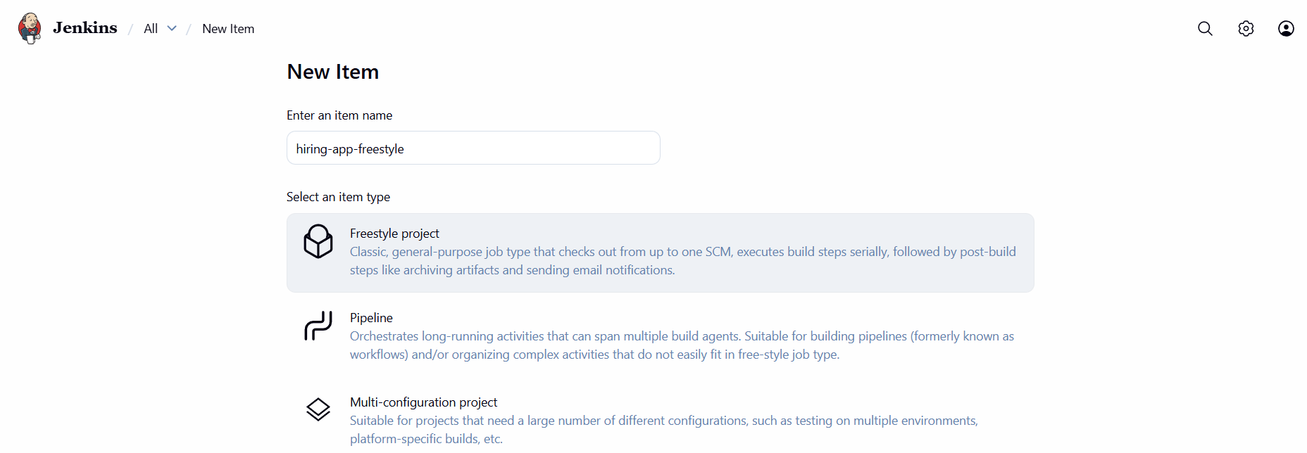
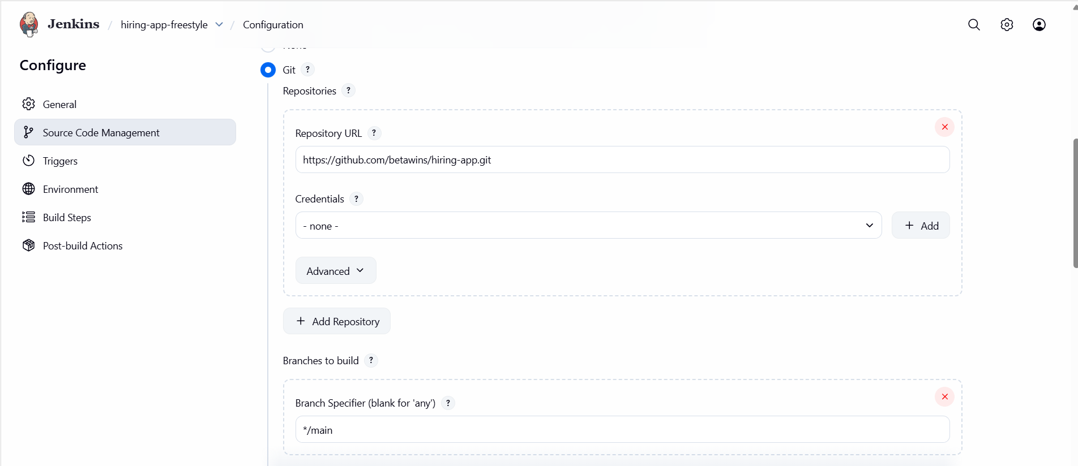

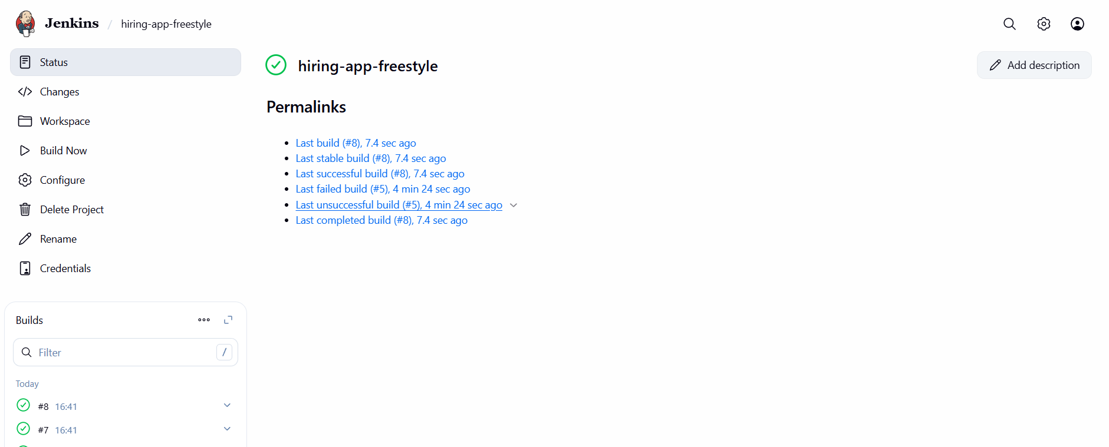

SonarQube Integration
Step 1: Launch an instance with 20GB volume, and run following commands.
- sudo yum install docker -y
- systemctl start docker
- docker pull postgres
- docker pull sonarqube
- docker network create sonarnet
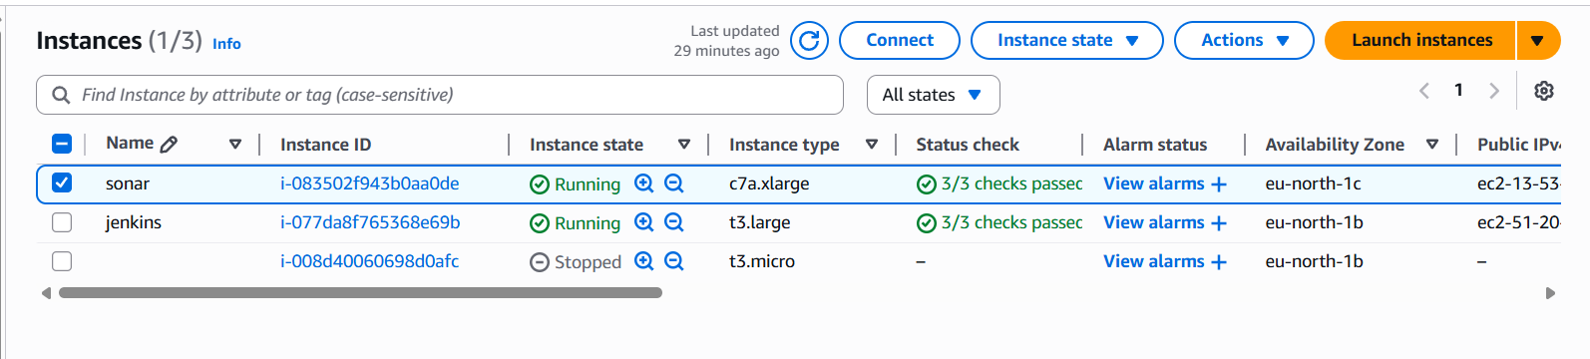
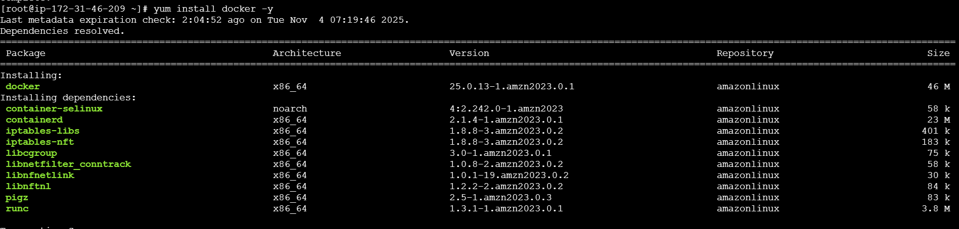
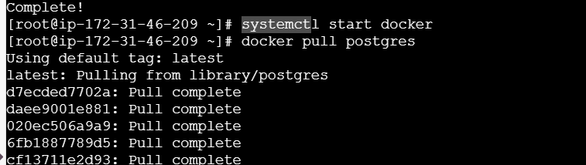

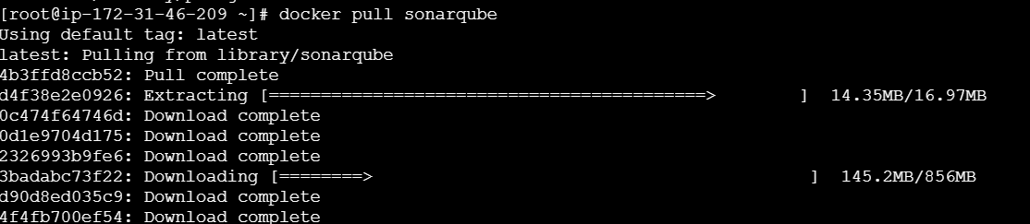
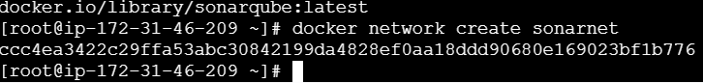
docker run -d --name sonardb --network sonarnet \
-e POSTGRES_USER=sonar \
-e POSTGRES_PASSWORD=sonar \
-e POSTGRES_DB=sonarqube \
-p 5432:5432 \
postgres:15
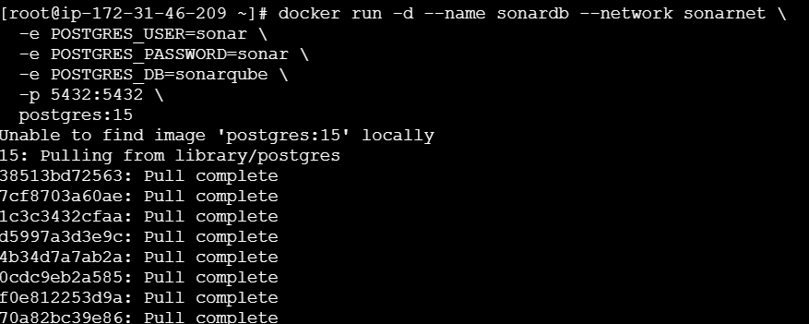
sudo sysctl -w vm.max_map_count=262144
sudo sysctl -w fs.file-max=65536
ulimit -n 65536
ulimit -u 4096
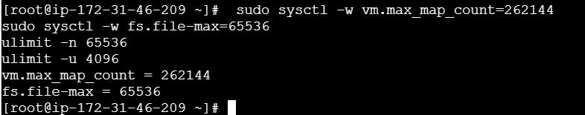

docker run -d --name sonarqube --network sonarnet \
-e SONAR_JDBC_URL=jdbc:postgresql://sonardb:5432/sonarqube \
-e SONAR_JDBC_USERNAME=sonar \
-e SONAR_JDBC_PASSWORD=sonar \
-e SONAR_ES_BOOTSTRAP_CHECKS_DISABLE=true \
-p 9000:9000 \
sonarqube:latest
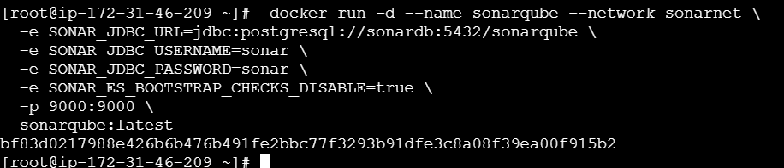
Step 2: Run public_ip:9000 in browser and configure new password.
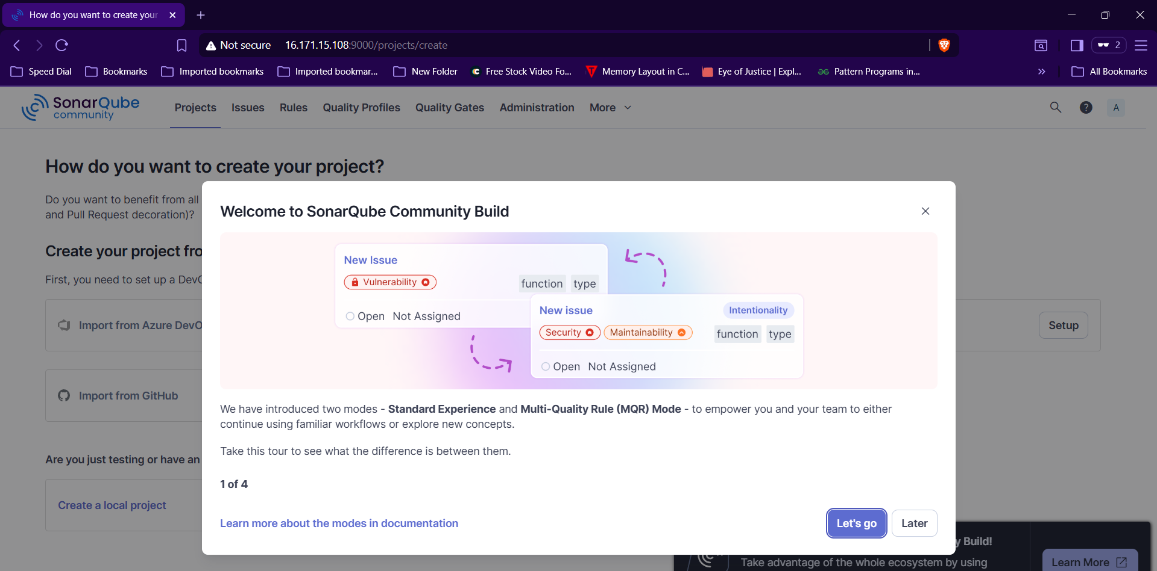
Step 3: Install sonarqube scanner plugin and sonarqube in Jenkins server.
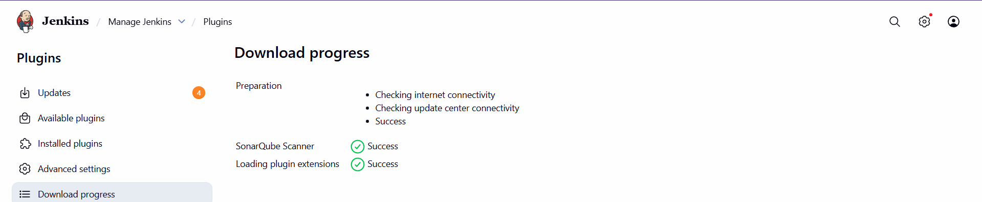
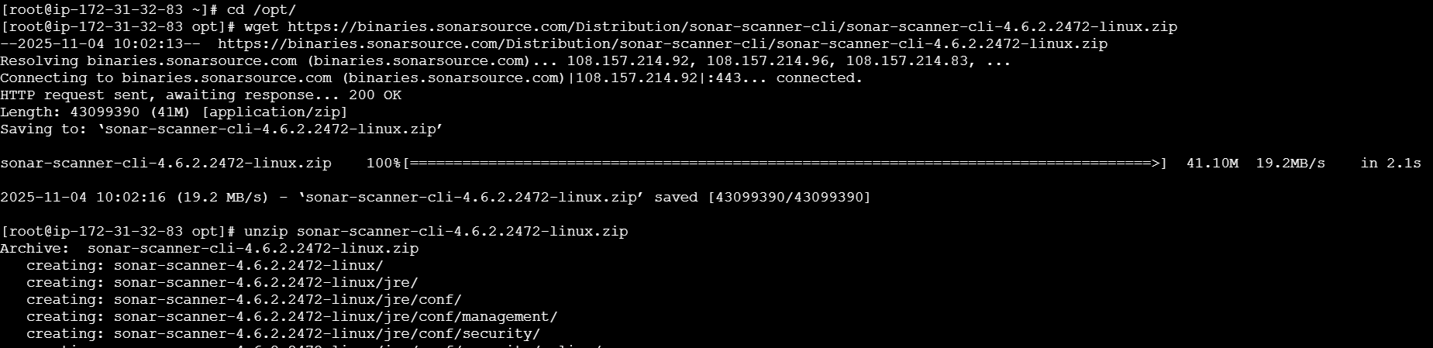
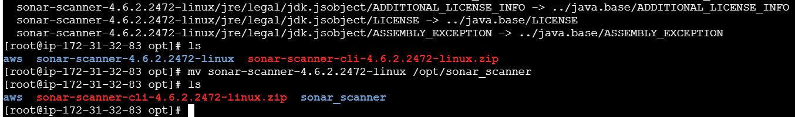
Step 4: change the URL to http://pub_ip_of_sonar_server:9000 in sonar-scanner.properties file
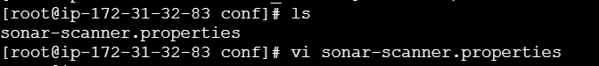
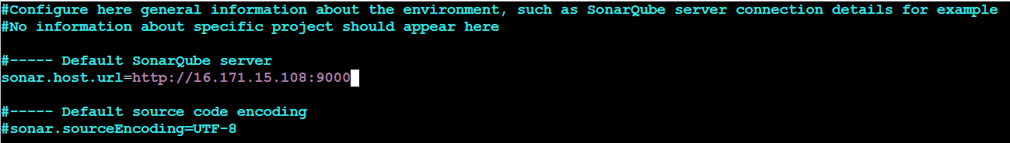
Step 5: Goto Manage JenkinsGlobal Tool ConfigurationSonarQube Scanner and configure home pathsave.
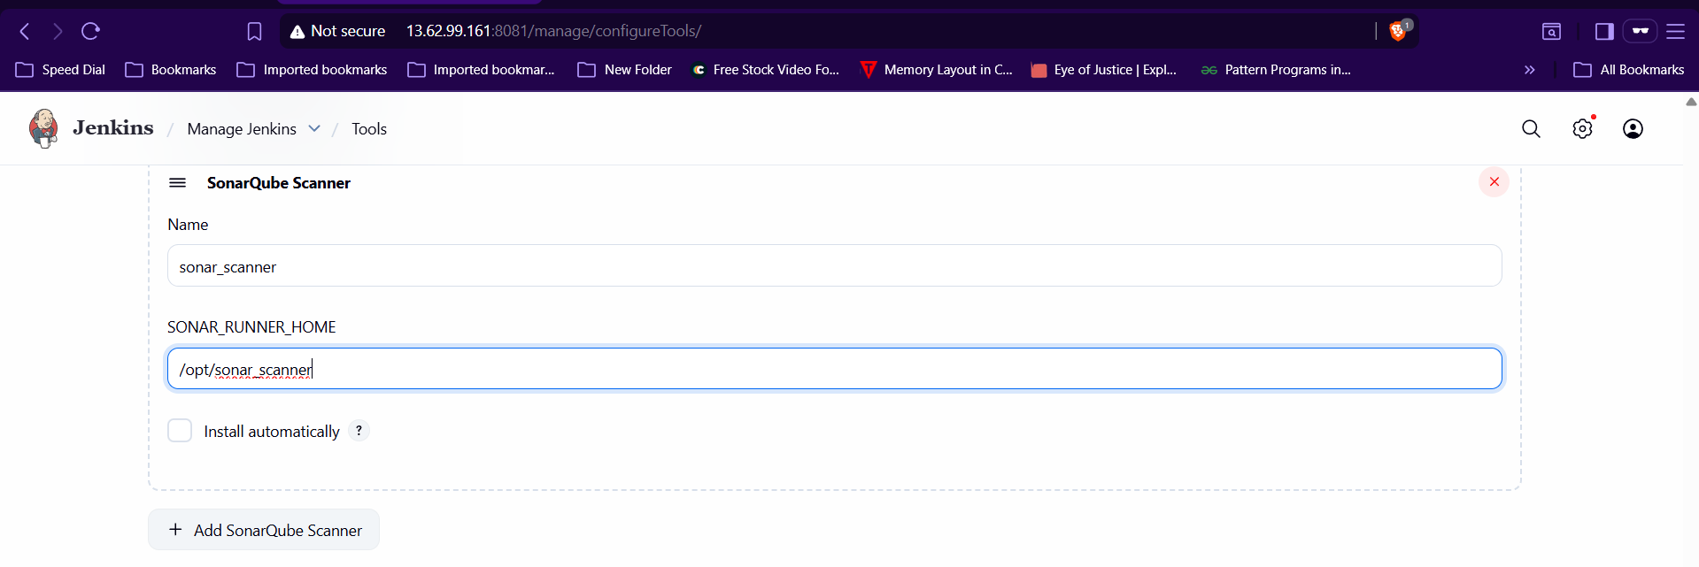
Step 6:Goto SonarqubeMyaccountsecurityGenerate Token.
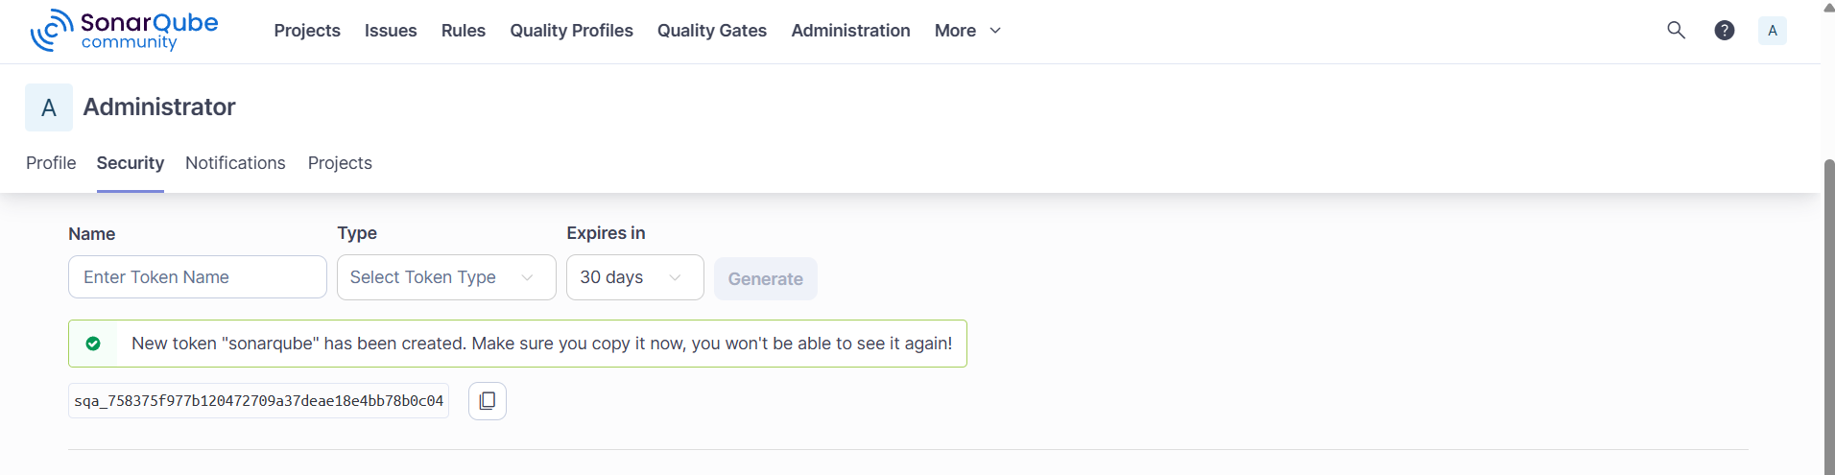

Step 7: In jenkins GUI goto Manage Jenkinssystemsonarqube installationprovide details with token save.
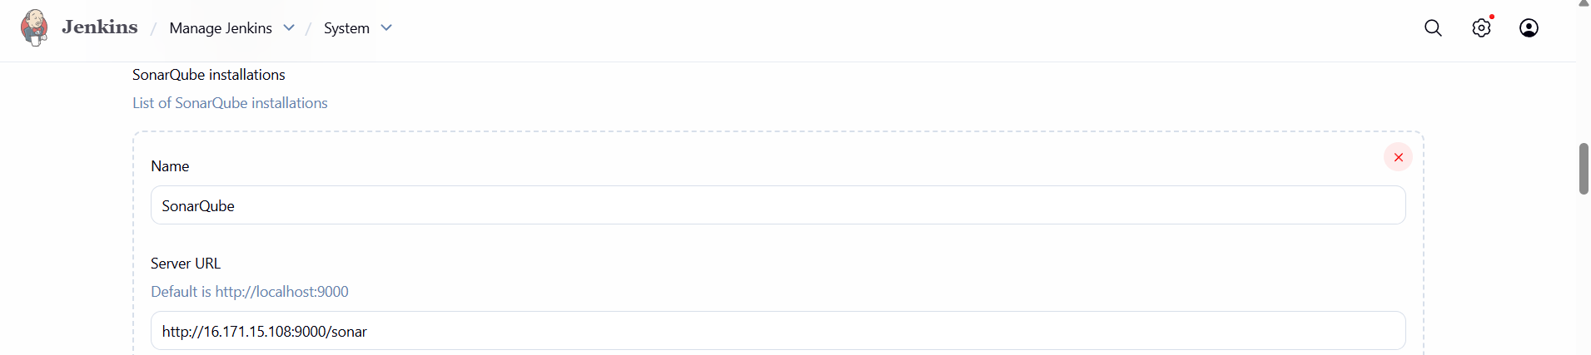
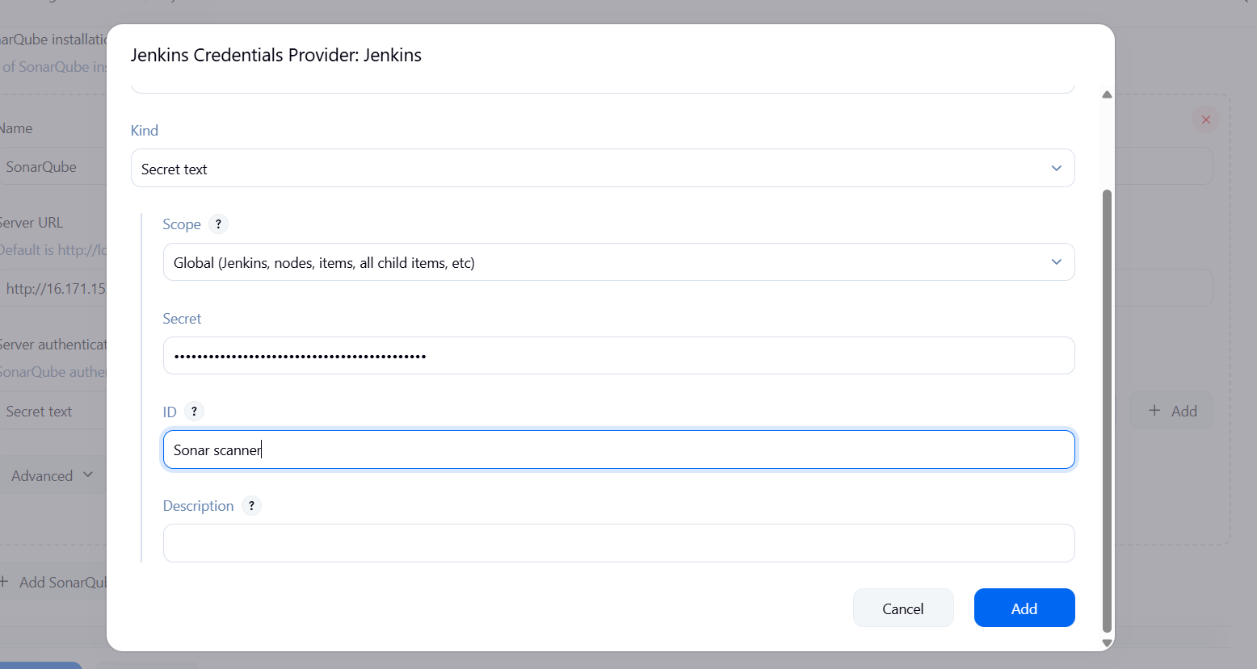
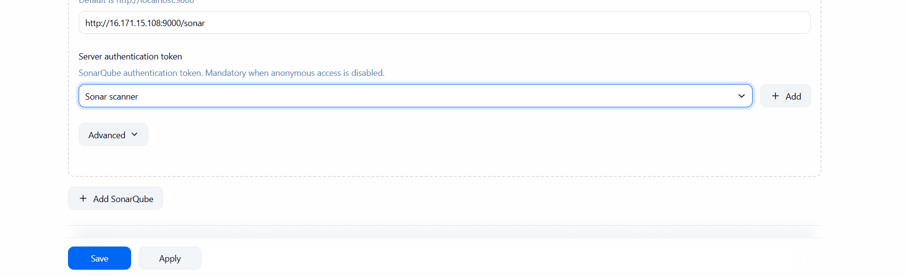
Step 8: Goto Jobconfigurationenter analysis report in Execute sonarqube scanner and buid it.+
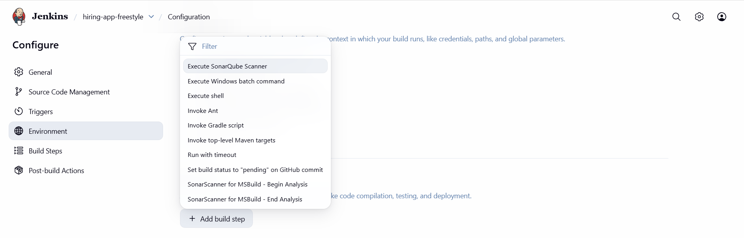
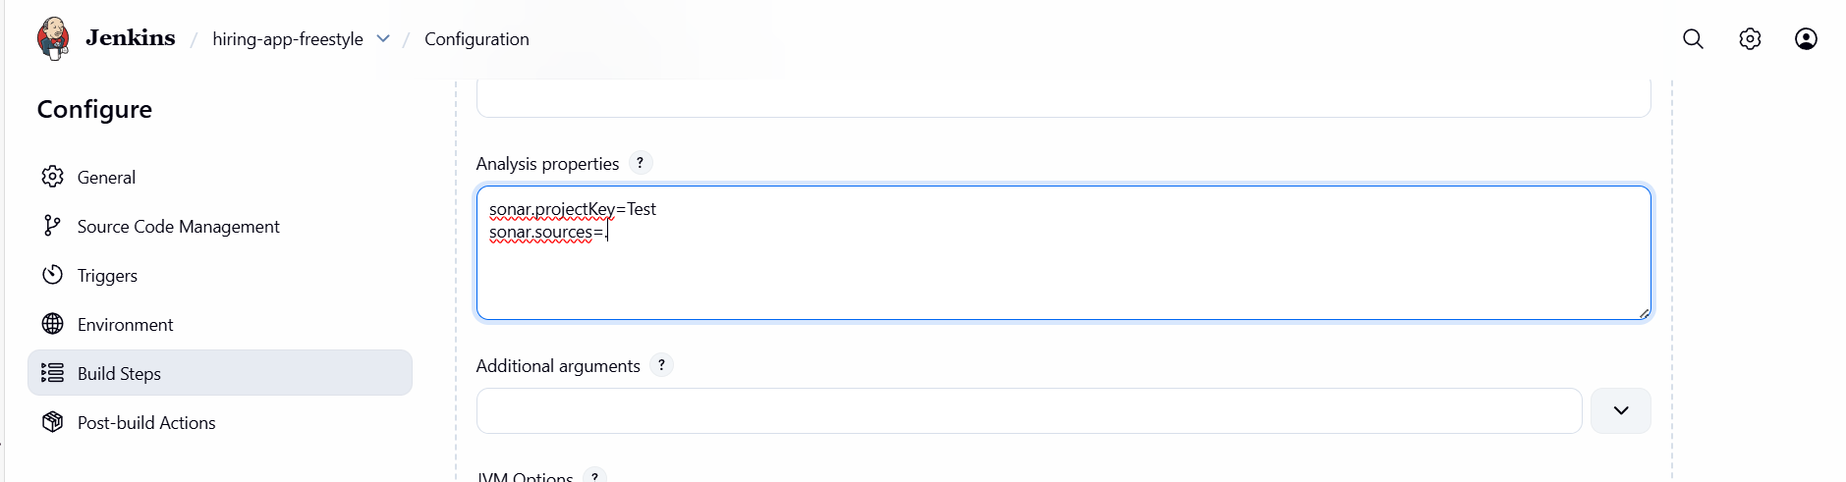
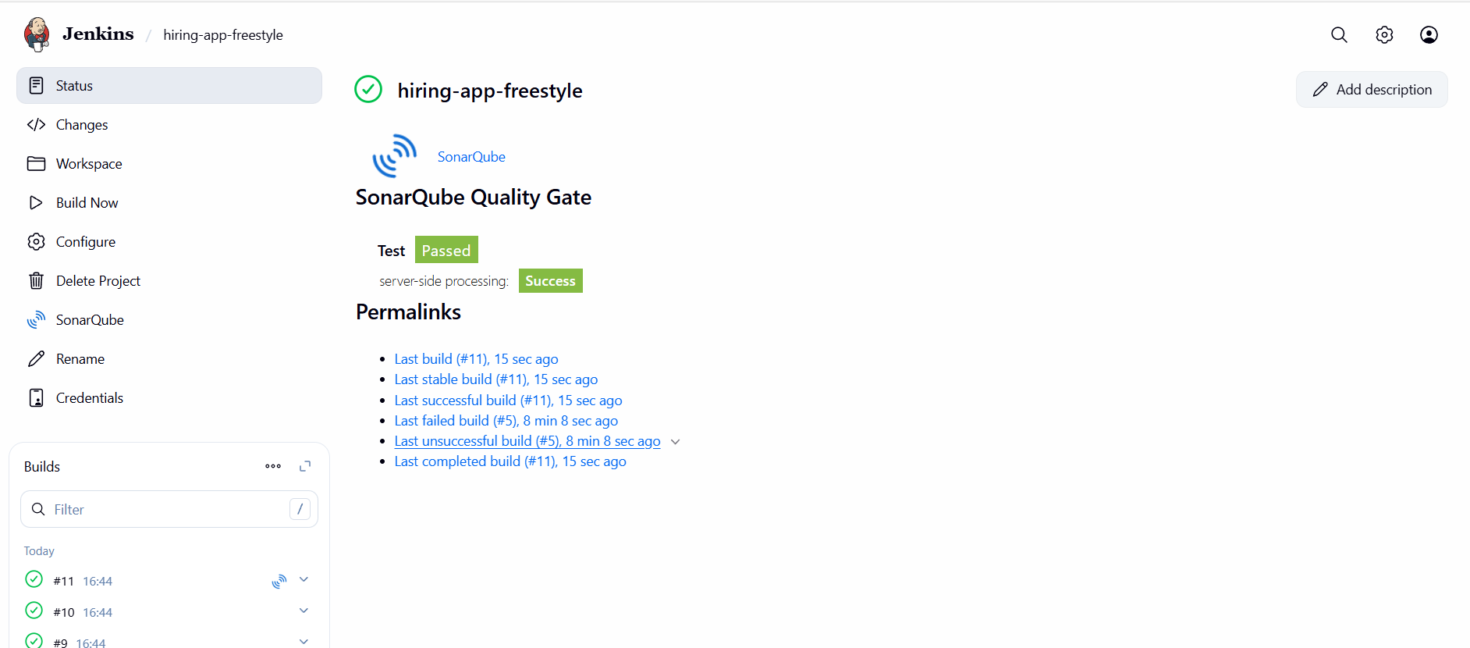
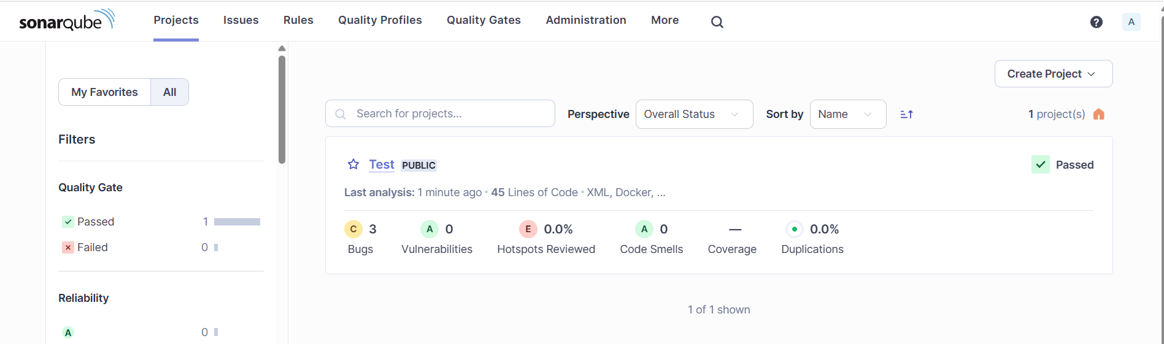

Maven Compilation
Step 1: In Jenkins server goto /opt directory and download maven using official URL and extract it.
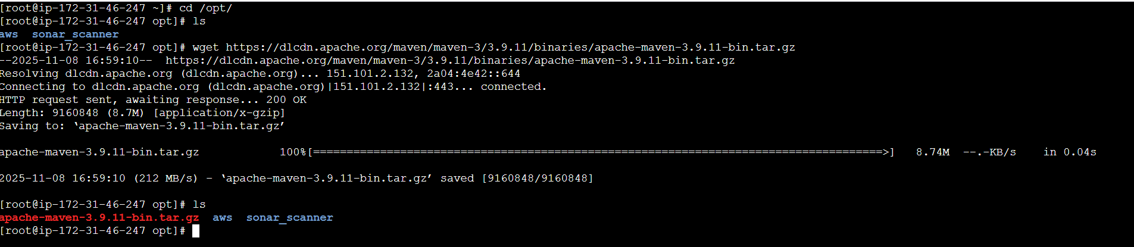

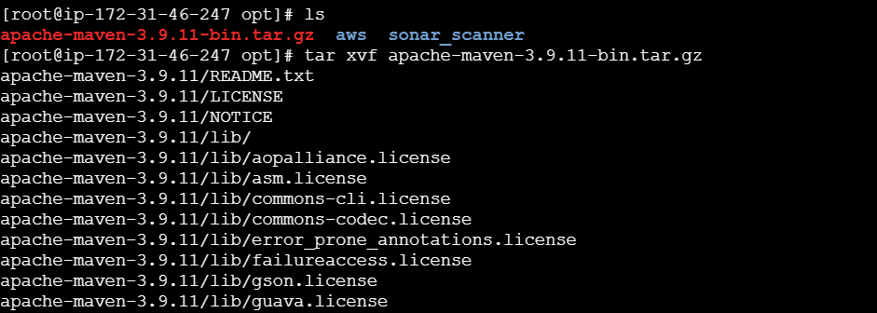
Step 2: goto /bin and copy the path, now goto root directoryopen .bash_profile file and paste following 3 lines.
MVN_HOME=/opt/apache-maven-3.9.11/bin
PATH=$PATH:$HOME/bin:$MVN_HOME
export PATH
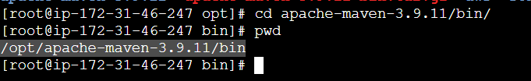
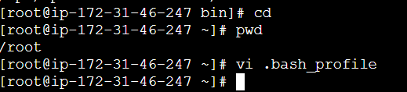
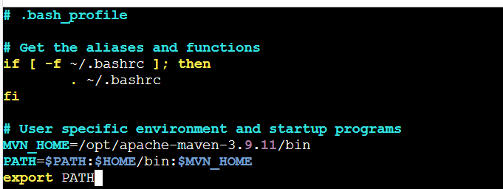
Step 3: Restart the file using source ~/.bash_profile.
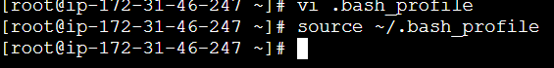

Step 4: Goto Jenkins GUIManage JenkinstoolsMaven installationEnter name & path save it.
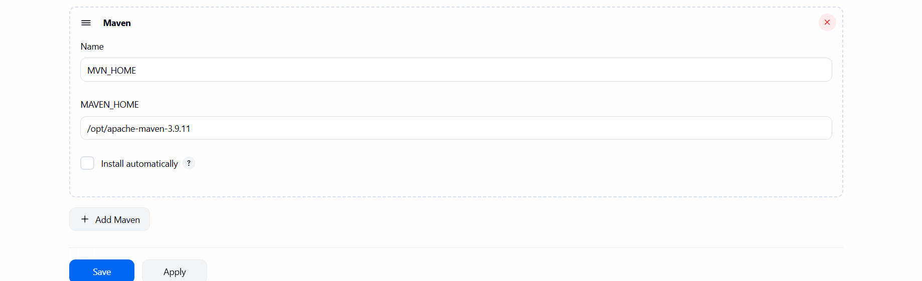
Step 5: Goto Jobconfigurebuid stepsselect invoke top-level maven targetsenter version and goal save and click build now, our package will be created.
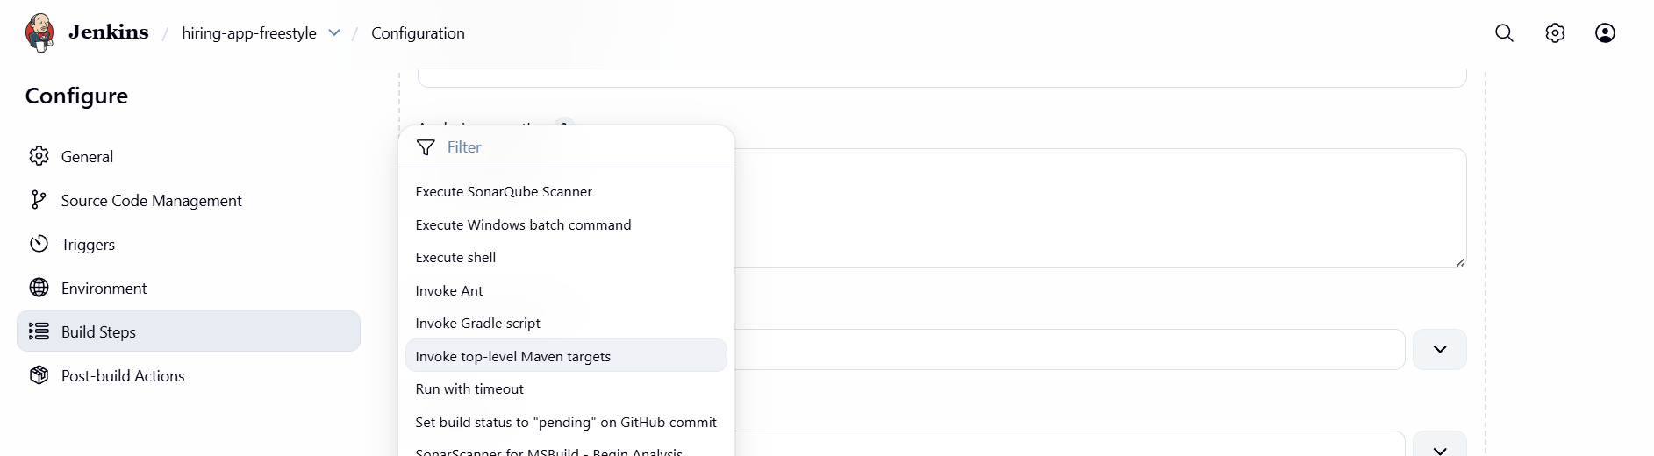
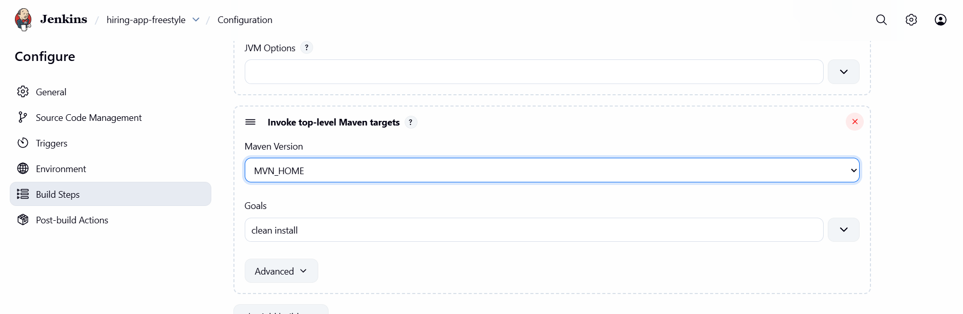
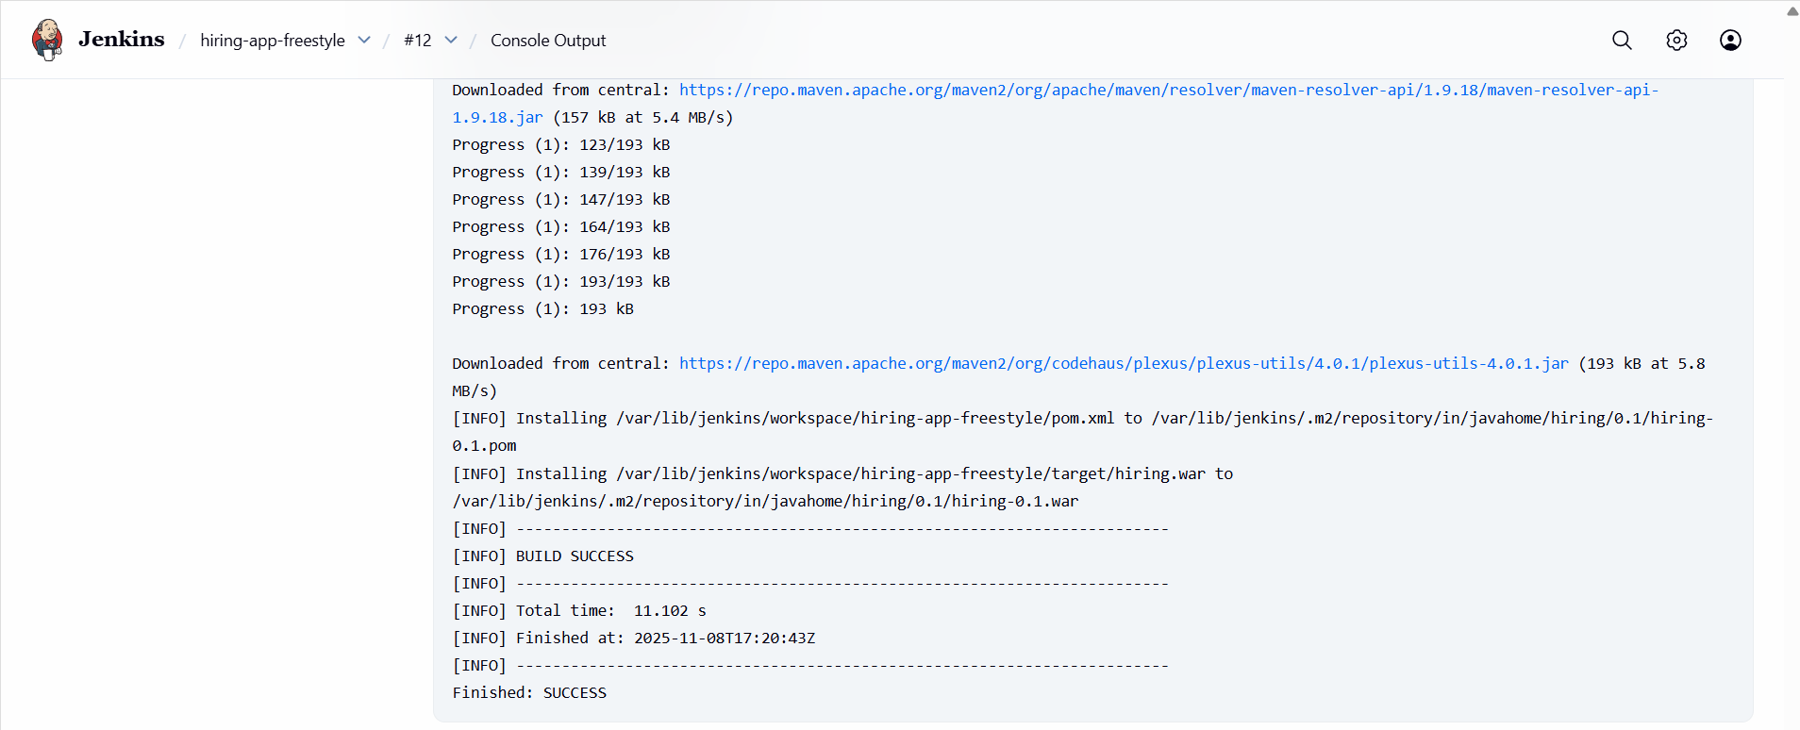
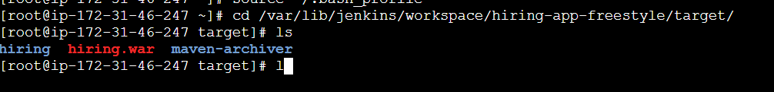

Nexus Artifactory
Step 1: Launch a new instance of type c7a.xlarge and 20gb of space and install java.
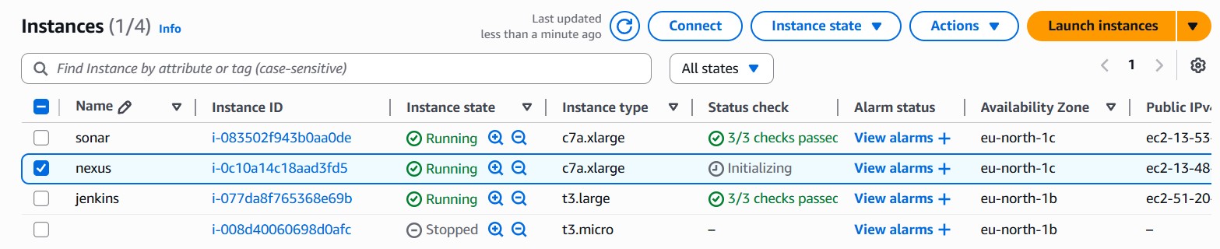

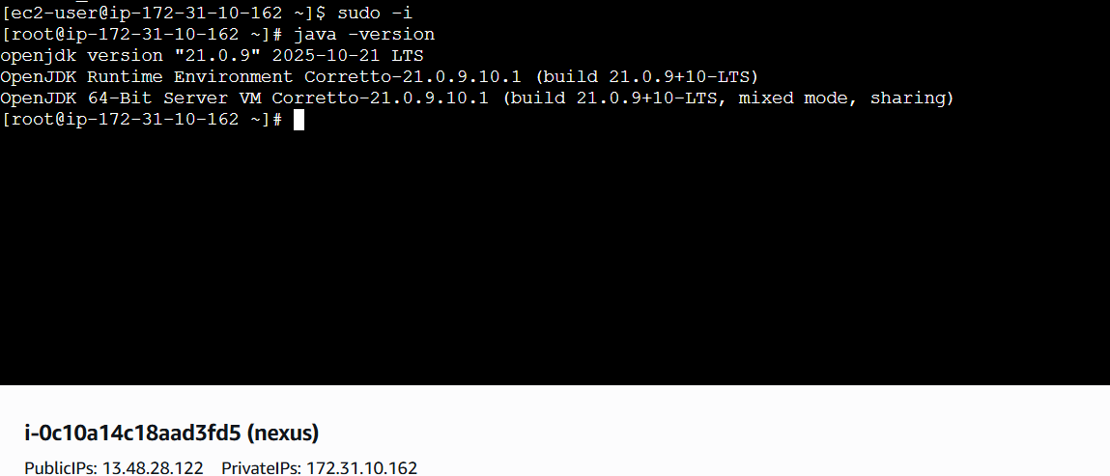
Step 2: Goto /opt directory, download and extract nexus file and rename it.
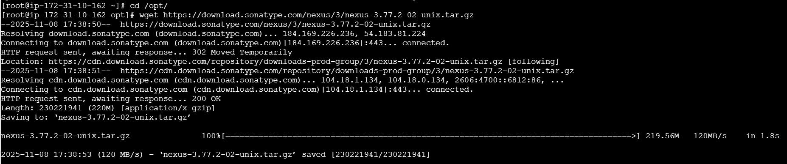
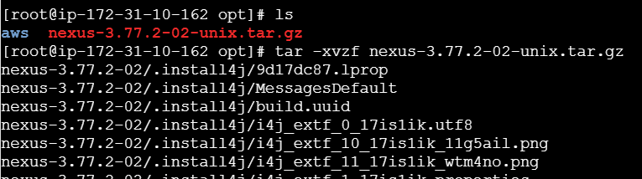
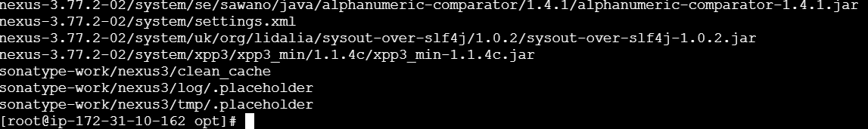
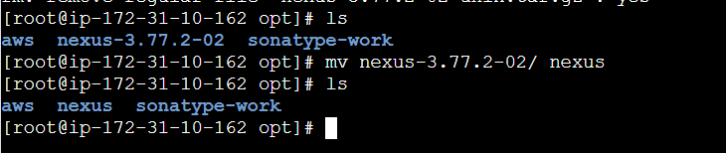
Step 3: open nexus.rc file and enter user as ec2-user and change ownership and start nexus.
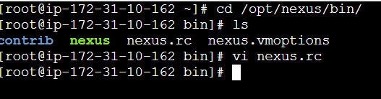
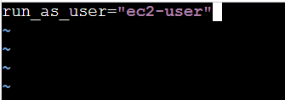
• sudo chown -R ec2-user:ec2-user nexus
• sudo mkdir -p /opt/sonatype-work/nexus3/log
• sudo chown -R ec2-user:ec2-user /opt/nexus
- sudo chown -R ec2-user:ec2-user /opt/sonatype-work
• sudo chmod -R 755 /opt/nexus /opt/sonatype-work
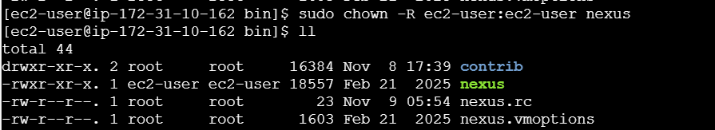
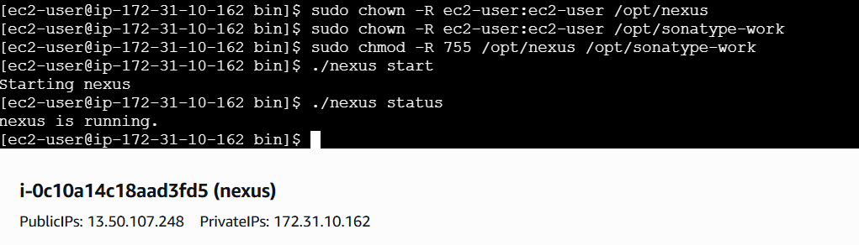

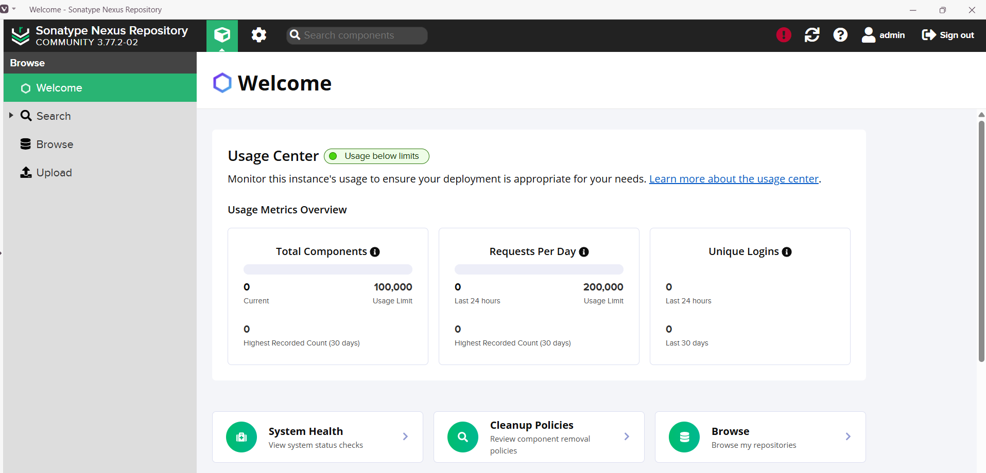
Step 4: Goto Jenkins GUImanage Jenkins pluginsAvailable plugins install nexus artifact.
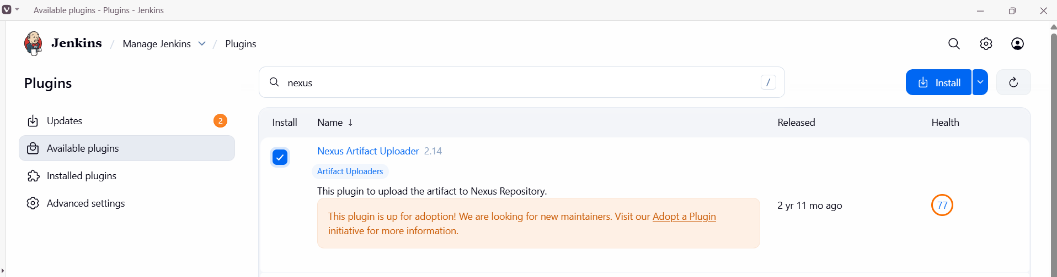
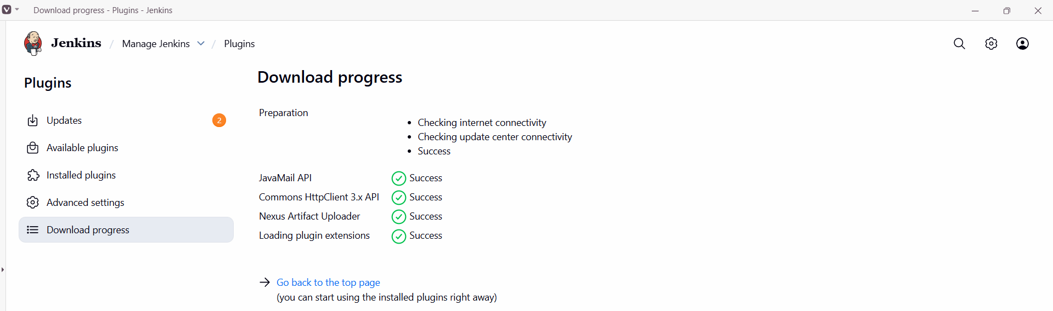
Step 5: Goto JobconfigureBuild stepsAdd build stepsselect Nexus artifact uploaderenter details, save and Build it.
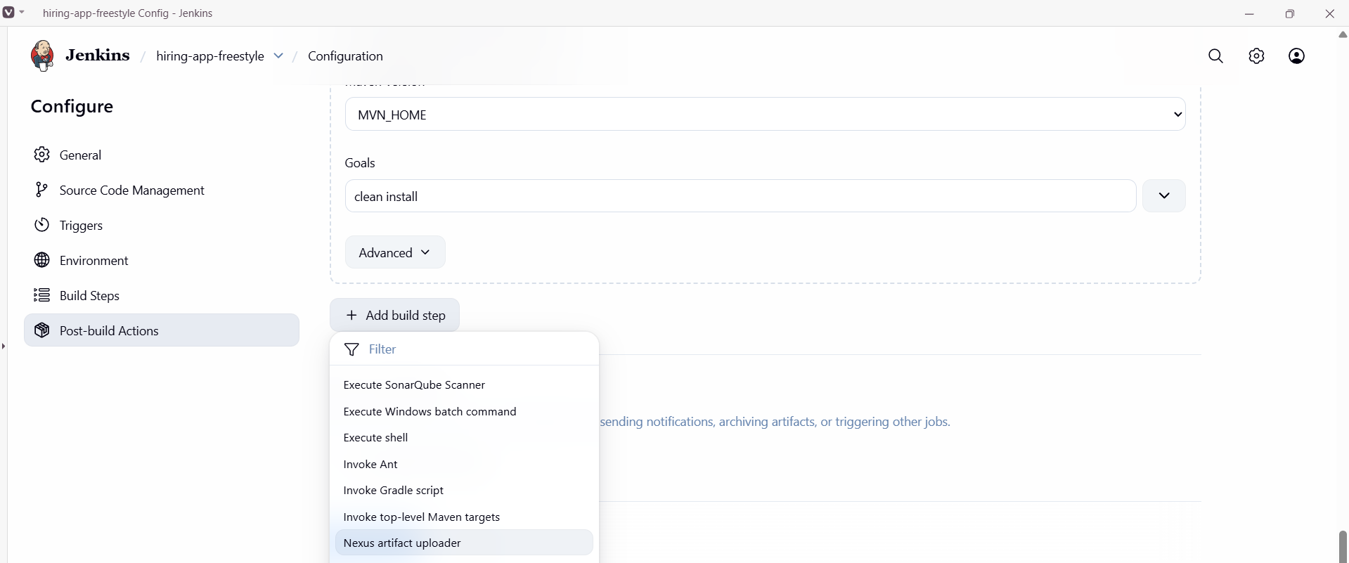
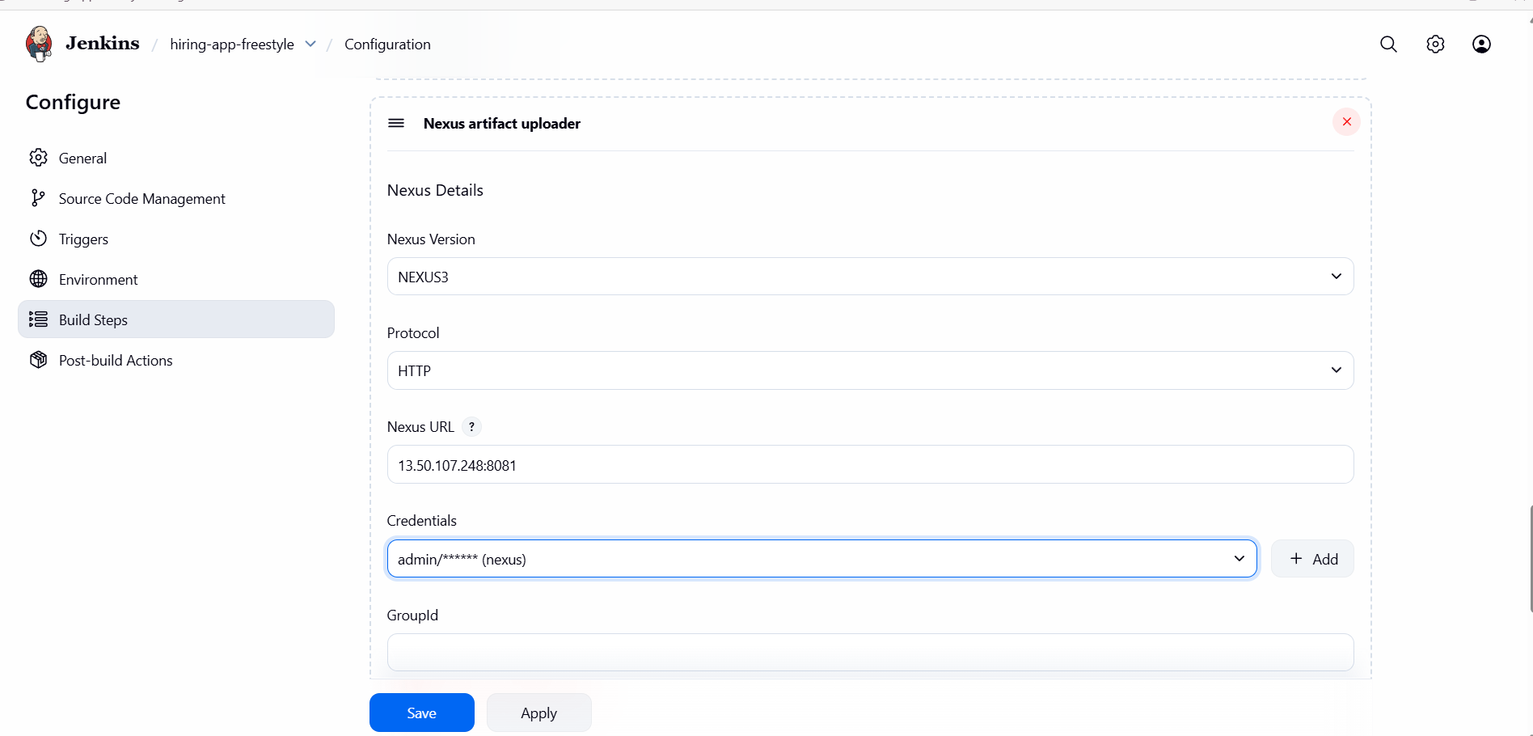
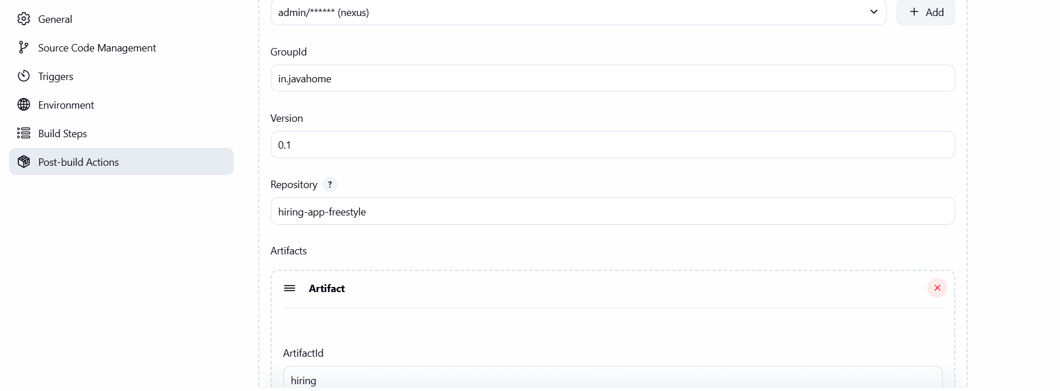
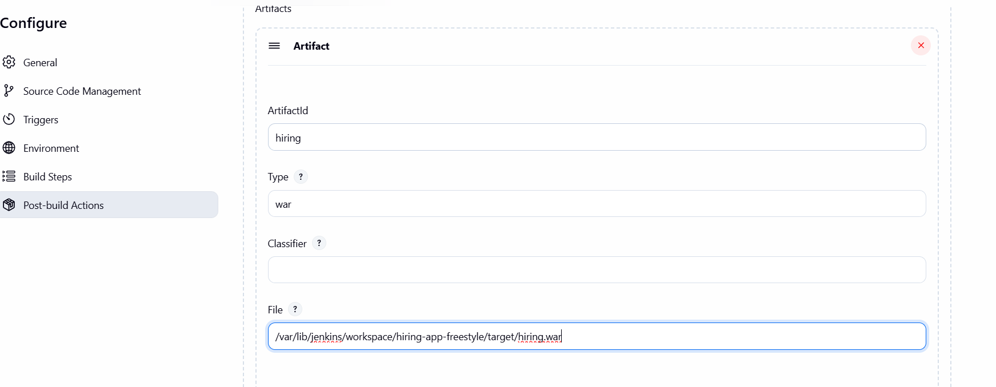
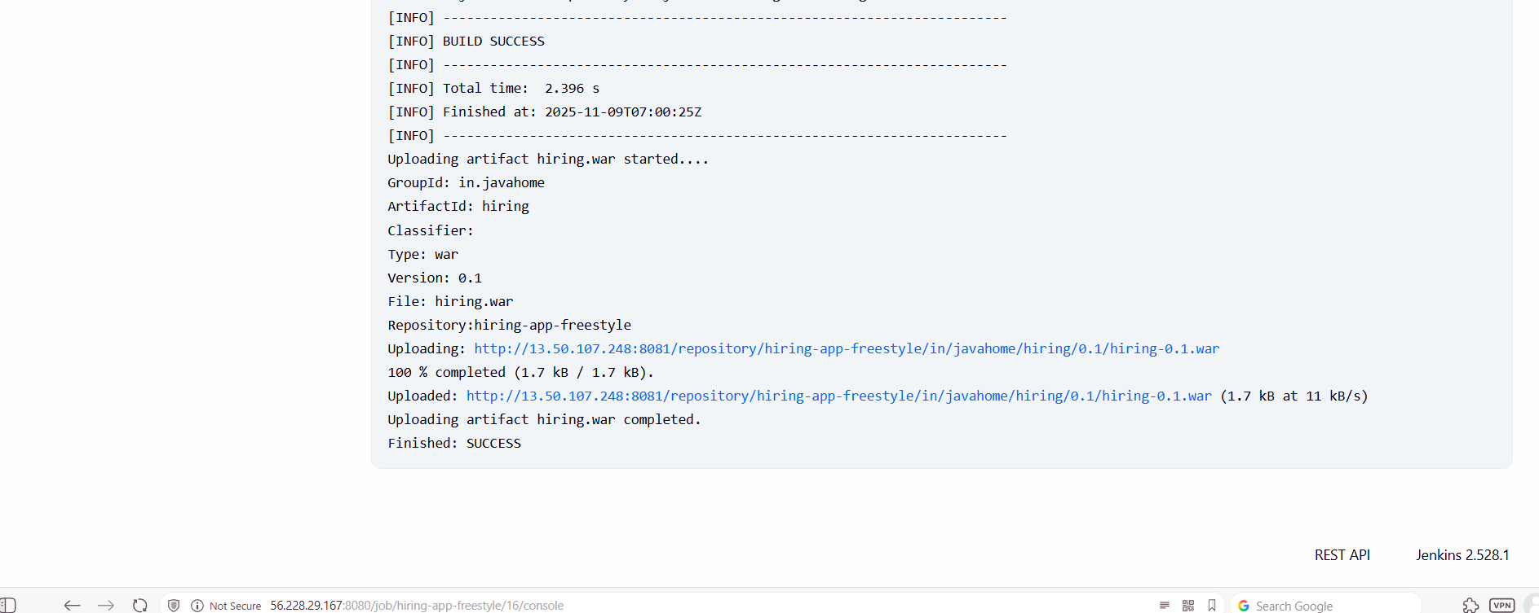
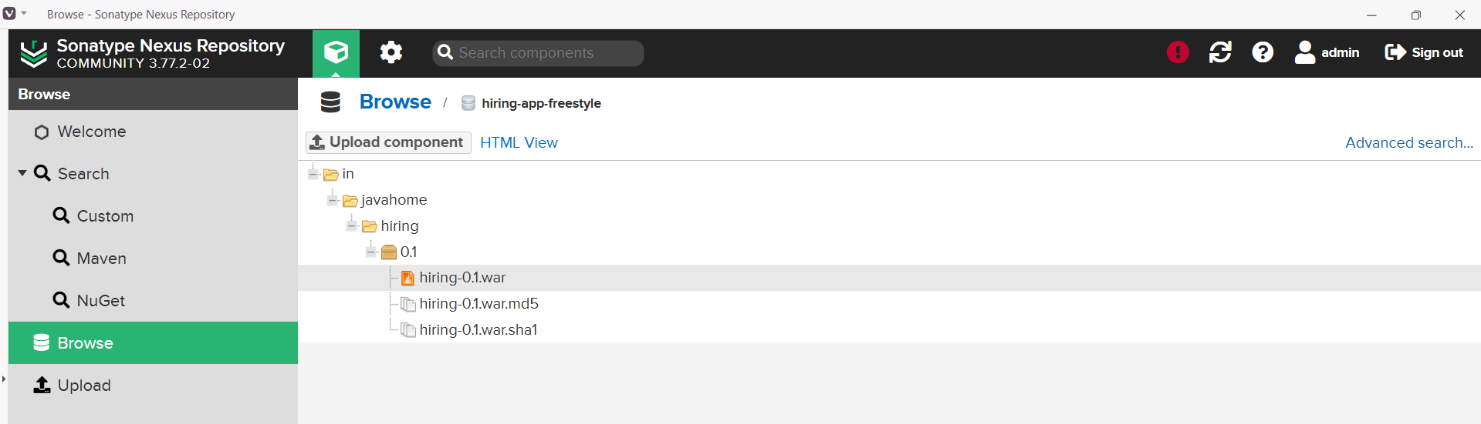
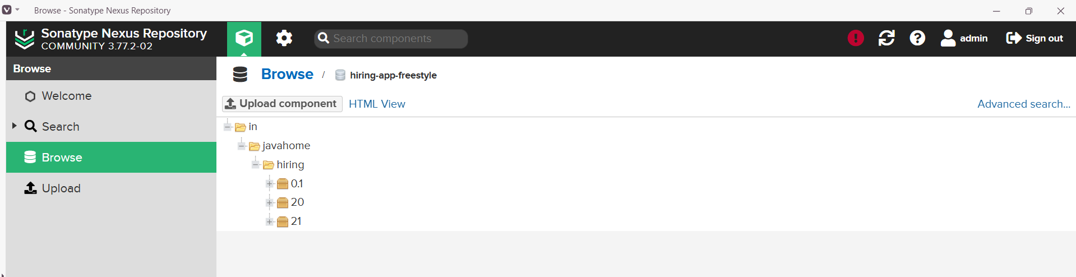

Slack Notification
Step 1: Goto Jenkins GUIManage Jenkinspluginsavailable pluginsinstall slack plugin.
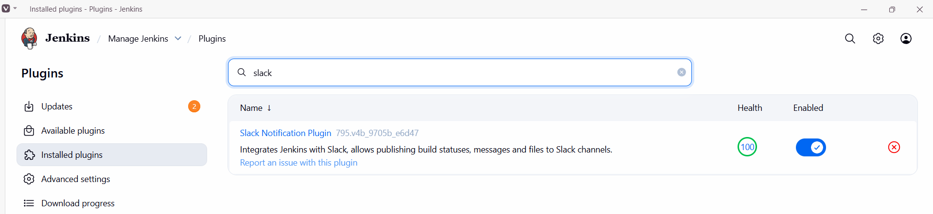

Step 2: Goto Jobconfigurepost build actionsselect slack notificationssave.
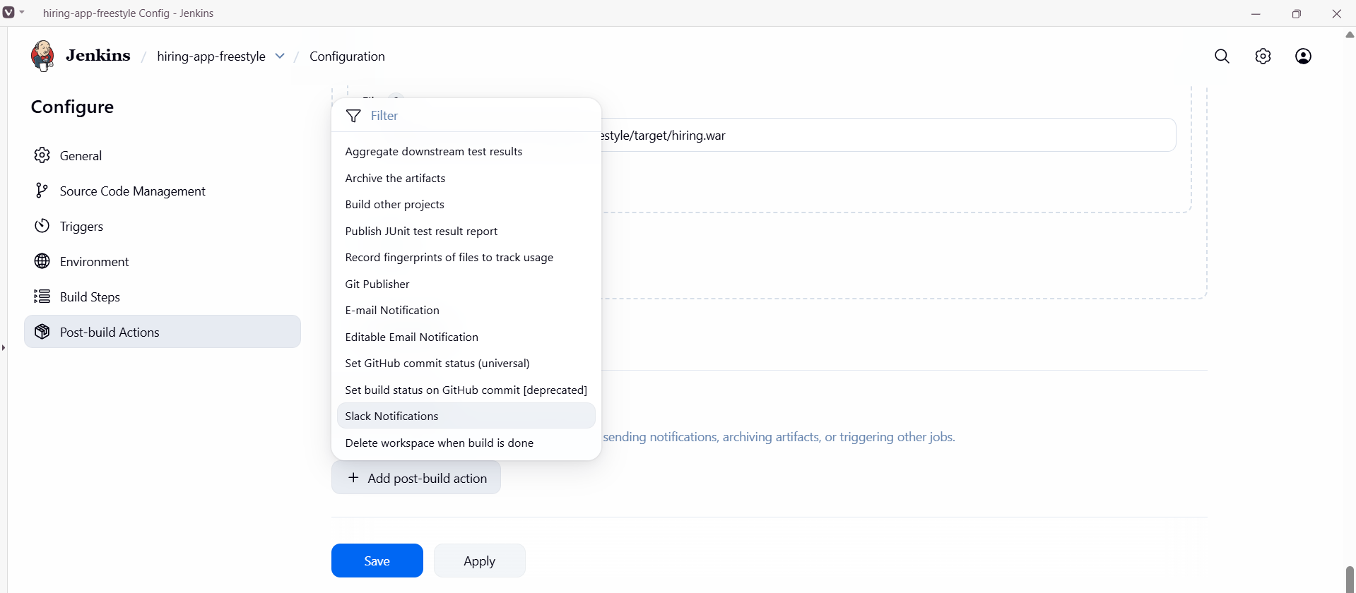
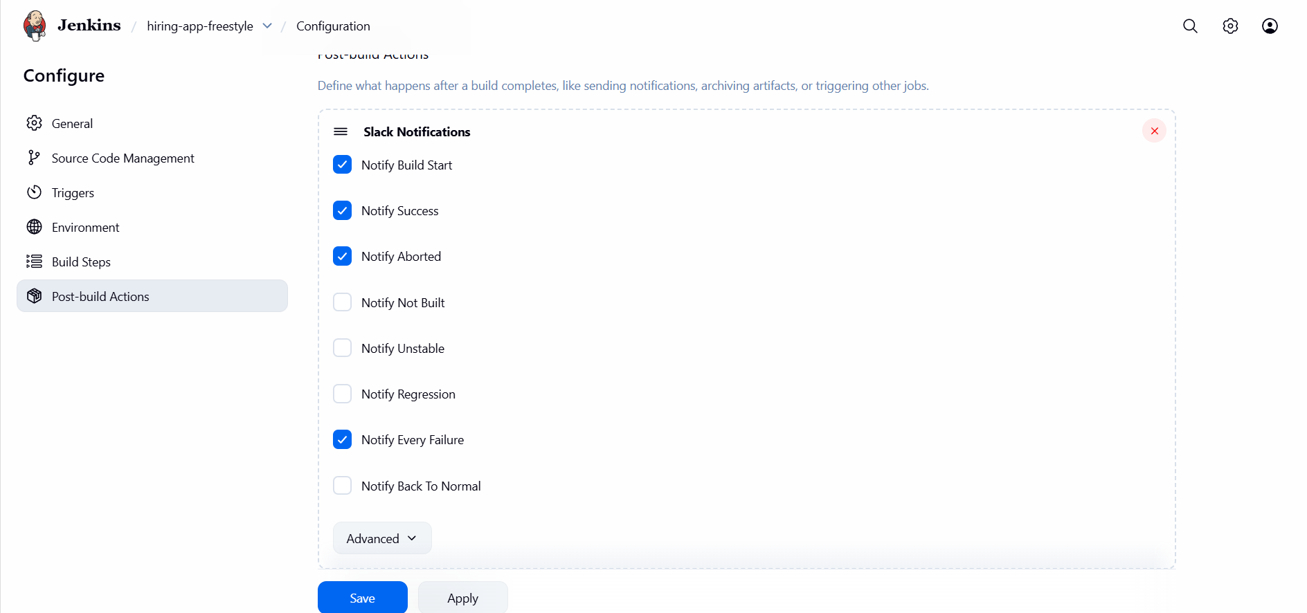
Step 3: Goto Slackmoreappsjenkins ciopen appconfigurationAdd to slackselect channelAdd Jenkins integration.
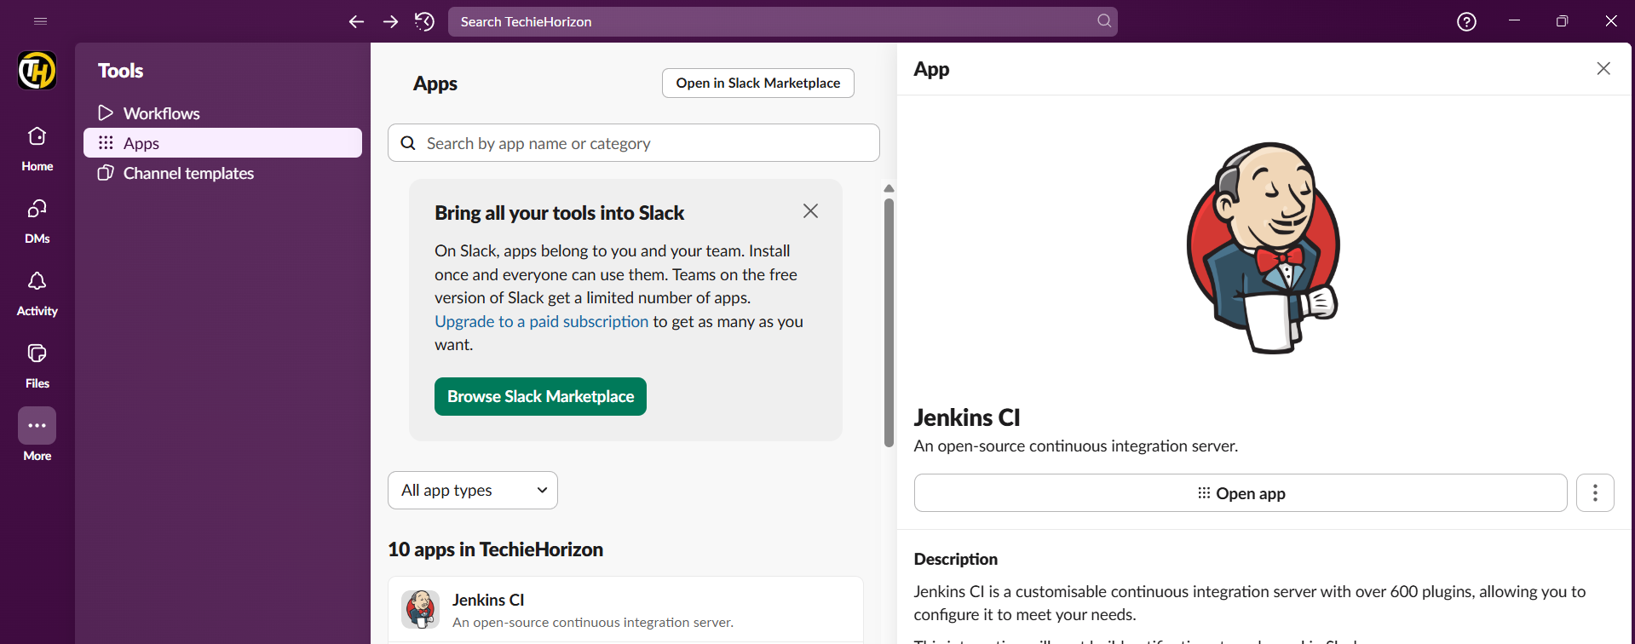
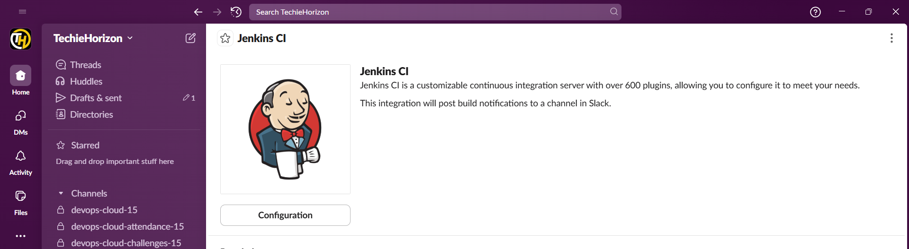
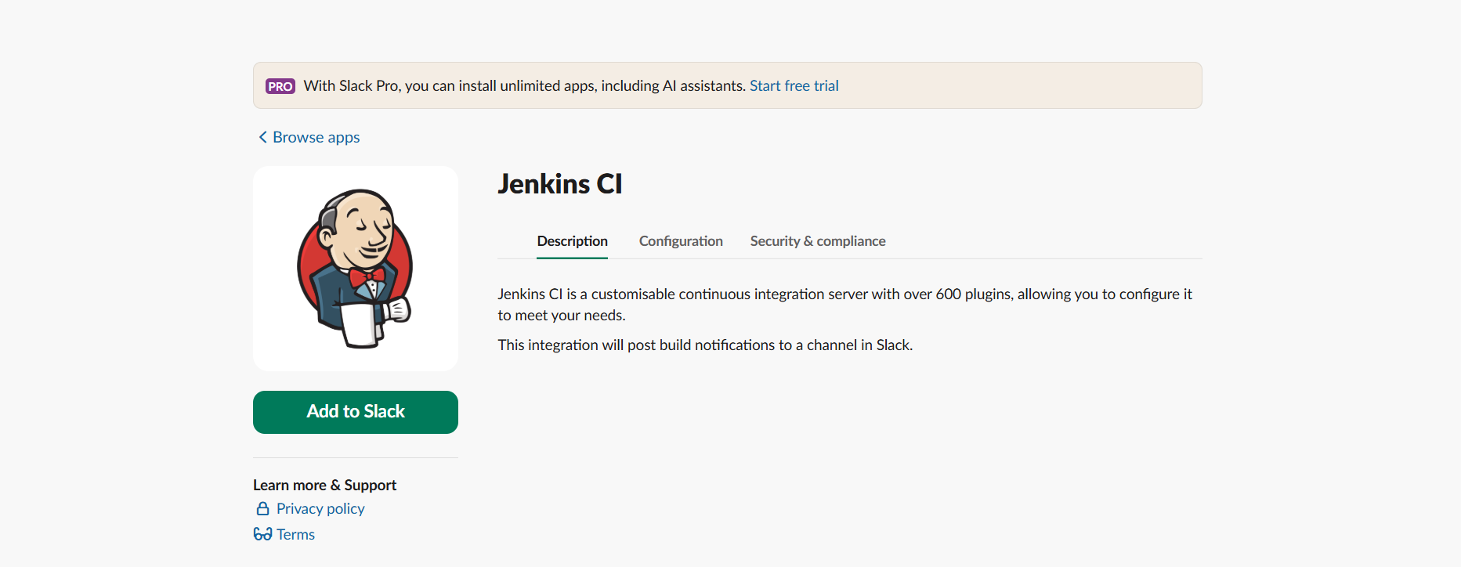
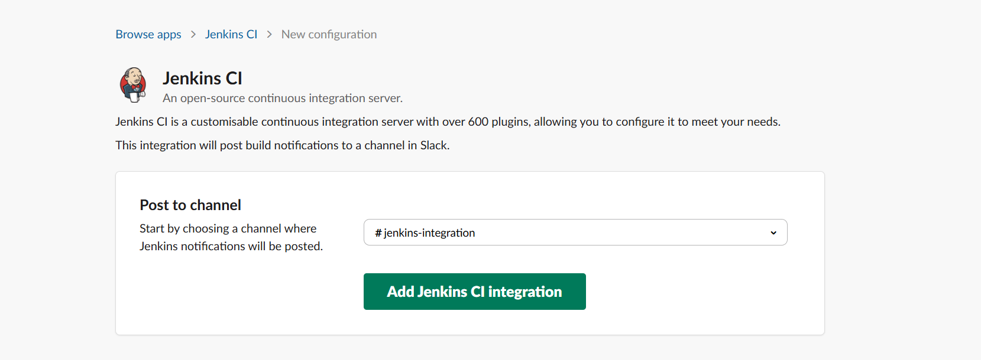
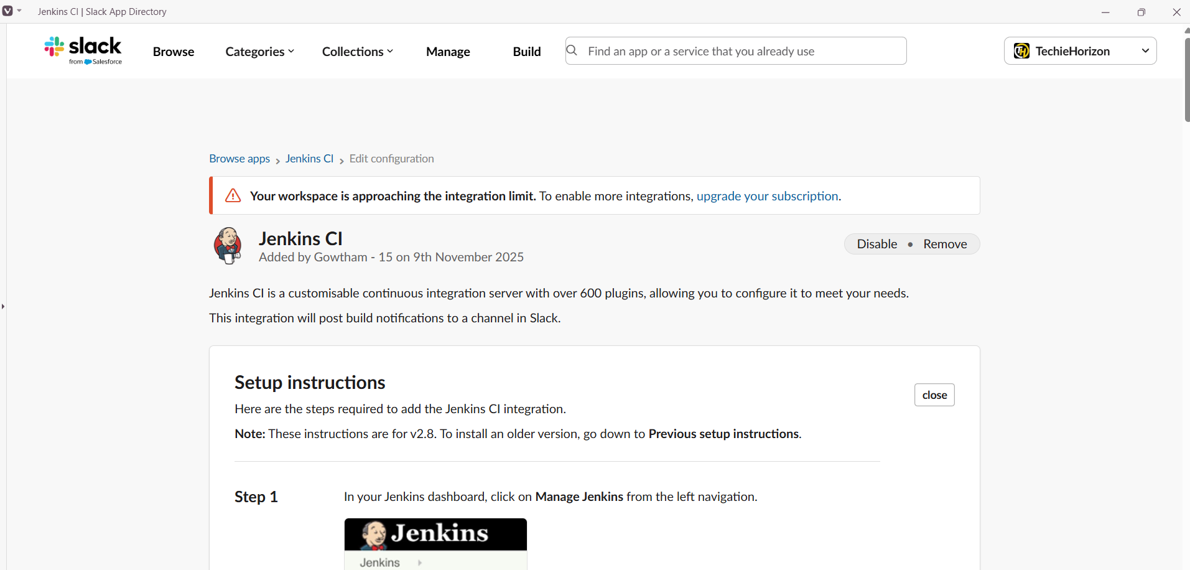
Step 4: Goto Jenkins GUIsystemslackconfigure slack and Build a job.
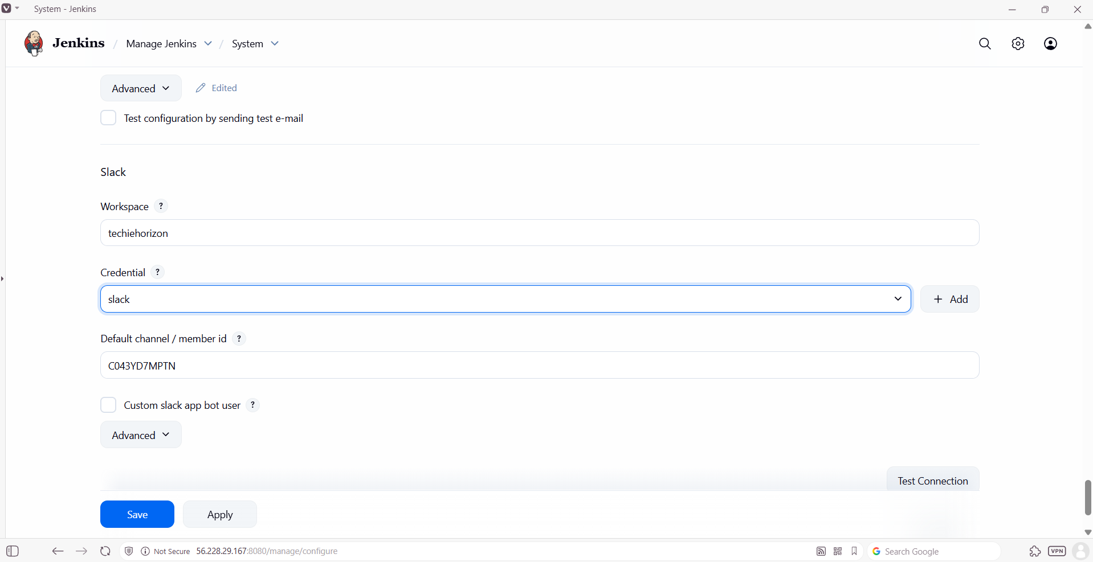
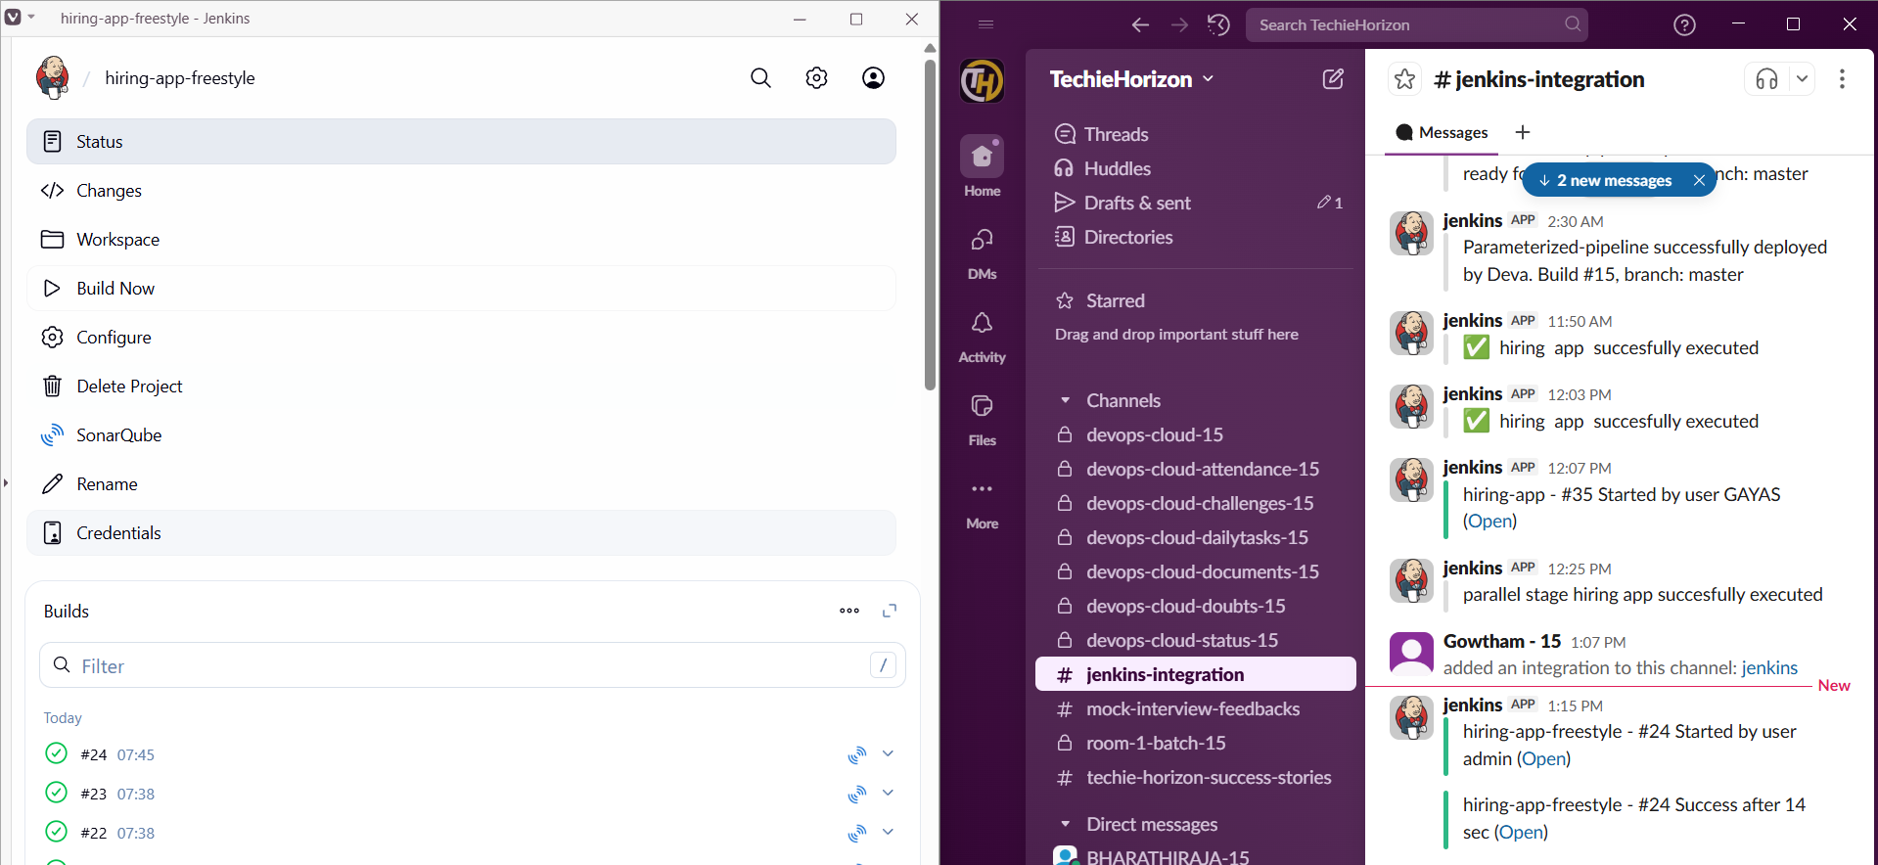

Deploy On tomcat
Step 1: Launch an instance and install apache tomcat.
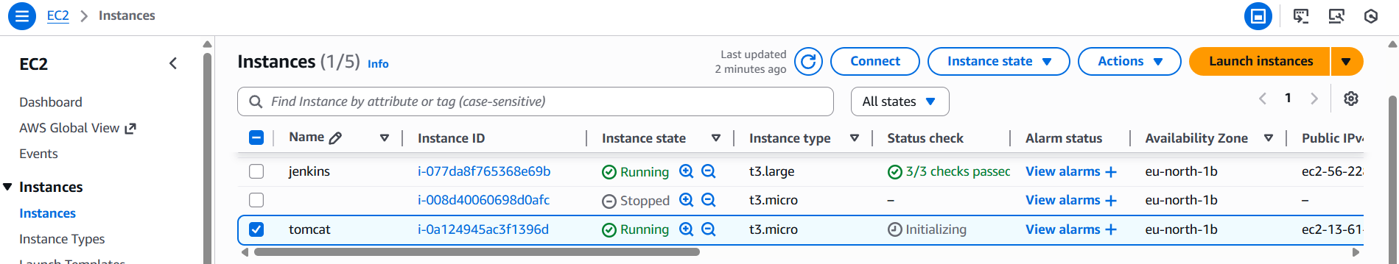
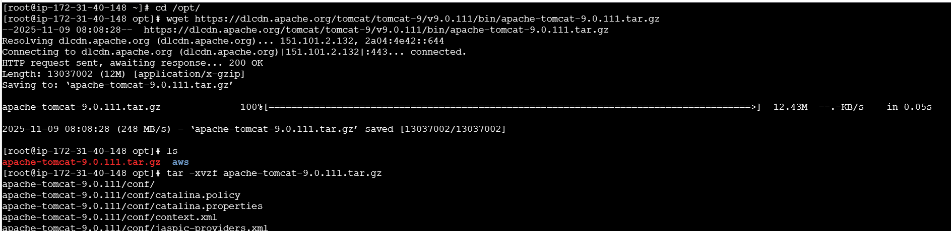
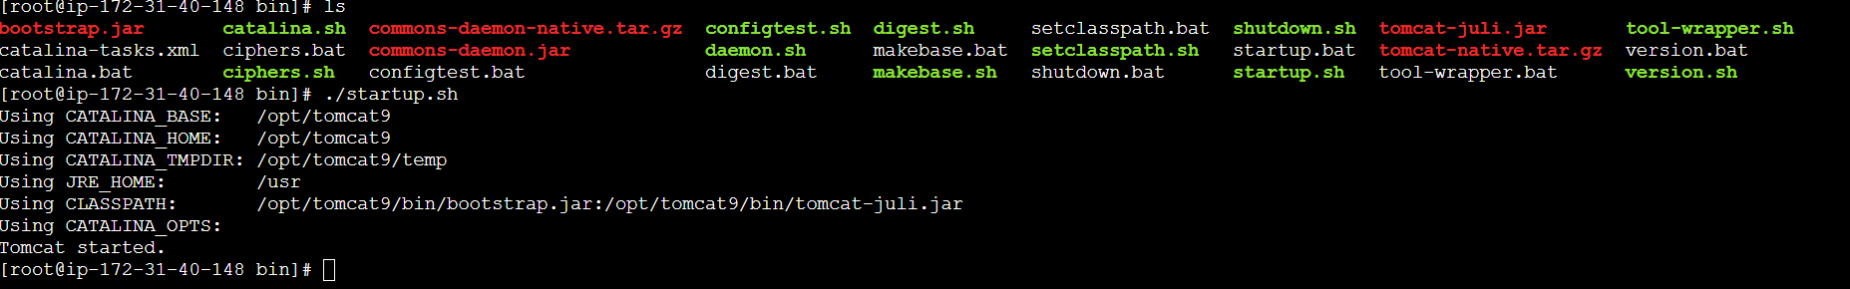
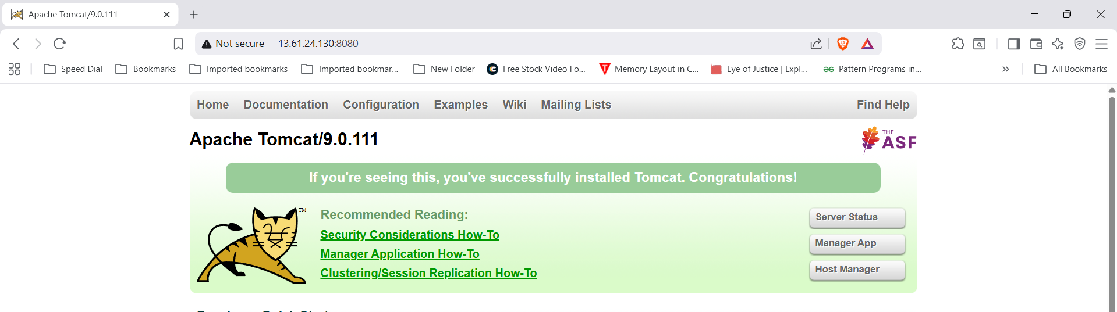

Step 2: comment (<!-- & -->) `Value ClassName` field on files which are under webapp directory.
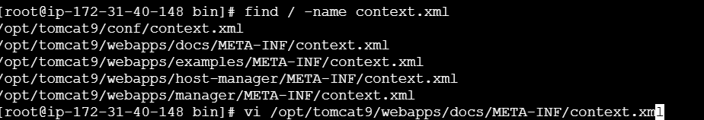
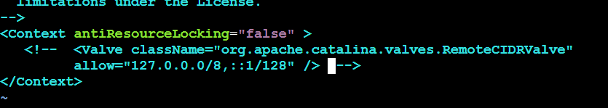
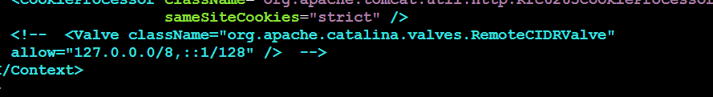
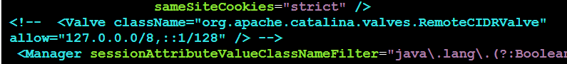
Step 3: Goto tomcat home directory and Add below users to conf/tomcat-user.xml file
<role rolename="manager-gui"/>
<role rolename="manager-script"/>
<role rolename="manager-jmx"/>
<role rolename="manager-status"/>
<user username="admin" password="admin" roles="manager-gui, manager-script, manager-jmx, manager-status"/>
<user username="deployer" password="deployer" roles="manager-script"/>
<user username="tomcat" password="s3cret" roles="manager-gui"/>
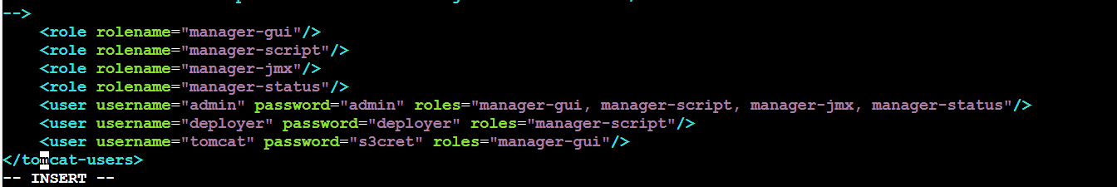
Step 4: Restart serivce and try to login to tomcat application from the browser.
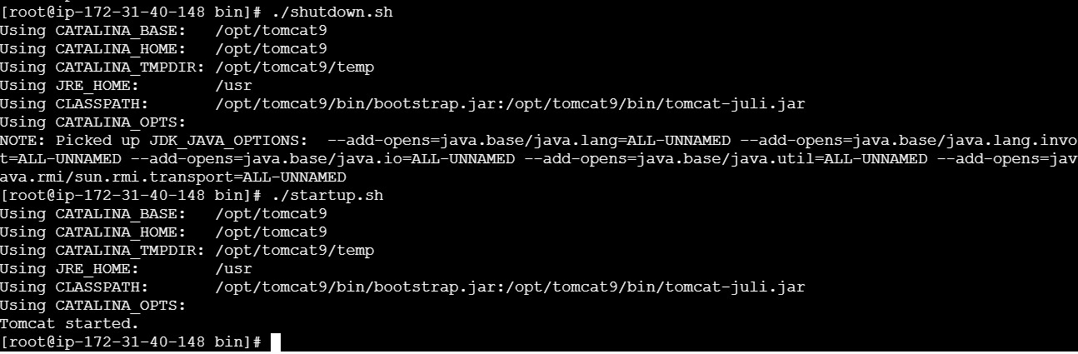
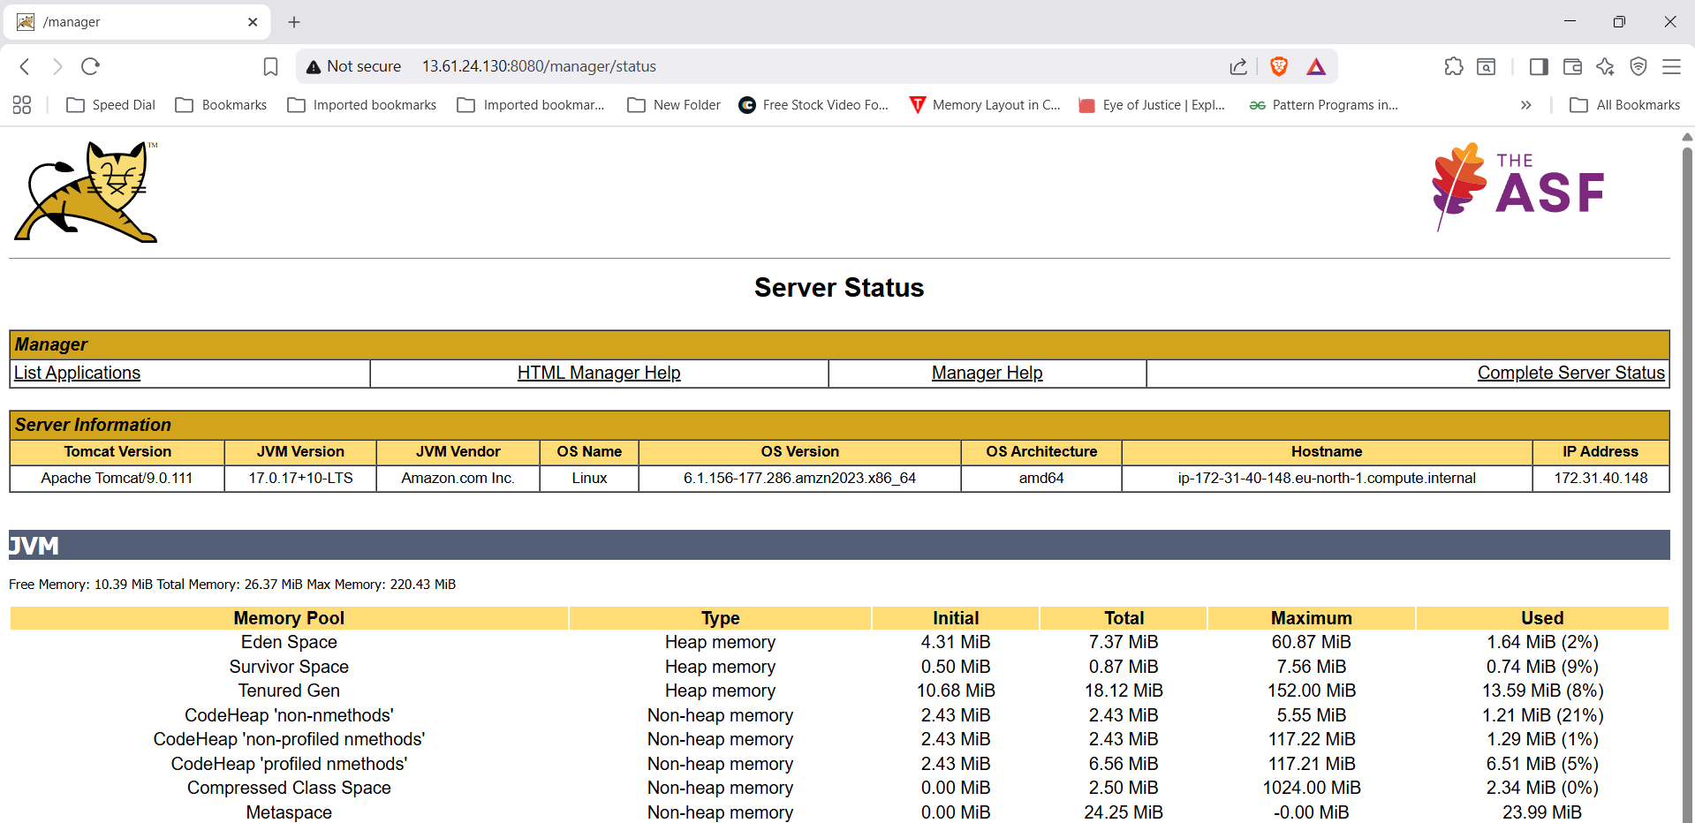

Step 5: Goto Jenkins GUImanage Jenkinspluginsavailable pluginsinstall deploy to container.
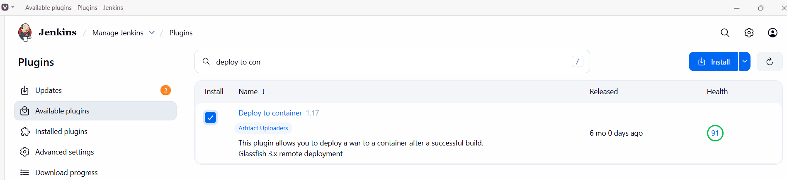
Step 3: Goto Jobconfigurepost build actionsselect deploy war to containerconfigure & save and Build.
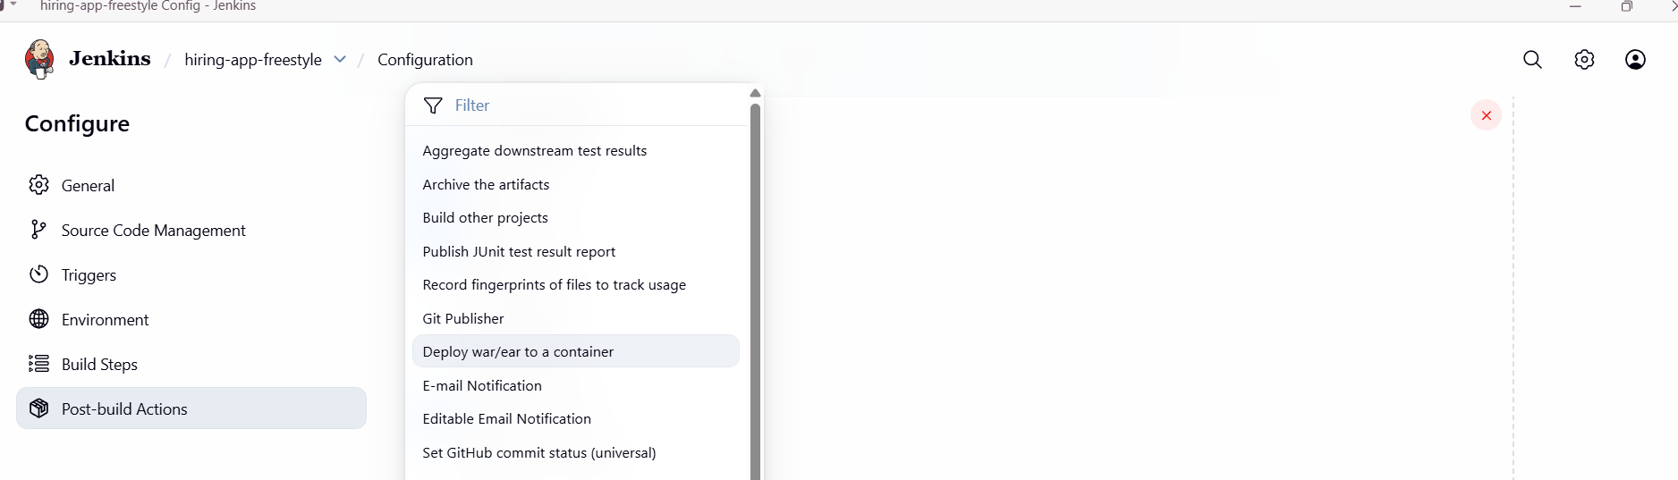
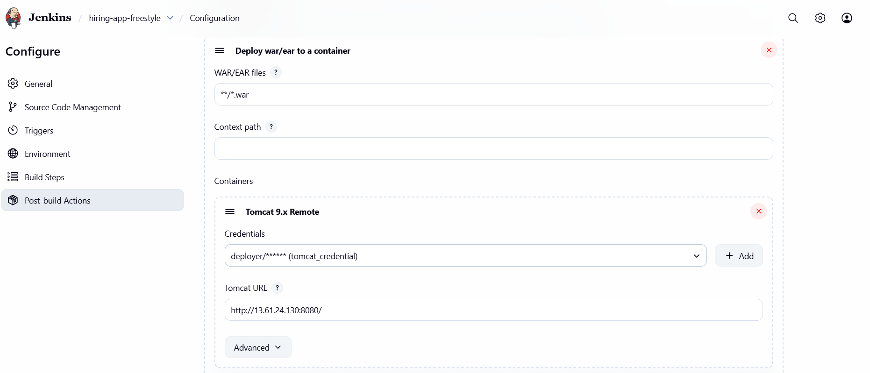
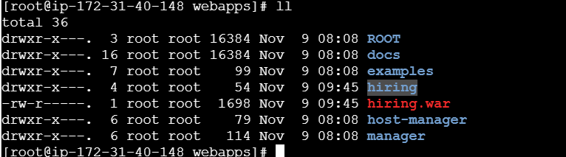
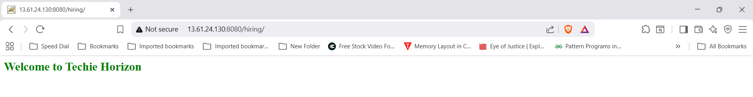
Task – 2
Setup a Jenkins CICD pipeline using Declarative pipeline using feature-1.1 branch. https://github.com/betawins/sabear_simplecutomerapp/tree/feature-1.1 stages:
    - Git Clone
    - SonarQube Integration
    - Maven Compilation
    - Nexus Artifactory
    - Slack Notification
    - Deploy On tomcat
- Git Clone
Step 1: create a new job in Jenkins with declarative pipeline and Build it.
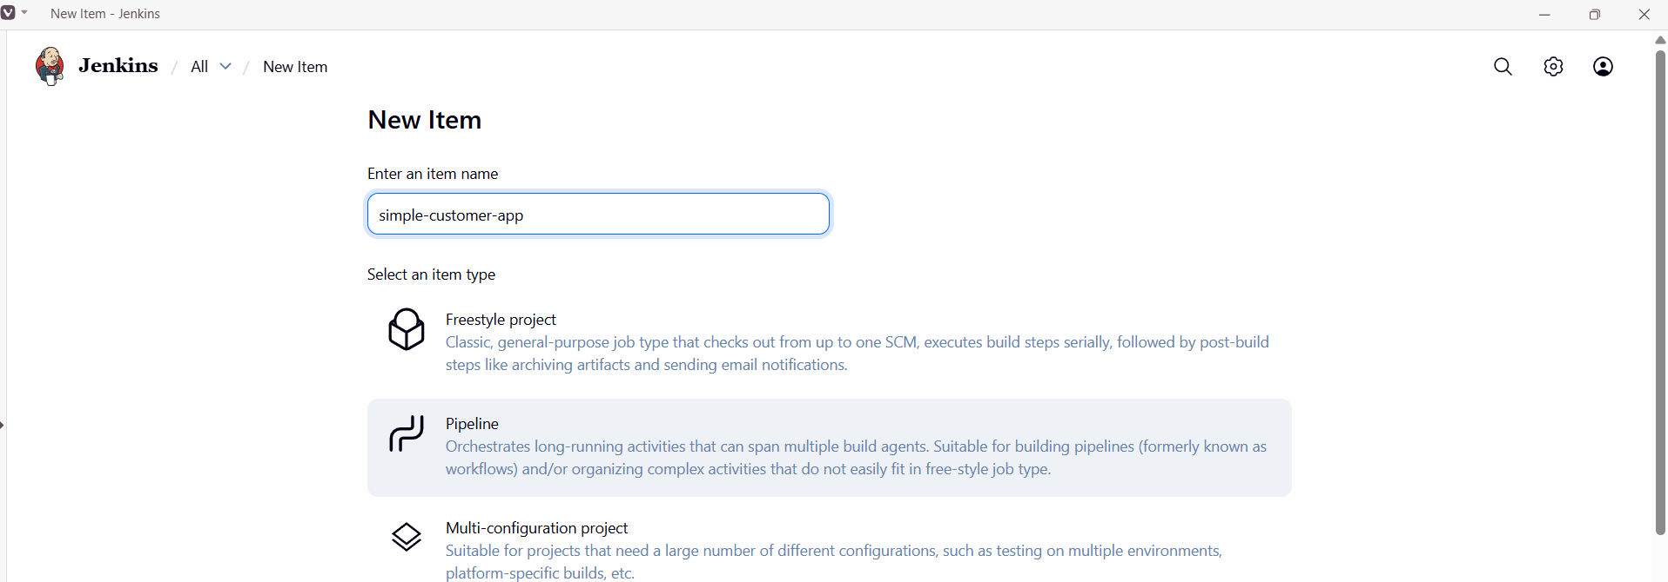
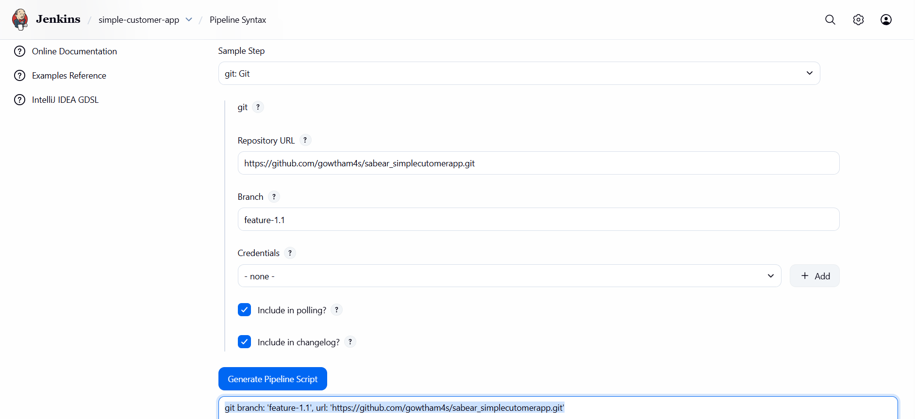
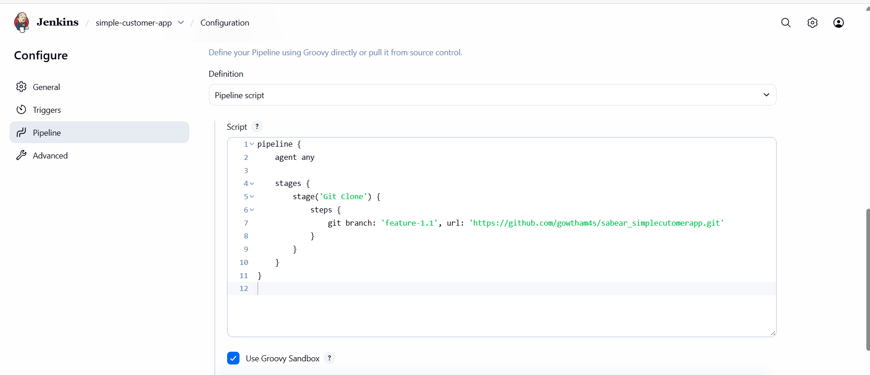
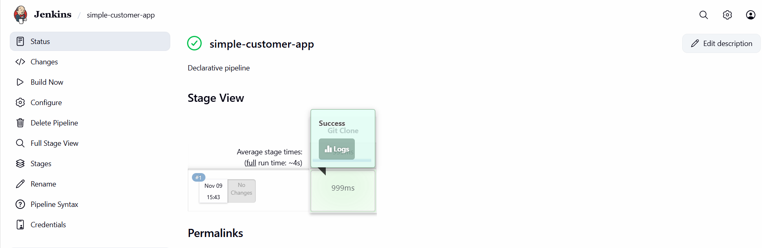
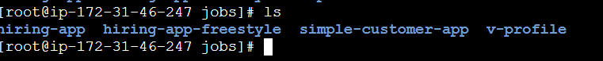

SonarQube Integration
Step 1: Goto Pipeline syntaxselect withSonarQubeEnvclick generate pipeline scriptadd that in declarative pipeline script and Build it.
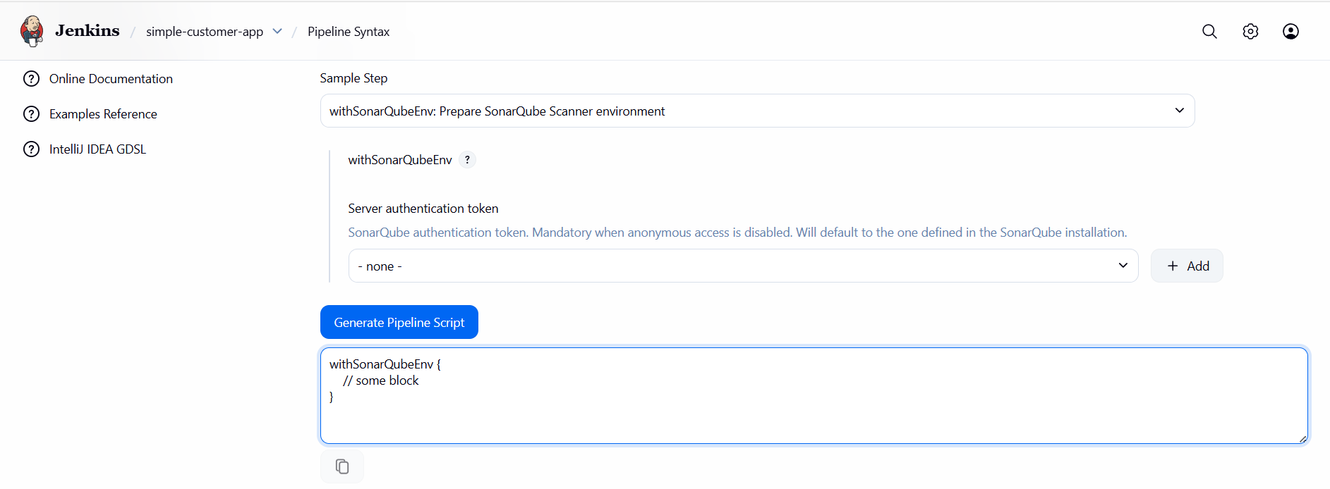

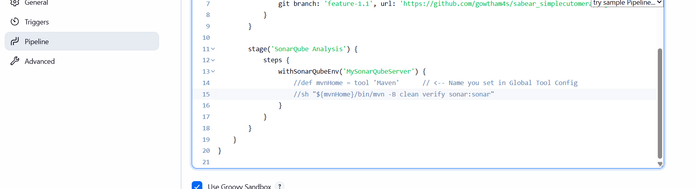
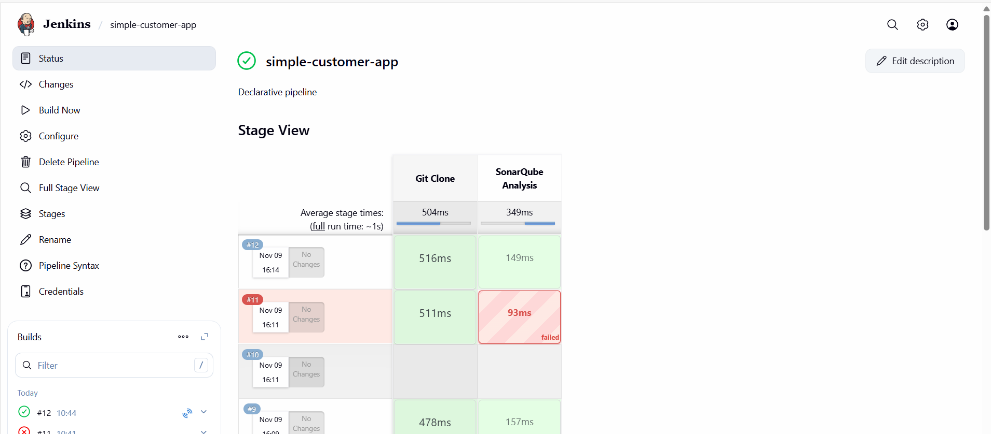
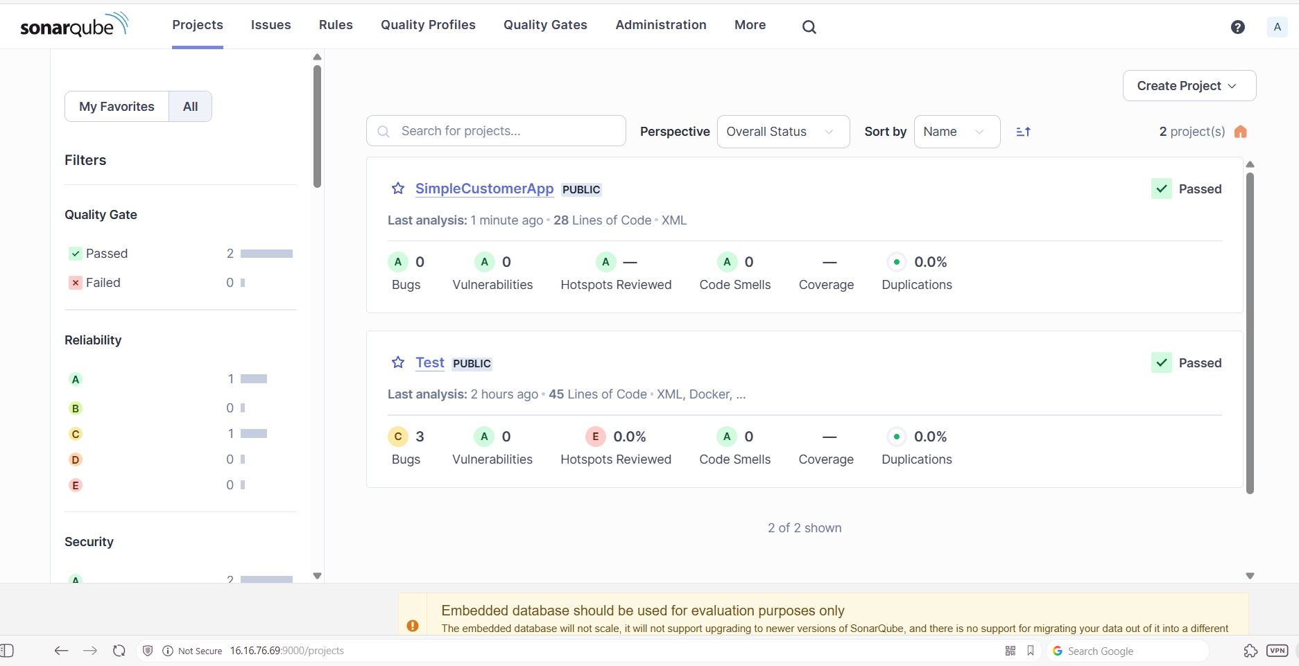

Maven Compilation
Step 1: Add Maven location and name in the script and Build.
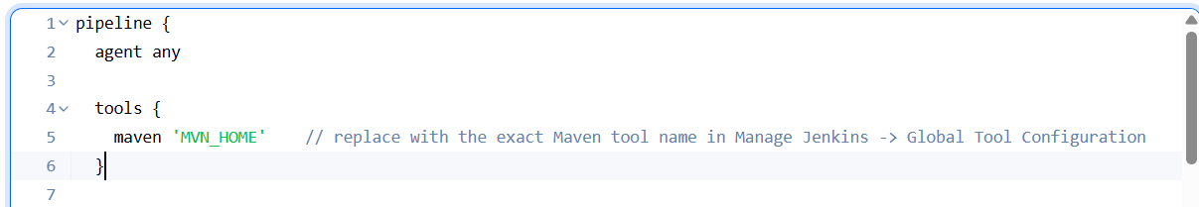
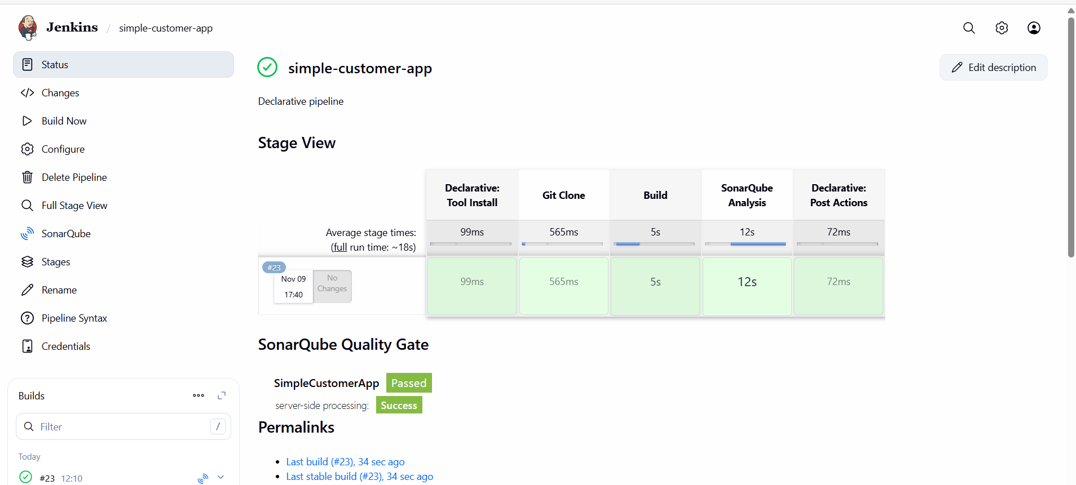
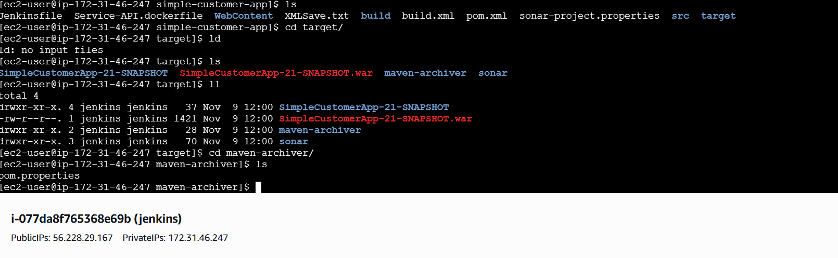

Nexus Artifactory
Step 1:Create a new repository in nexus.
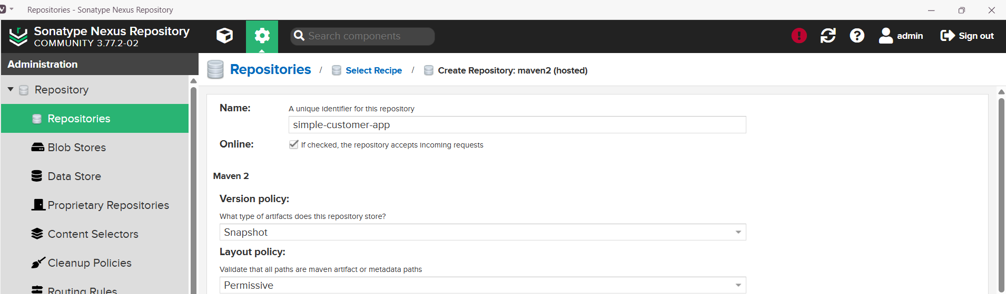
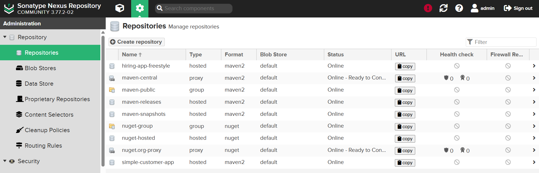
Step 2: Goto pipeline syntaxEnter detailsGenerate pipeline script
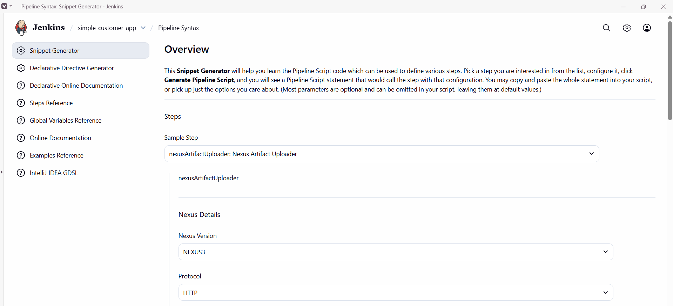
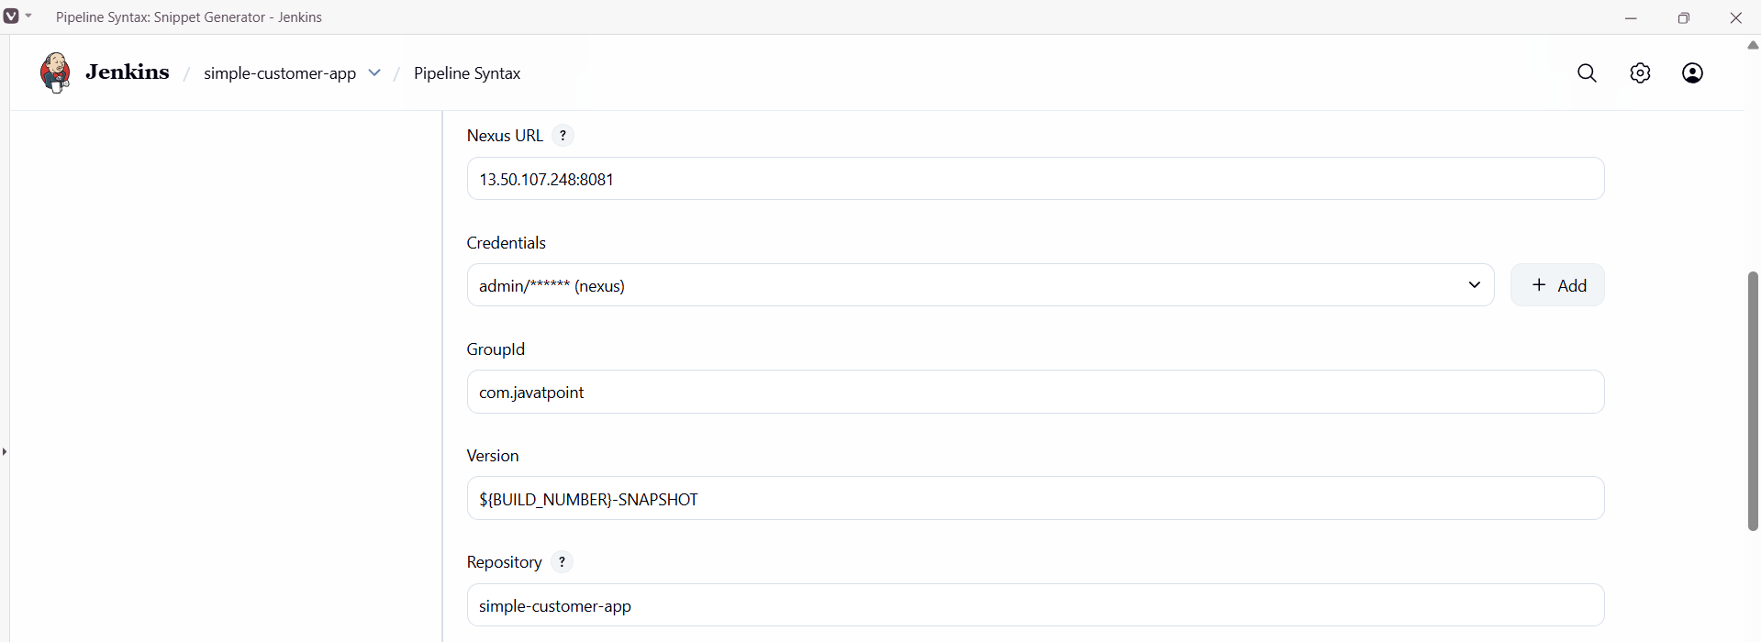
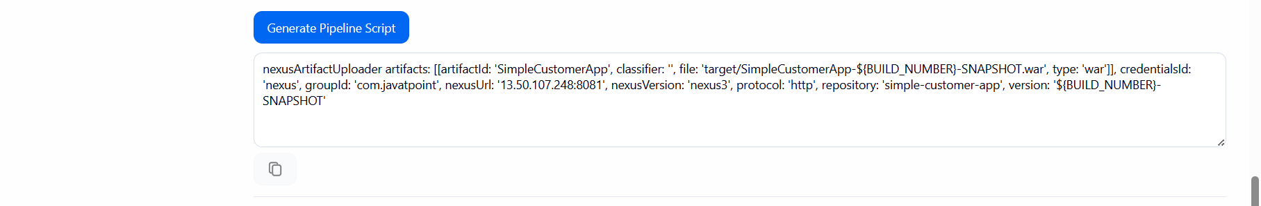
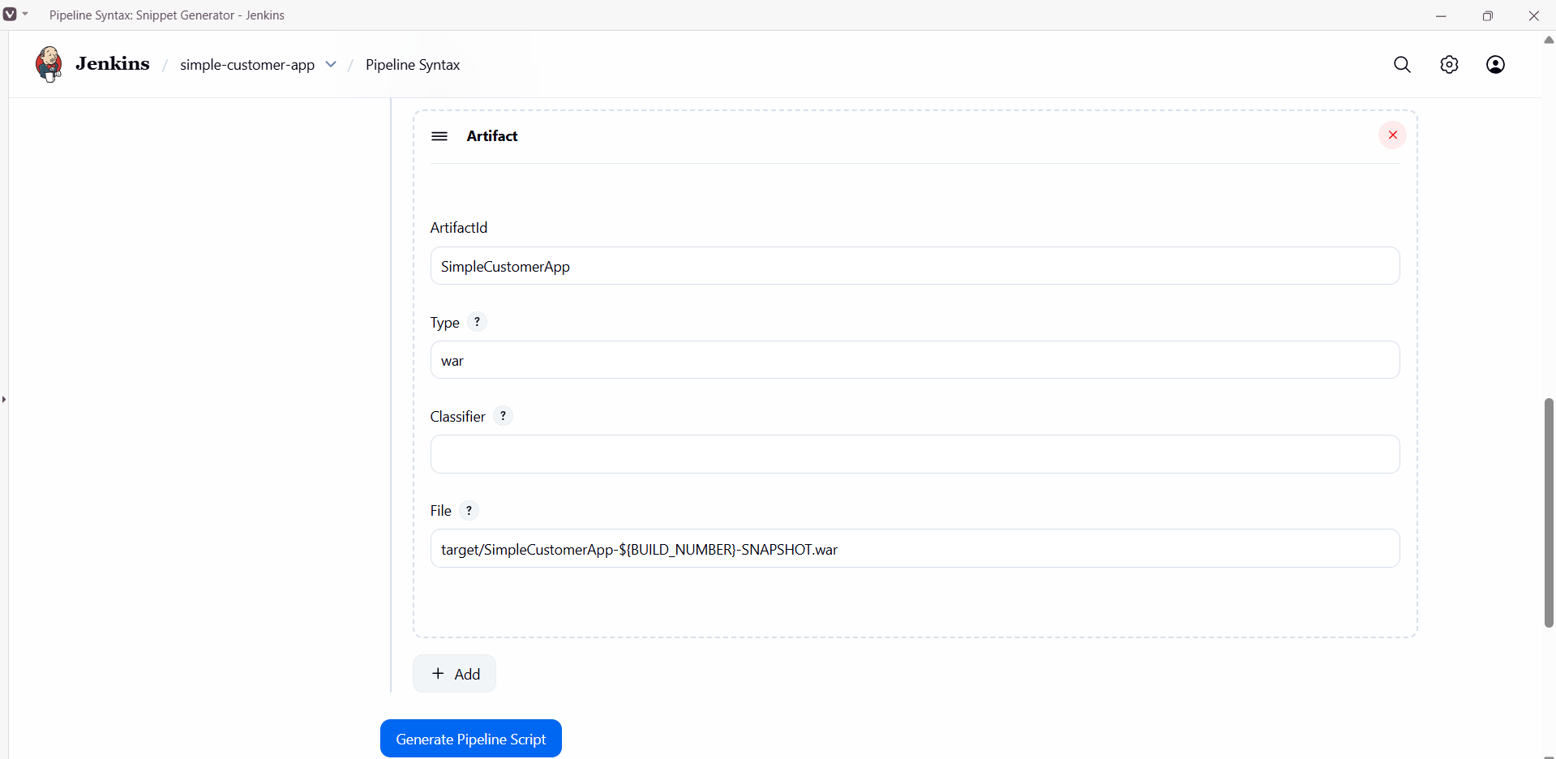

Step 3: Update the script and Build it.
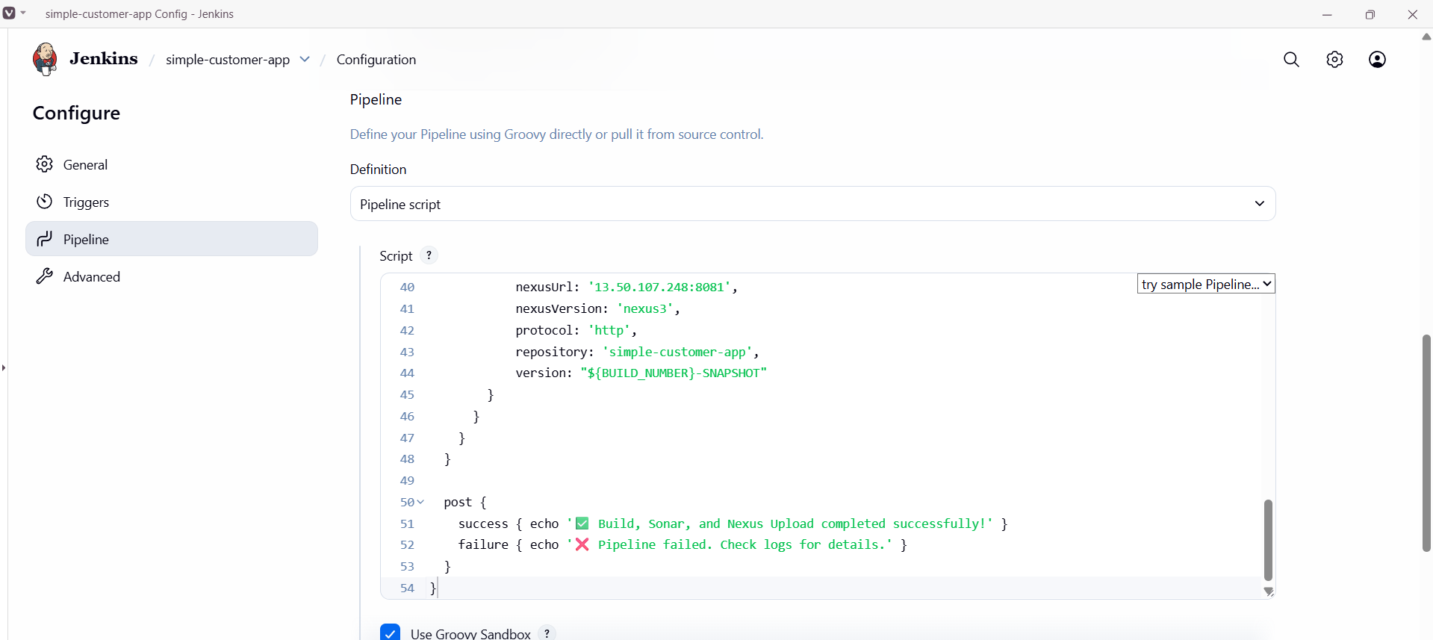
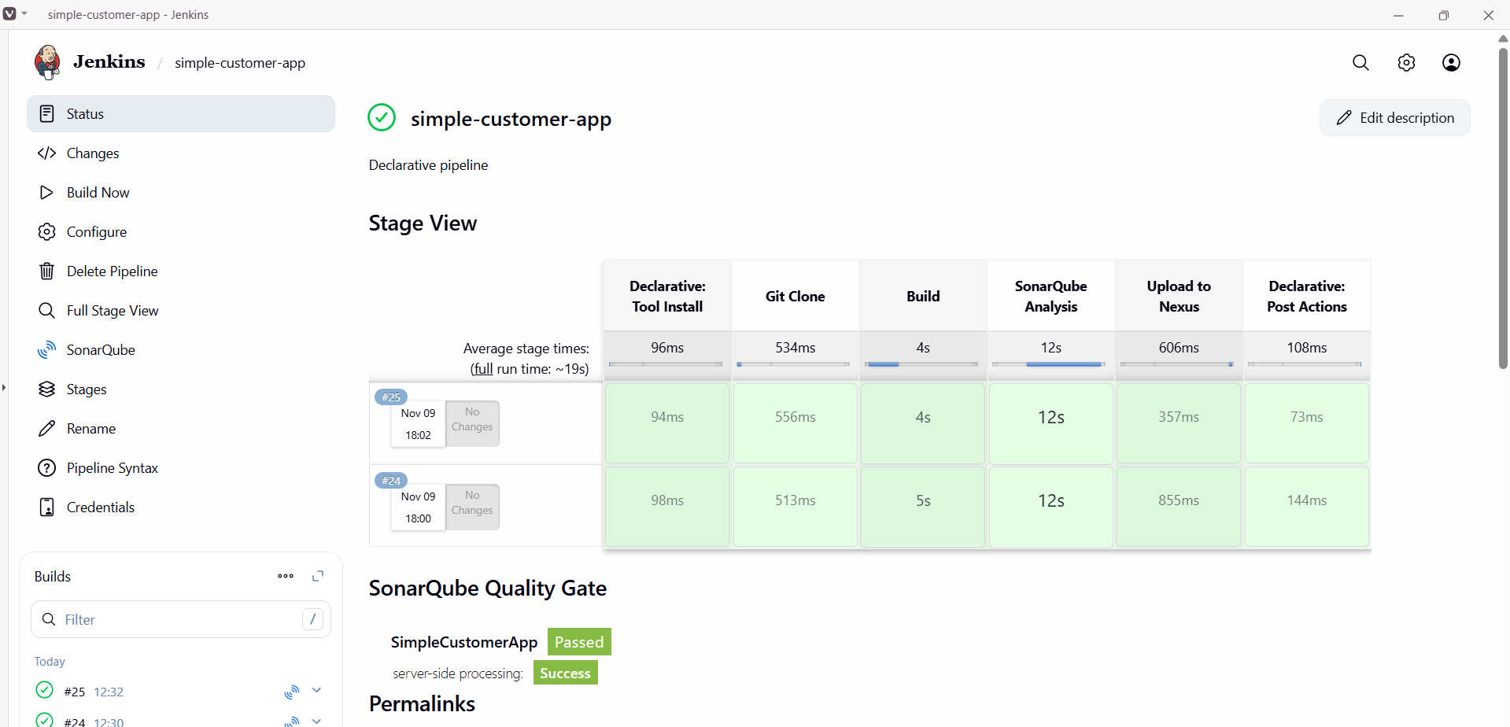
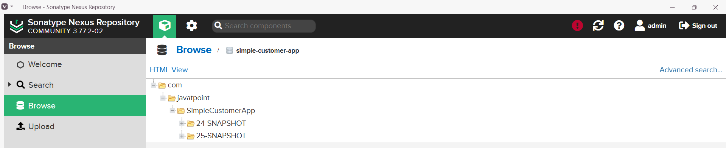

Slack Notification
Step 1: Goto Pipeline syntaxSelect sendSlack: send Slack MessageEnter detailsGenerate pipeline script.
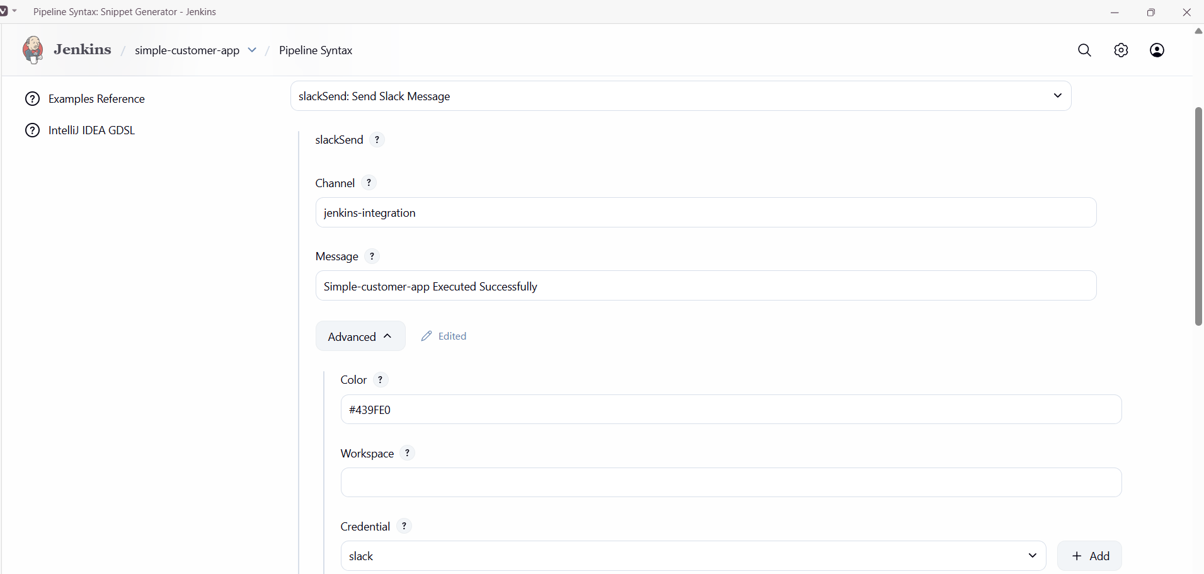
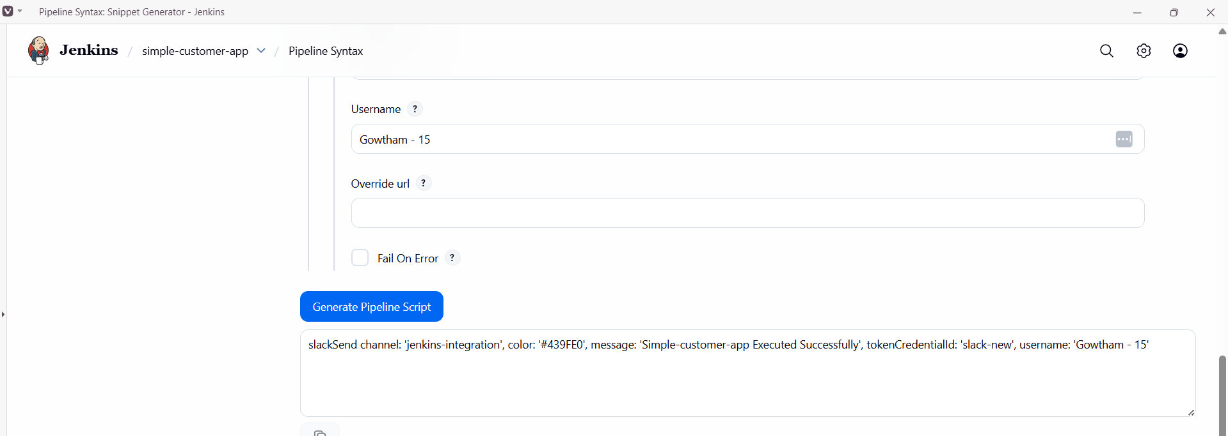

Step 2: Update the Script and Buid the Job.
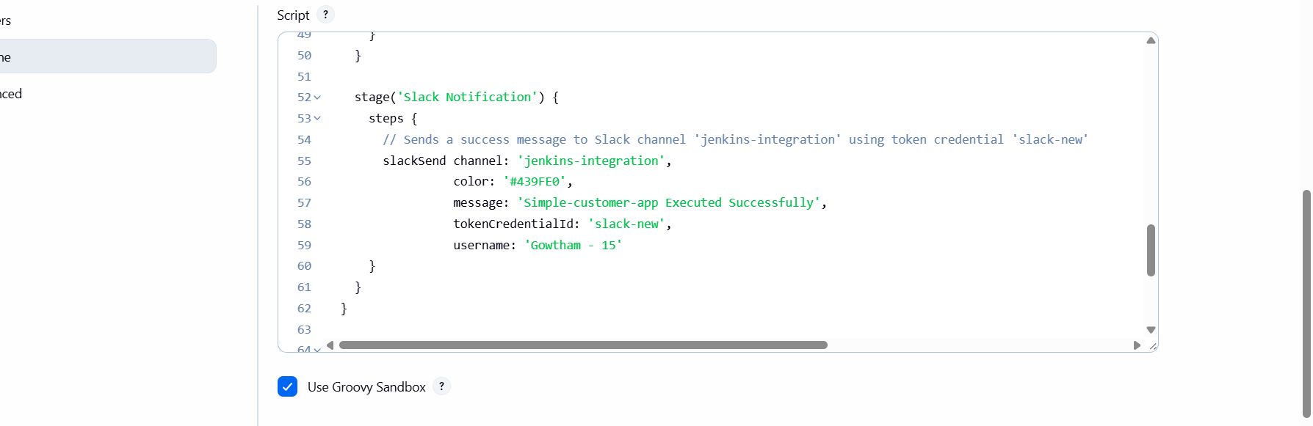
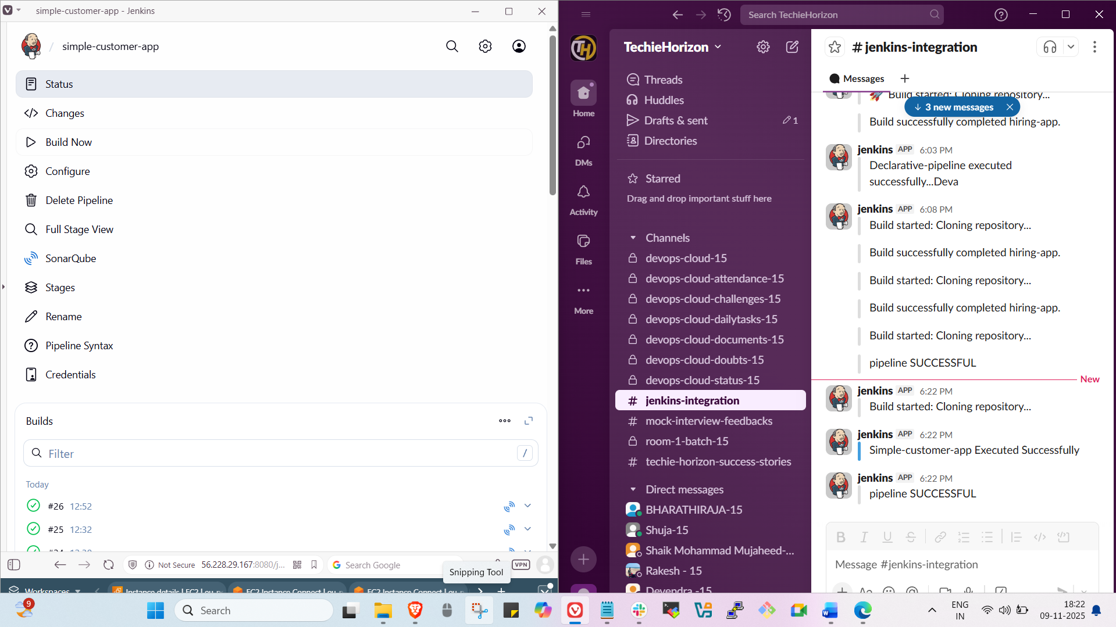

Deploy on Tomcat
Step 1: Goto Pipeline syntaxselect Deploy war to a containerEnter detailsgenerate pipeline scriptUpdate the script & Build the job.
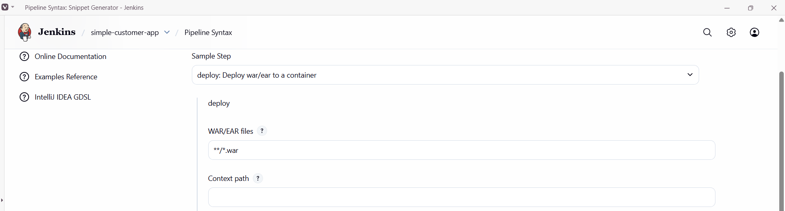

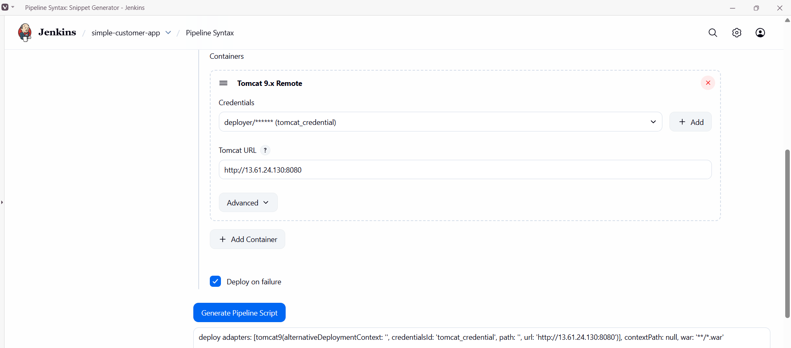

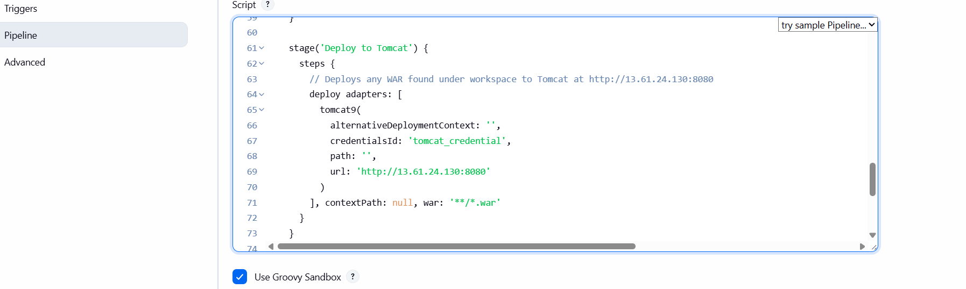
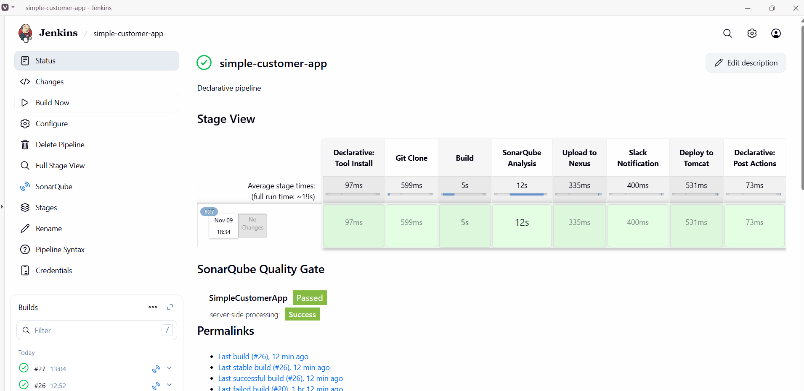

Full Script
pipeline {
agent any

tools {
// Use the exact Maven tool name configured in Manage Jenkins -> Global Tool Configuration
maven 'MVN_HOME'
}

stages {
stage('Git Clone') {
steps {
git branch: 'feature-1.1', url: 'https://github.com/gowtham4s/sabear_simplecutomerapp.git'
}
}

stage('Build') {
steps {
// produce the WAR under target/
sh 'mvn -B clean package'
}
}

stage('SonarQube Analysis') {
steps {
withSonarQubeEnv('MySonarQubeServer') {
sh 'mvn -B sonar:sonar -Dsonar.verbose=true'
}
}
}

stage('Upload to Nexus') {
steps {
script {
nexusArtifactUploader artifacts: [[
artifactId: 'SimpleCustomerApp',
classifier: '',
file: "target/SimpleCustomerApp-${BUILD_NUMBER}-SNAPSHOT.war",
type: 'war'
]],
credentialsId: 'nexus', // Jenkins credentials ID for Nexus (username/password)
groupId: 'com.javatpoint',
nexusUrl: '13.50.107.248:8081',
nexusVersion: 'nexus3',
protocol: 'http',
repository: 'simple-customer-app',
version: "${BUILD_NUMBER}-SNAPSHOT"
}
}
}

stage('Slack Notification') {
steps {
slackSend channel: 'jenkins-integration',
color: '#439FE0',
message: "Simple-customer-app Executed Successfully (Build ${BUILD_NUMBER})",
tokenCredentialId: 'slack-new',
username: 'Gowtham - 15'
}
}

stage('Deploy to Tomcat') {
steps {
// Deploys any WAR found under workspace to Tomcat at http://13.61.24.130:8080
deploy adapters: [
tomcat9(
alternativeDeploymentContext: '',
credentialsId: 'tomcat_credential',
path: '',
url: 'http://13.61.24.130:8080'
)
], contextPath: null, war: '**/*.war'
}
}
}

post {
success {
echo "Pipeline finished successfully. Build ${BUILD_NUMBER}"
}
failure {
echo "Pipeline failed. Check console output for details."
// optional failure Slack notification:
// slackSend channel: 'jenkins-integration', color: 'danger', message: "Simple-customer-app FAILED (Build ${BUILD_NUMBER})", tokenCredentialId: 'slack-new', username: 'Gowtham - 15'
}
}
}

Task – 3
Setup a Jenkins CICD pipeline using Scripted pipeline using feature-1.1 branch. https://github.com/betawins/sabear_simplecutomerapp/tree/feature-1.1 stages:
    - Git Clone
    - SonarQube Integration
    - Maven Compilation
    - Nexus Artifactory
    - Slack Notification
    - Deploy On tomcat
Git Clone
Step 1: create a new job in Jenkins with declarative pipeline and Build it.
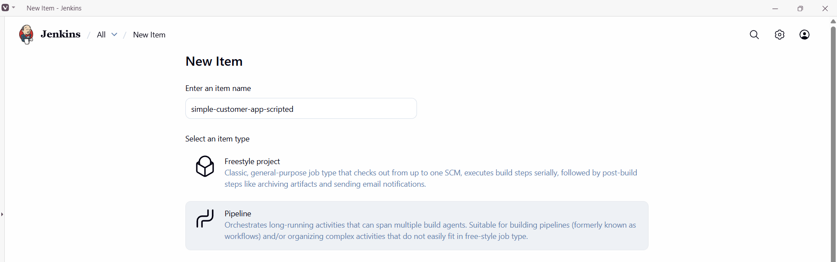
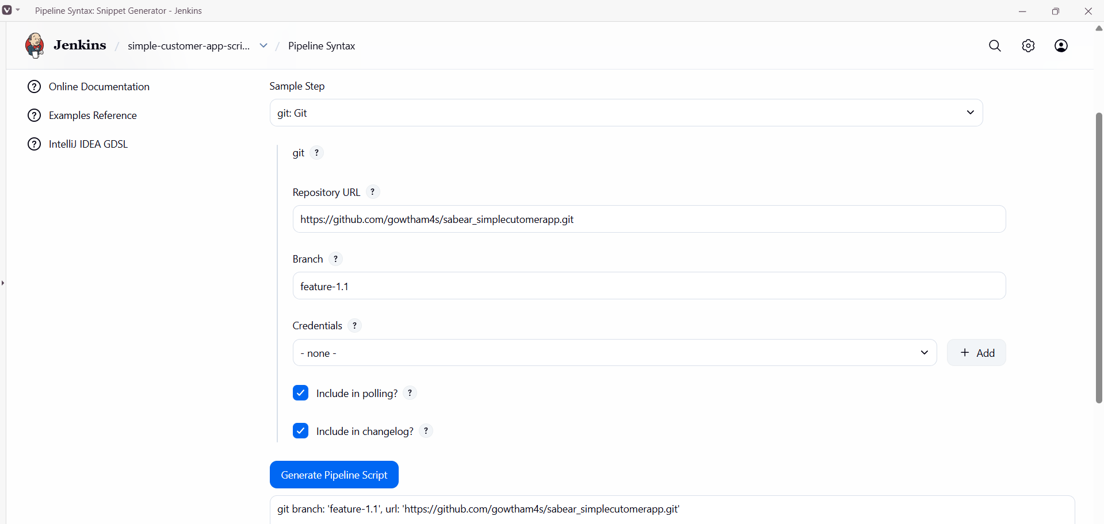

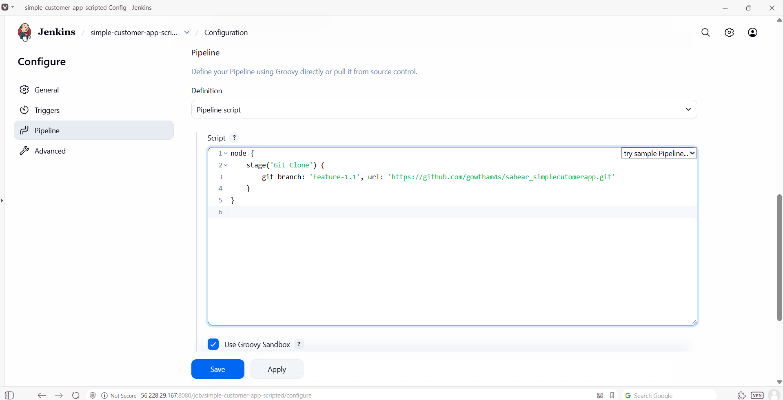
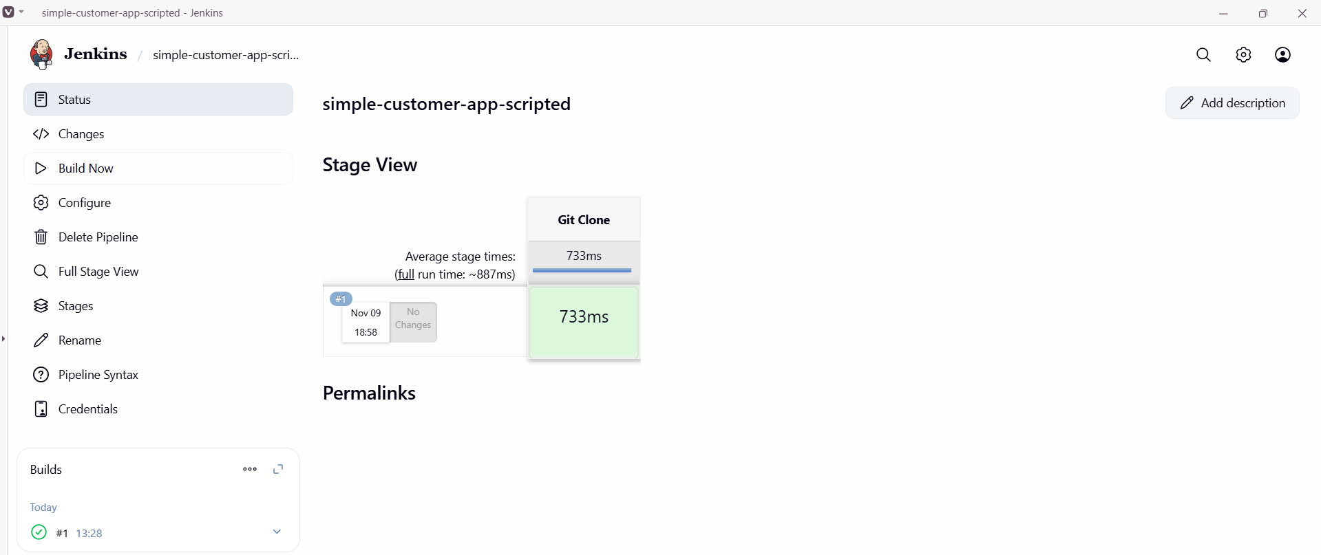

Maven compilation
Step 1: Add maven to the script and build it.
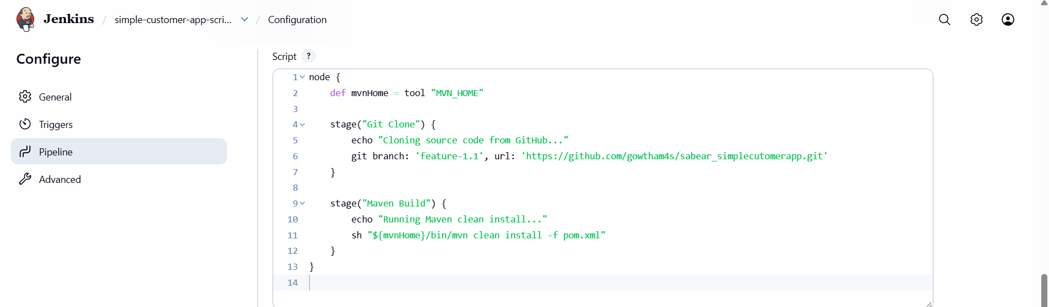

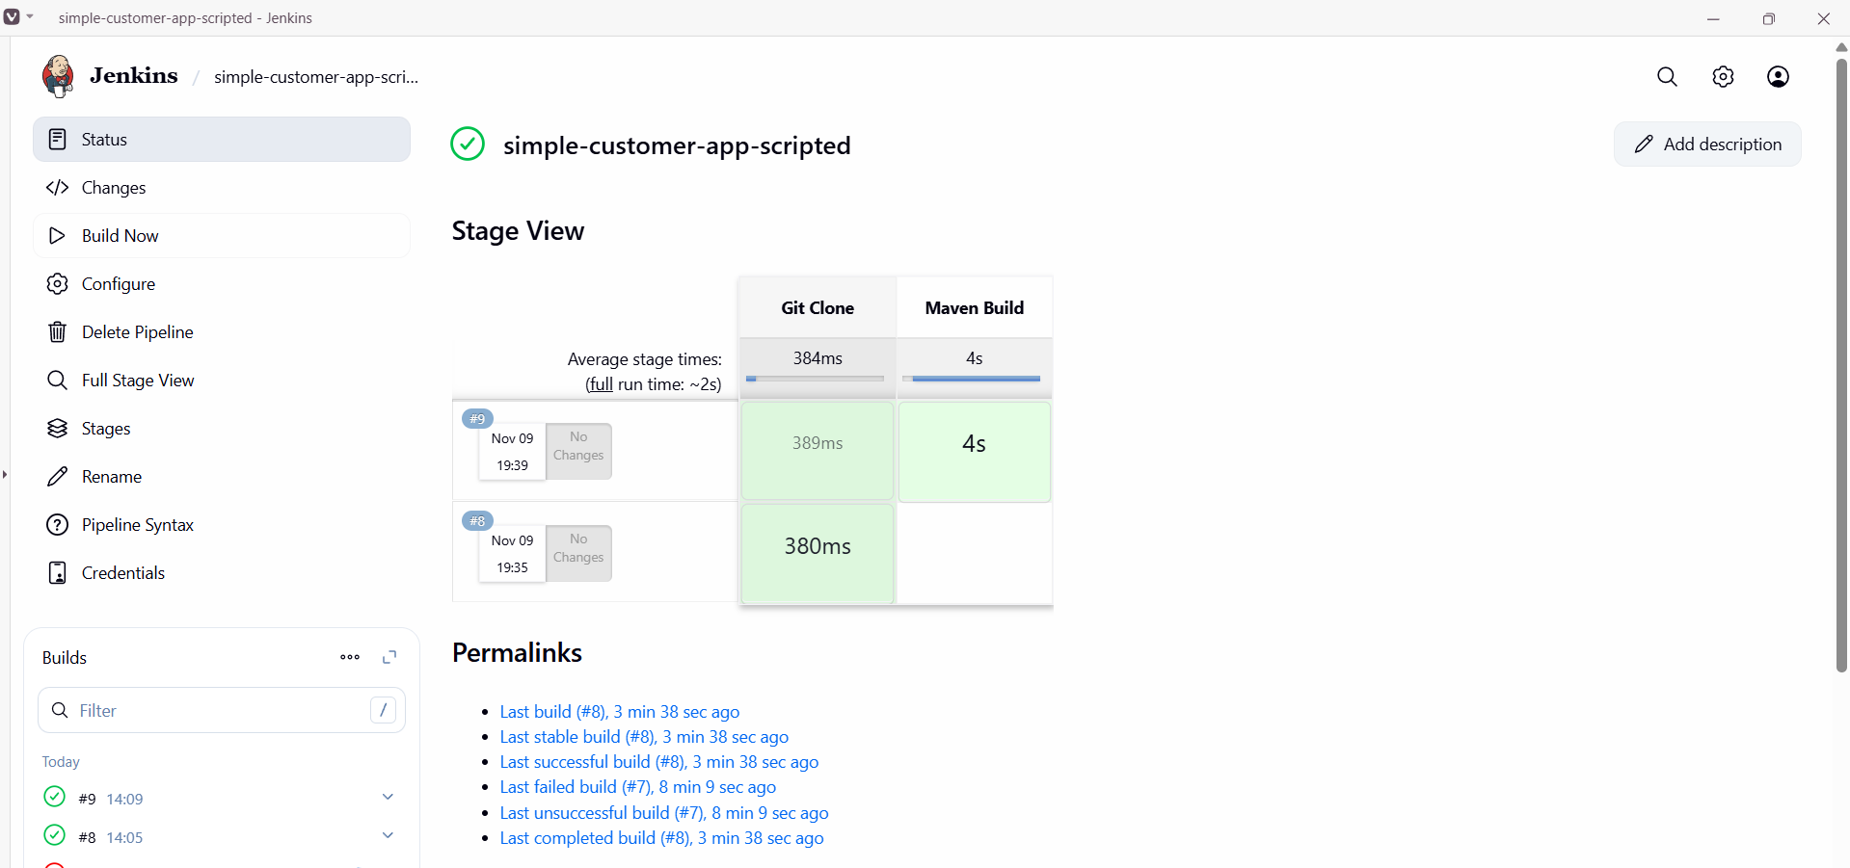

SonarQube Integration
Step 1: Goto Pipeline syntaxselect withSonarQubeEnvclick generate pipeline scriptadd that in declarative pipeline script and Build it.
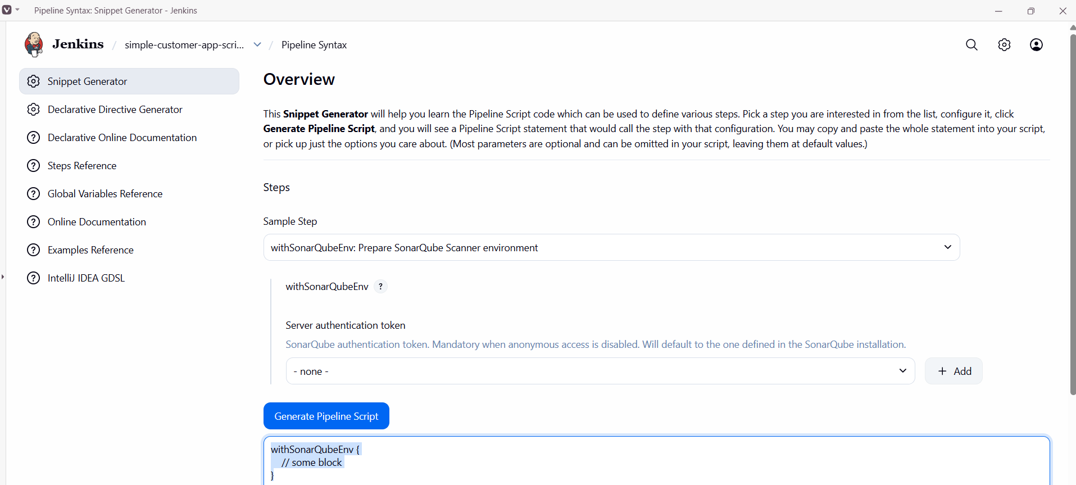
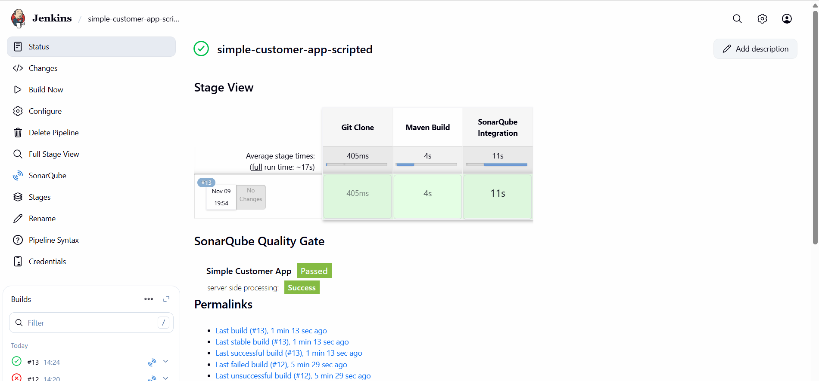
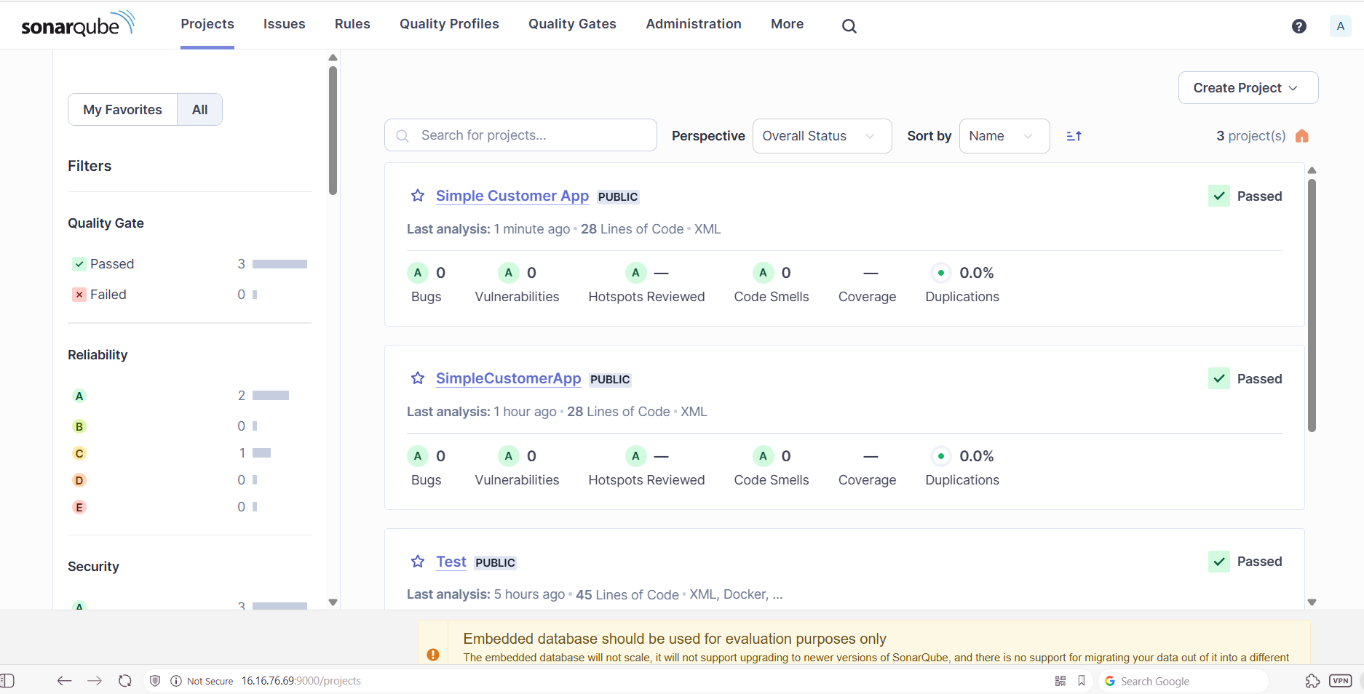

Nexus Artifactory
Step 1:Create a new repository in nexus.
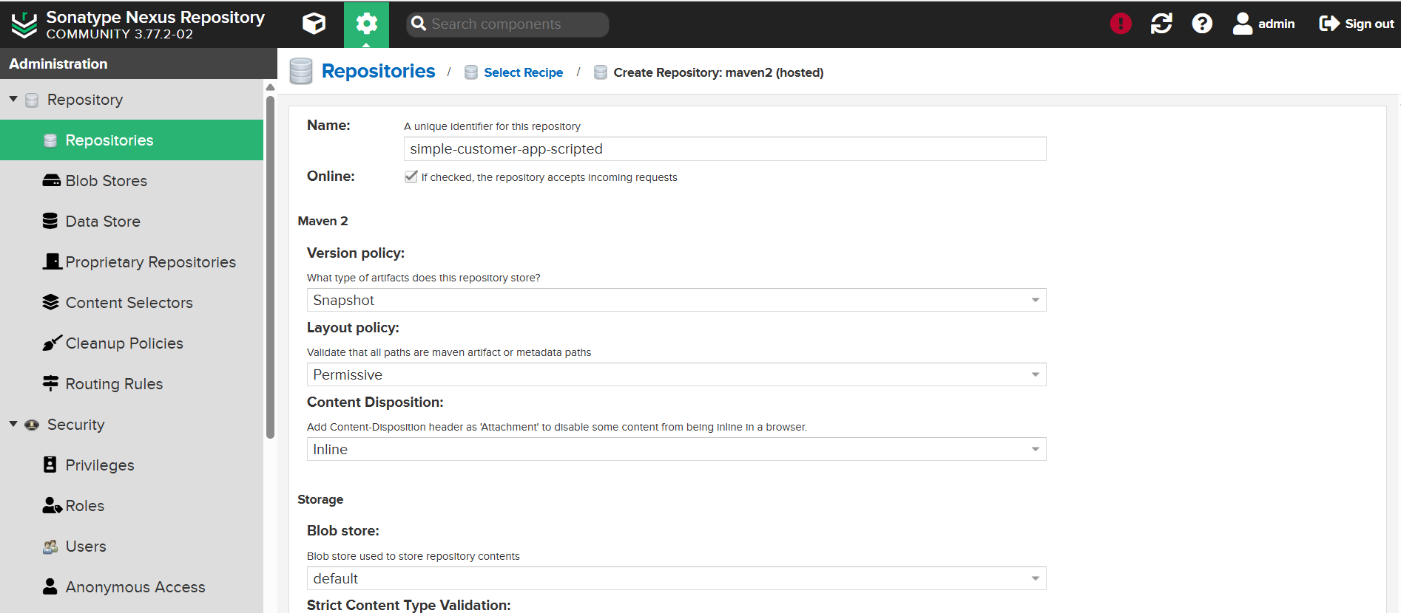
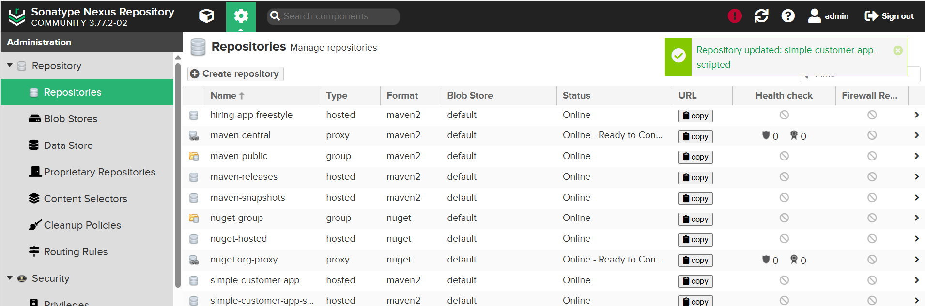

Step 2: Goto pipeline syntaxEnter detailsGenerate pipeline scriptupdate script & Build.
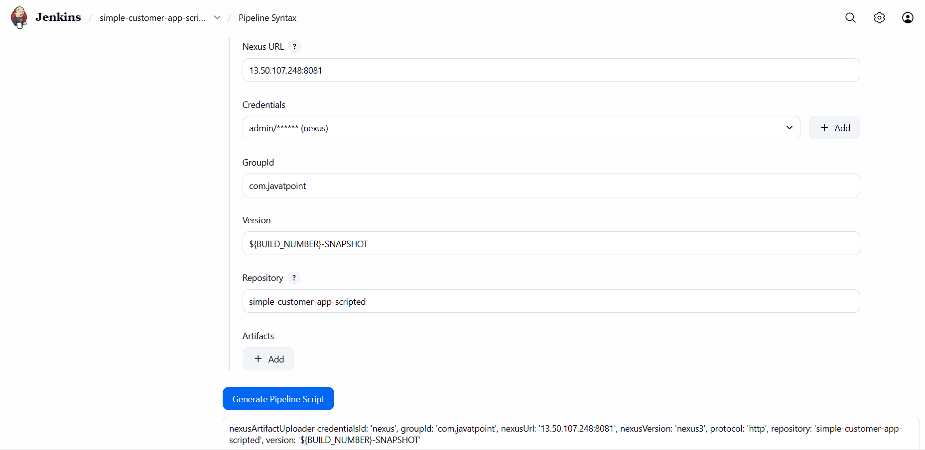
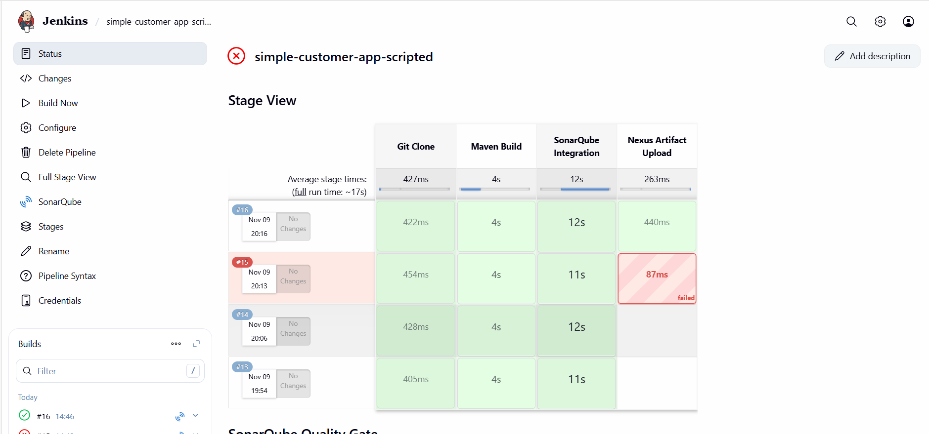
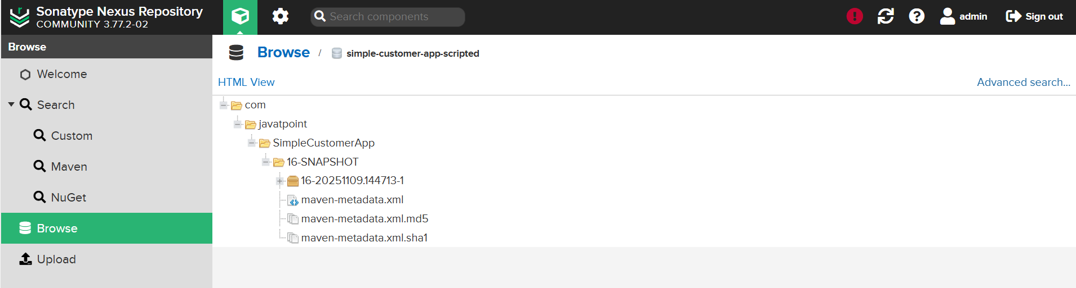

Slack Notification
Step 1: Goto Pipeline syntaxSelect sendSlack: send Slack MessageEnter detailsGenerate pipeline script.
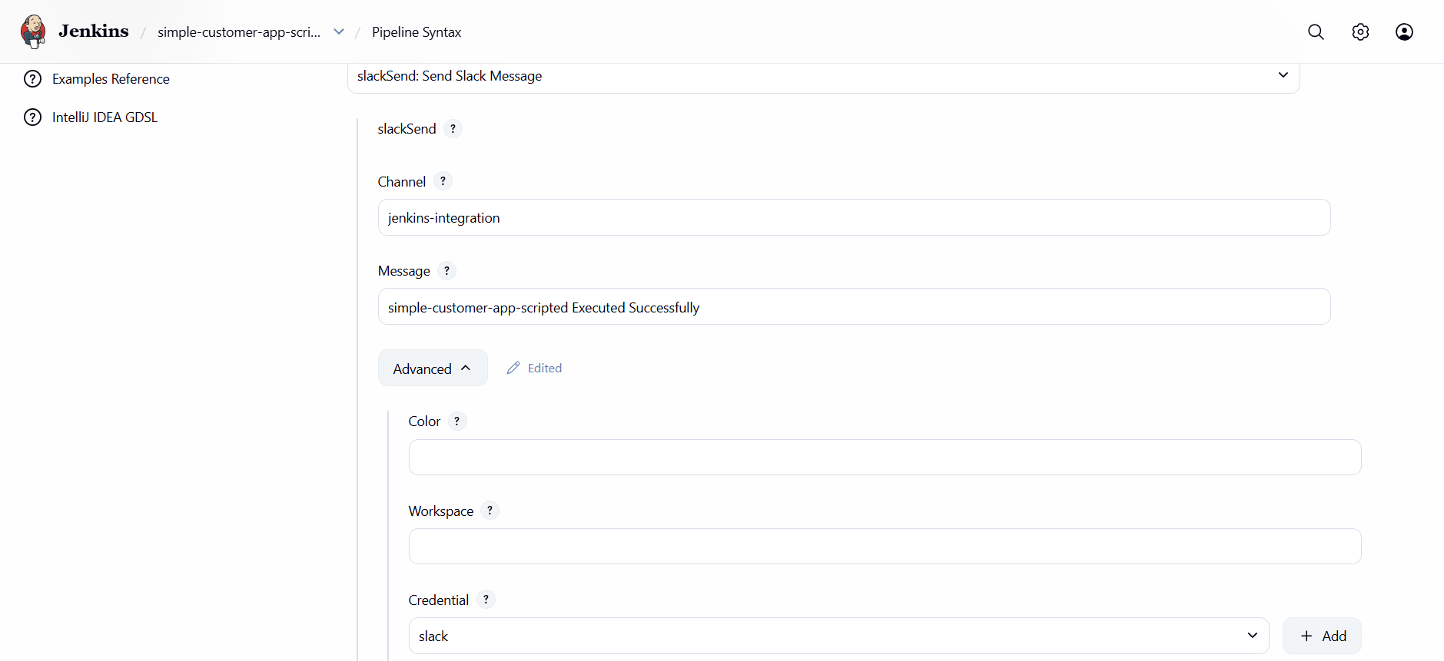
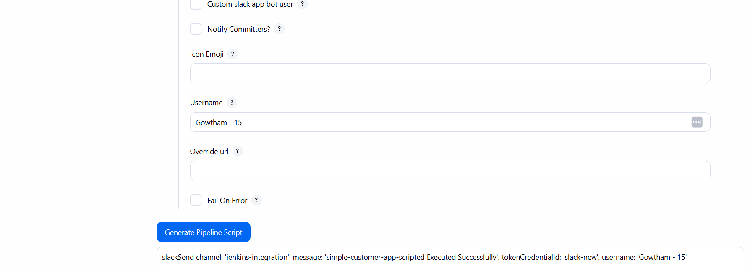
Step 2: Update the Script and Build the Job.
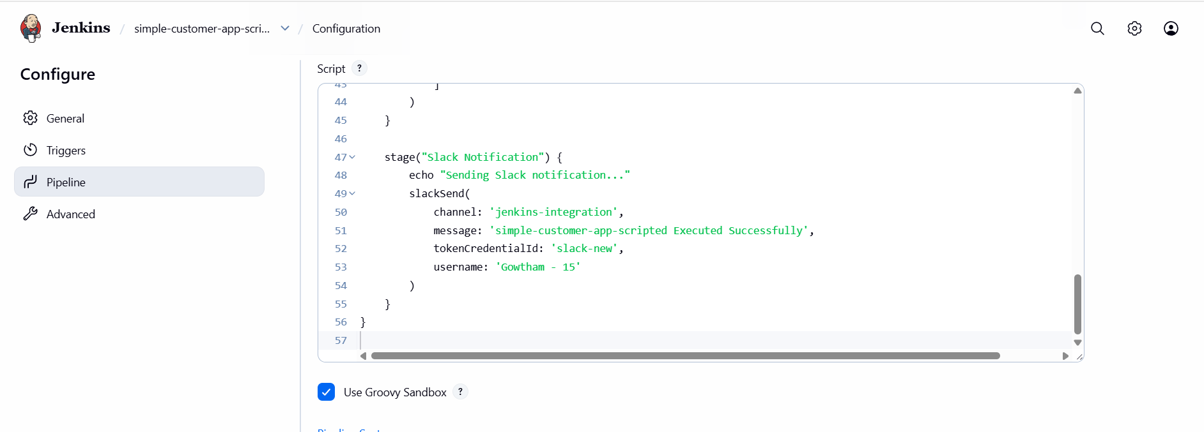
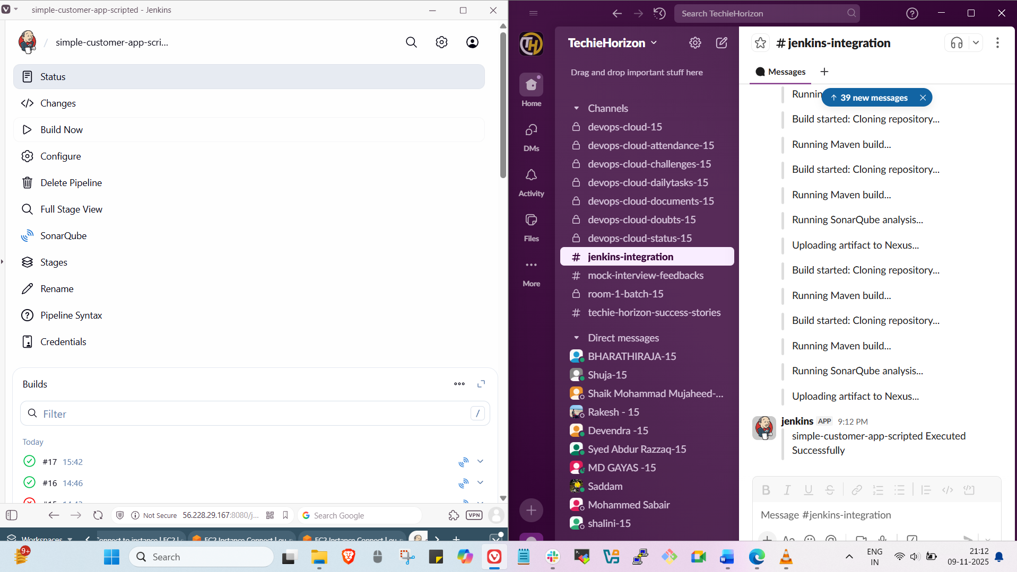

Deploy on Tomcat
Step 1: Goto Pipeline syntaxselect Deploy war to a containerEnter detailsgenerate pipeline scriptUpdate the script & Build the job.
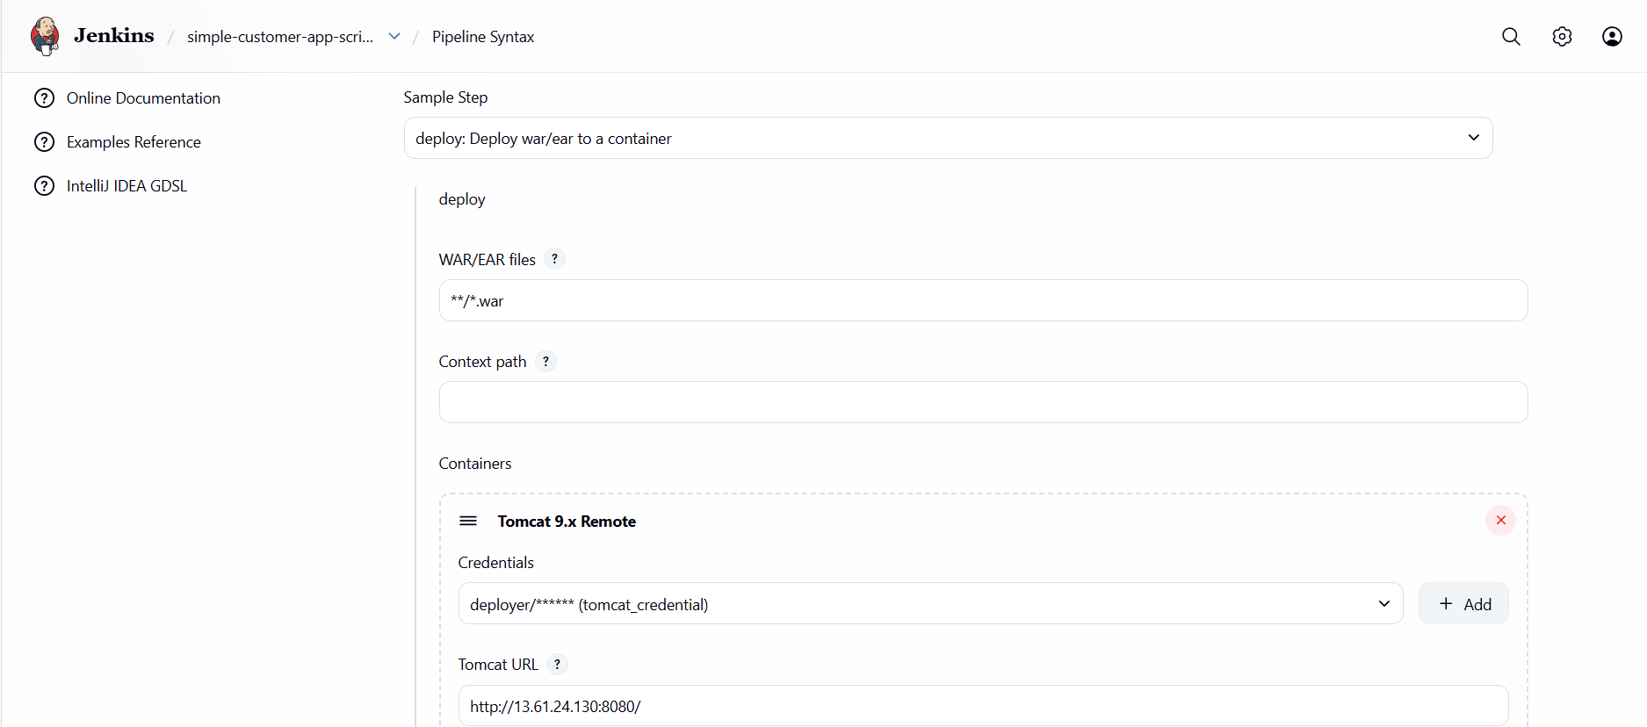
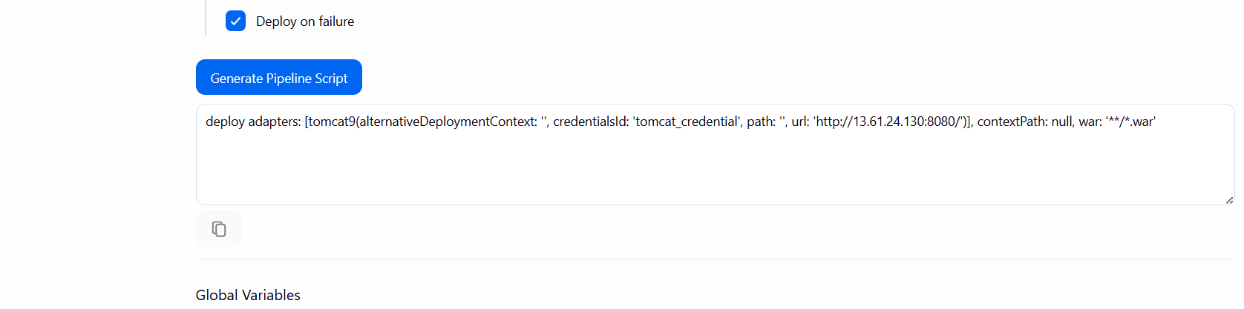

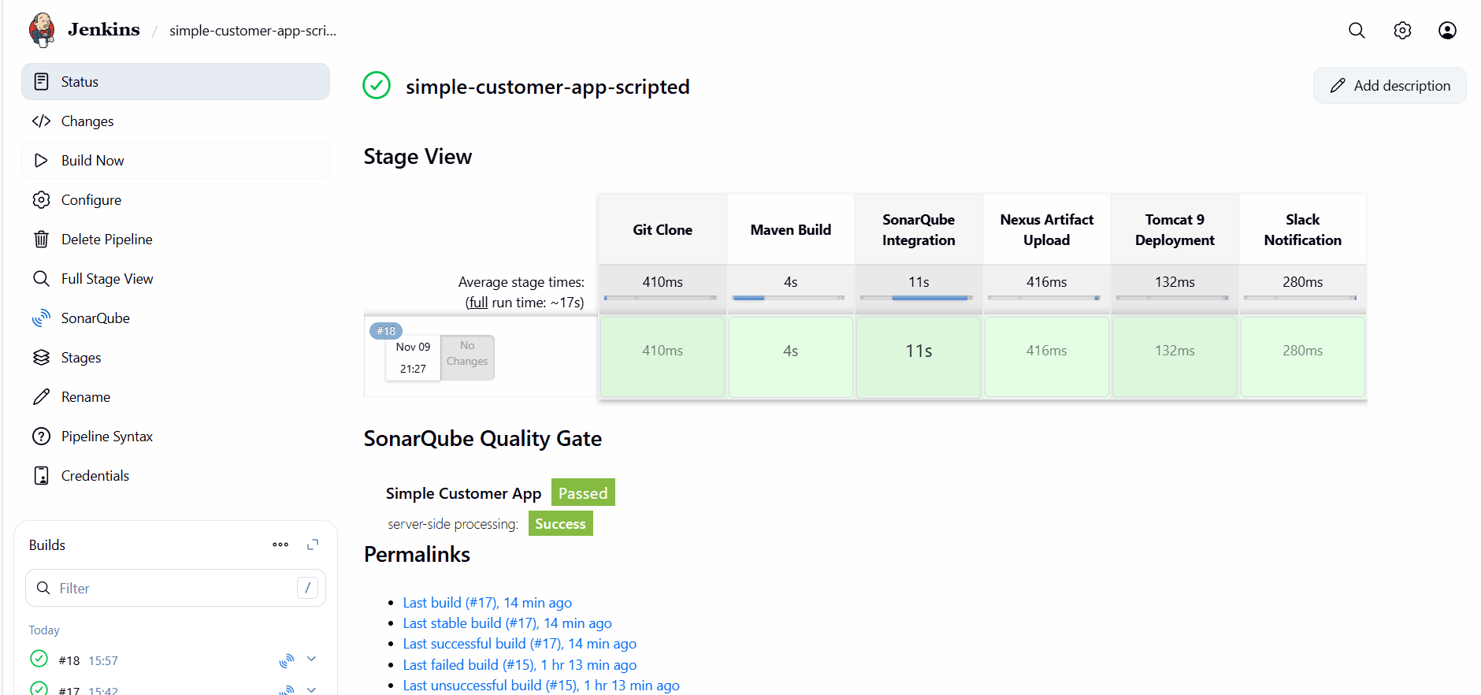

Full Scripted
node {
def mvnHome = tool "MVN_HOME"

stage("Git Clone") {
echo "Cloning source code..."
git branch: 'feature-1.1', url: 'https://github.com/gowtham4s/sabear_simplecutomerapp.git'
}

stage("Maven Build") {
echo "Building project with Maven..."
sh "${mvnHome}/bin/mvn clean install -f pom.xml"
}

stage("SonarQube Integration") {
echo "Running SonarQube analysis..."
withSonarQubeEnv('MySonarQubeServer') {
sh "${mvnHome}/bin/mvn sonar:sonar -Dsonar.projectKey=simplecustomerapp -Dsonar.projectName='Simple Customer App'"
}
}

stage("Nexus Artifact Upload") {
echo "Uploading build artifact to Nexus repository..."

// Dynamically find WAR file
def warFile = sh(script: "ls target/*.war | head -n 1", returnStdout: true).trim()
echo "Detected WAR file: ${warFile}"

nexusArtifactUploader(
nexusVersion: 'nexus3',
protocol: 'http',
nexusUrl: '13.50.107.248:8081',
groupId: 'com.javatpoint',
version: "${BUILD_NUMBER}-SNAPSHOT",
repository: 'simple-customer-app-scripted',
credentialsId: 'nexus',
artifacts: [
[
artifactId: 'SimpleCustomerApp',
classifier: '',
file: warFile,
type: 'war'
]
]
)
}

stage("Tomcat 9 Deployment") {
echo "Deploying WAR file to Tomcat 9 server..."
deploy adapters: [
tomcat9(
alternativeDeploymentContext: '',
credentialsId: 'tomcat_credential',
path: '',
url: 'http://13.61.24.130:8080/'
)
],
contextPath: null,
war: '**/*.war'
}

stage("Slack Notification") {
echo "Sending Slack notification..."
slackSend(
channel: 'jenkins-integration',
message: 'simple-customer-app-scripted Executed Successfully ✅',
tokenCredentialId: 'slack-new',
username: 'Gowtham - 15'
)
}
}

Task - 4
Write sample skeleton of pipelines.
Declarative Pipeline (Skeleton)
pipeline {
agent any

tools {
maven 'MVN_HOME'
}

environment {
SONAR = 'MySonarQubeServer'
SLACK_TOKEN = 'slack-new'
TOMCAT_CRED = 'tomcat_credential'
}

stages {
stage('Checkout') {
steps {
git branch: 'feature-1.1', url: 'https://github.com/your/repo.git'
}
}

stage('Build') {
steps {
sh 'mvn clean install -DskipTests=true'
}
}

stage('SonarQube') {
steps {
withSonarQubeEnv("${env.SONAR}") {
sh 'mvn sonar:sonar'
}
}
}

stage('Deploy') {
steps {
deploy adapters: [tomcat9(credentialsId: "${env.TOMCAT_CRED}", url: 'http://13.61.24.130:8080/')],
contextPath: null,
war: 'target/*.war'
}
}
}

post {
success {
slackSend channel: '#jenkins-integration', message: "Pipeline Successful", tokenCredentialId: "${env.SLACK_TOKEN}"
}
failure {
slackSend channel: '#jenkins-integration', message: "Pipeline Failed", tokenCredentialId: "${env.SLACK_TOKEN}"
}
}
}

Scripted Pipeline (Skeleton)

node {
def mvn = tool 'MVN_HOME'

stage('Checkout') {
git branch: 'feature-1.1', url: 'https://github.com/your/repo.git'
}

stage('Build') {
sh "${mvn}/bin/mvn clean install -DskipTests=true"
}

stage('SonarQube') {
withSonarQubeEnv('MySonarQubeServer') {
sh "${mvn}/bin/mvn sonar:sonar"
}
}

stage('Deploy') {
def war = sh(script: "ls target/*.war | head -n 1", returnStdout: true).trim()
deploy adapters: [tomcat9(credentialsId: 'tomcat_credential', url: 'http://13.61.24.130:8080/')],
contextPath: null,
war: war
}

stage('Slack Notify') {
slackSend channel: '#jenkins-integration', message: "Pipeline Successful", tokenCredentialId: 'slack-new'
}
}

Task - 5
Create a parameterized job in Jenkins. https://github.com/betawins/spring3-mvc-maven-xml-hello-world-1.git

Git Clone
Step 1: create a new job in Jenkins with parameter and Build it.
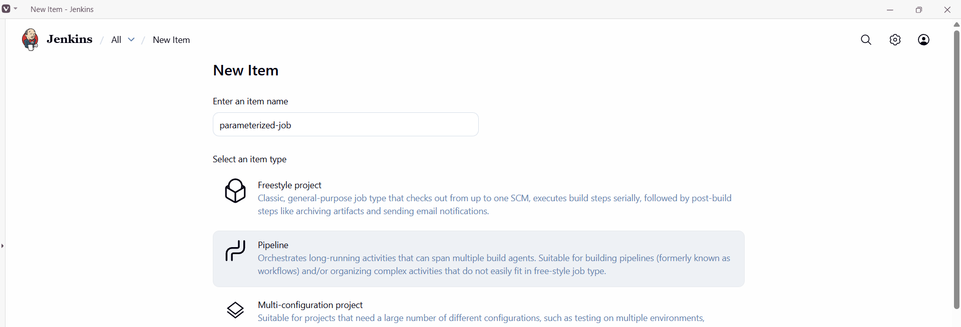
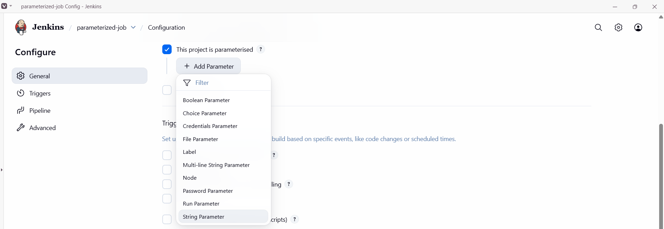
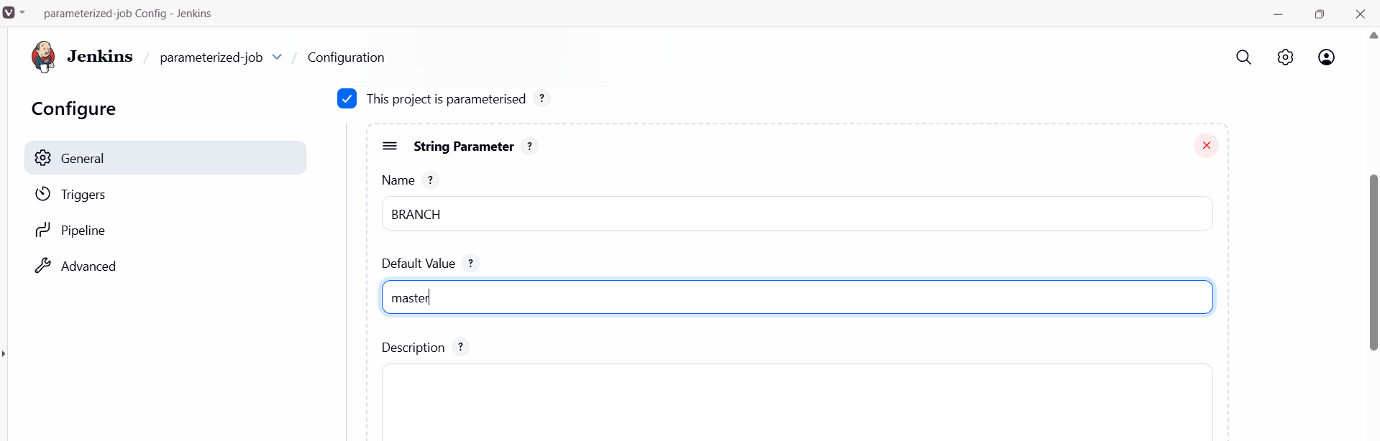

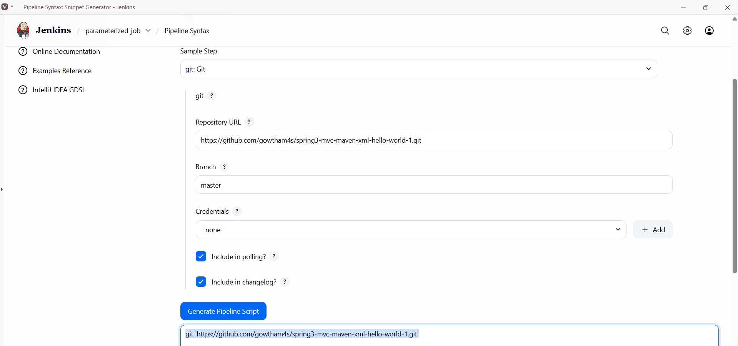

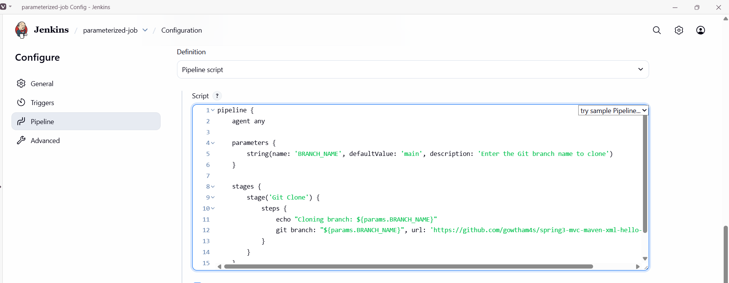
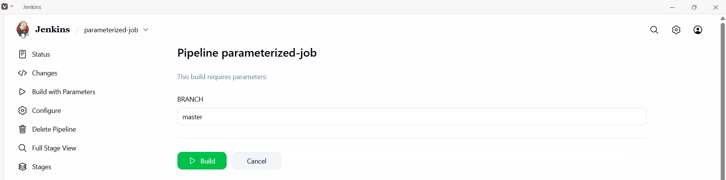
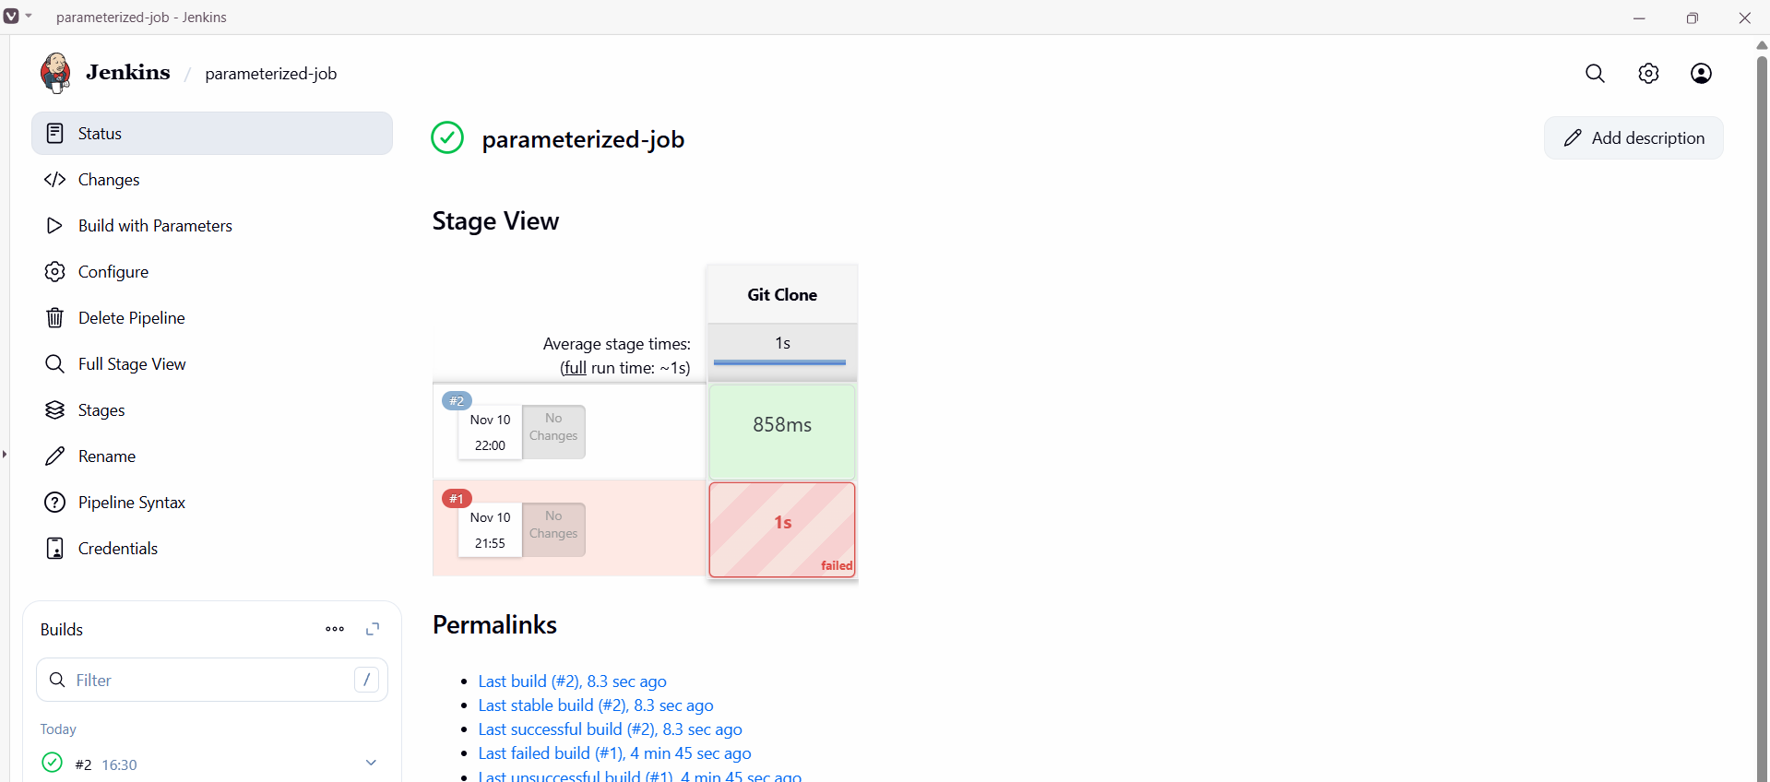
Maven compilation
Step 1: Add maven to the script and build it.
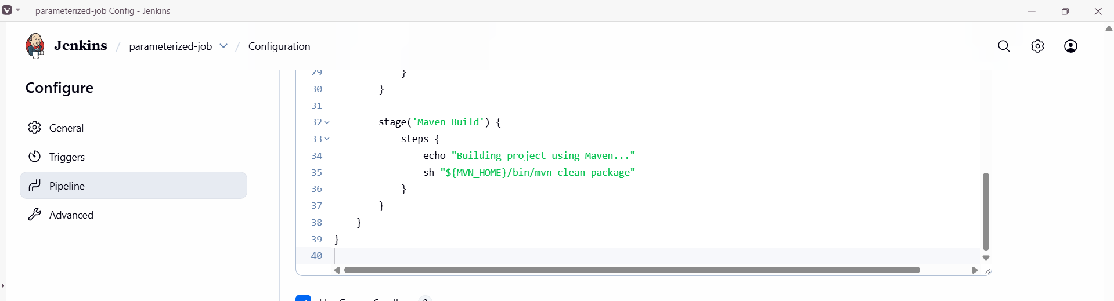
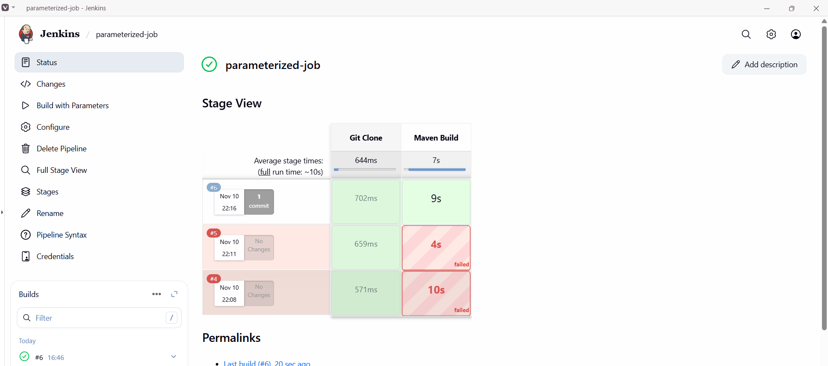

SonarQube Integration
Step 1: Goto Pipeline syntaxselect withSonarQubeEnvclick generate pipeline scriptadd that in parameterized pipeline script and Build it.
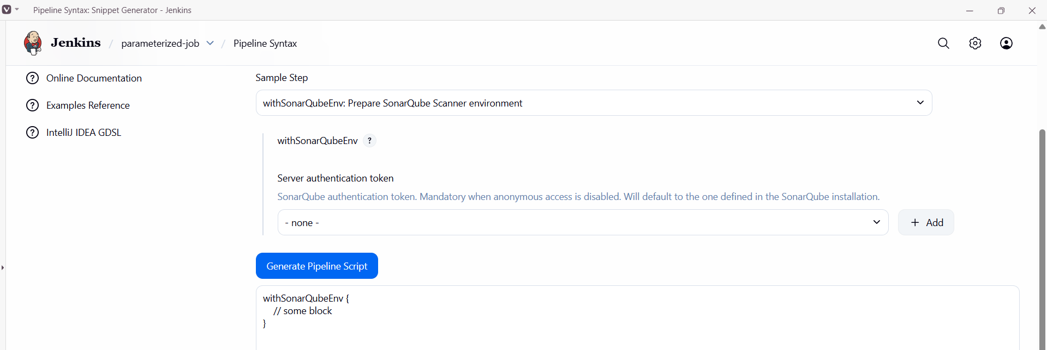

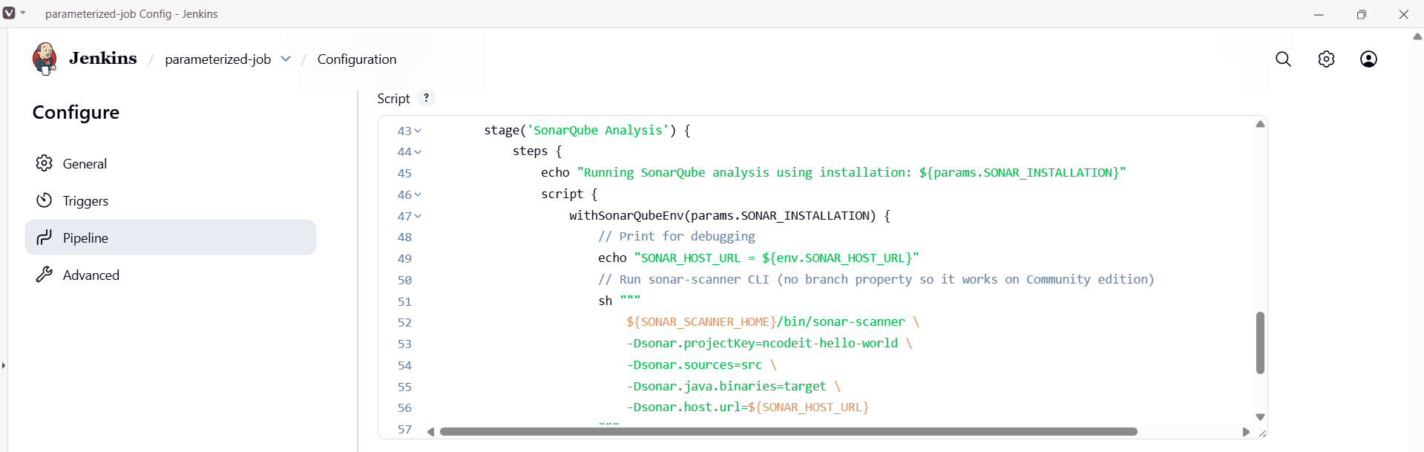
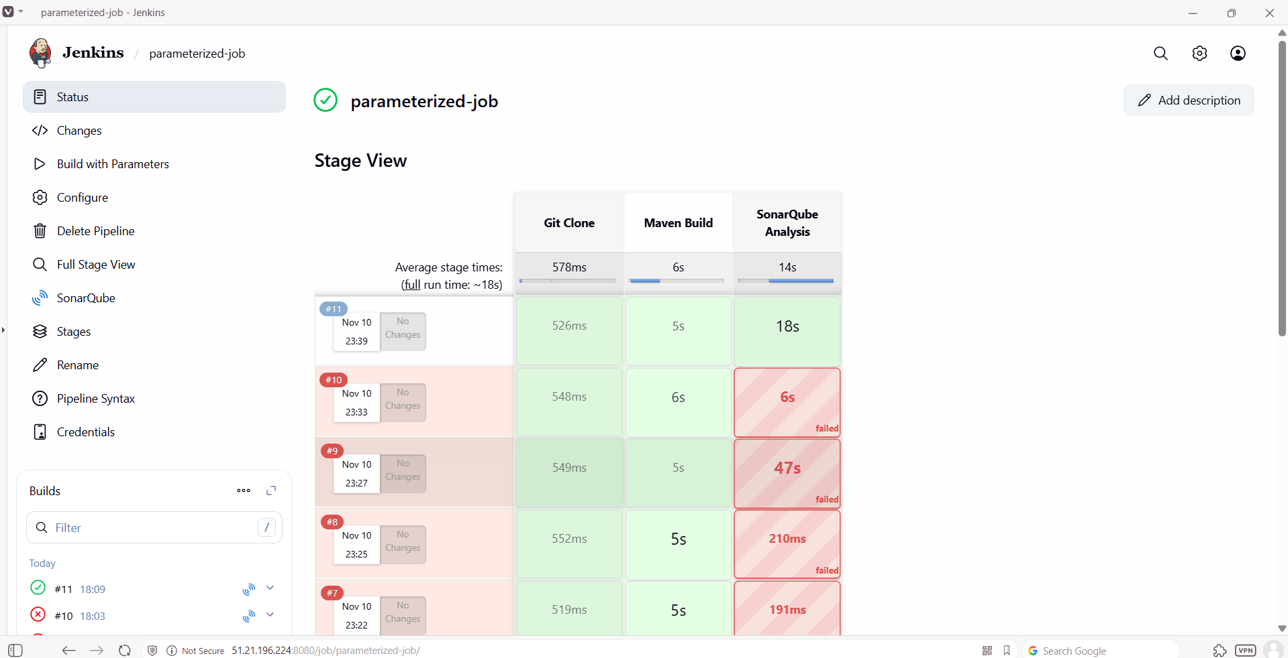
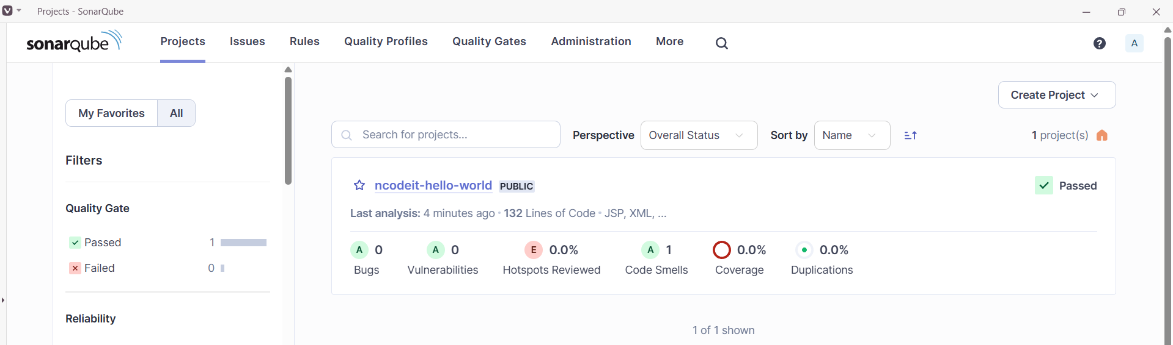

Nexus Artifactory
Step 1:Create a new repository in nexus.
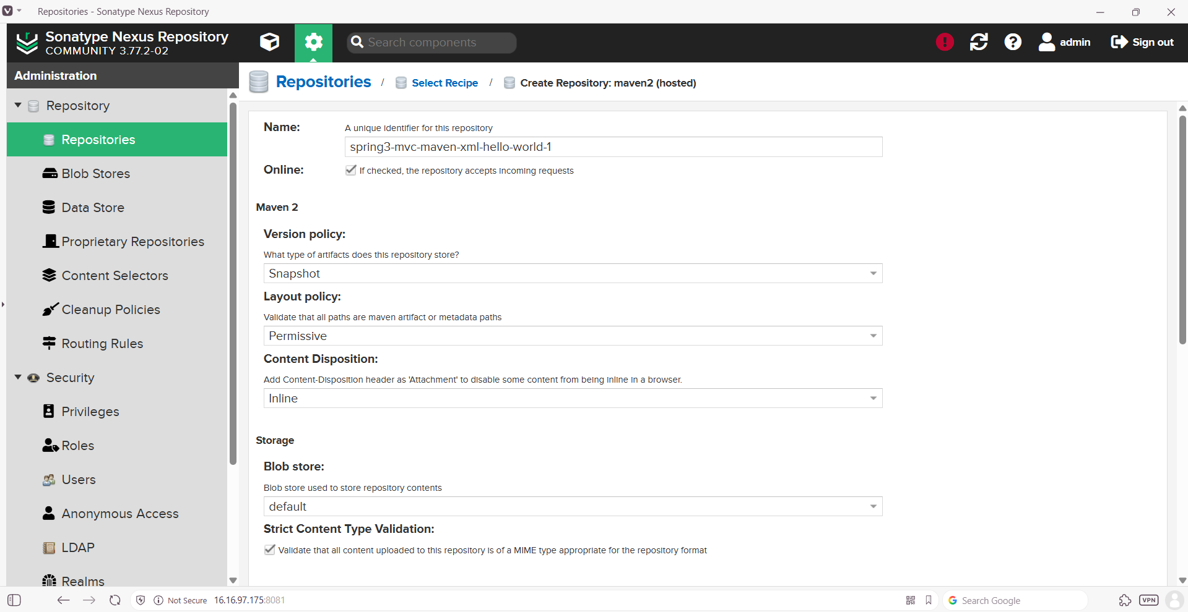
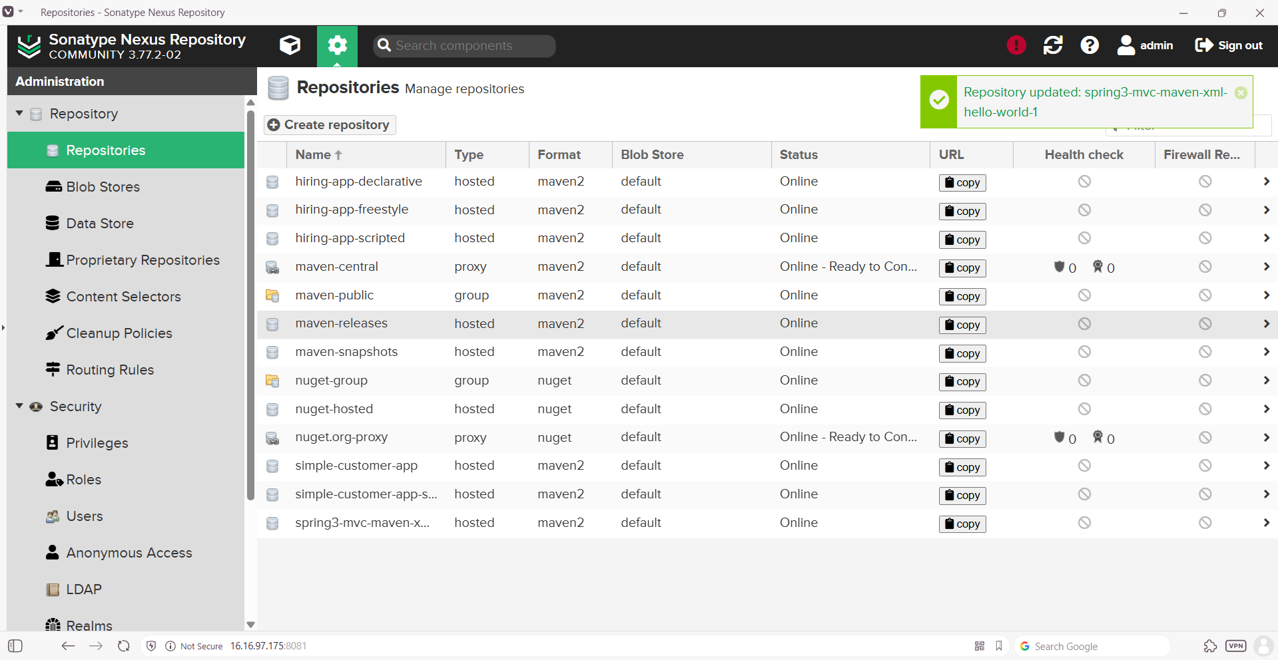

Step 2: Goto pipeline syntaxEnter detailsGenerate pipeline scriptupdate script & Build.
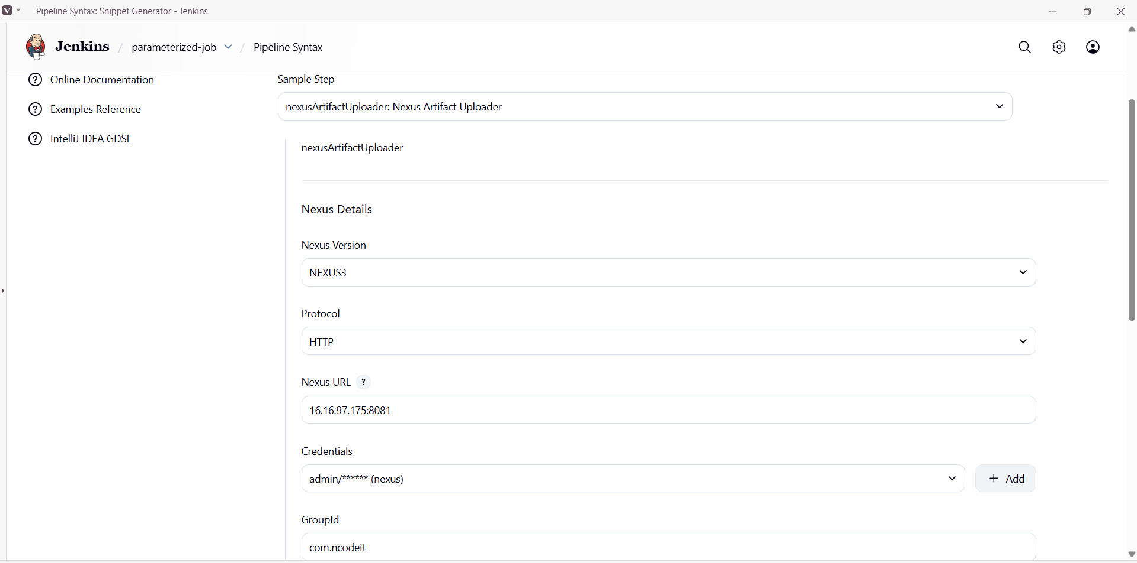
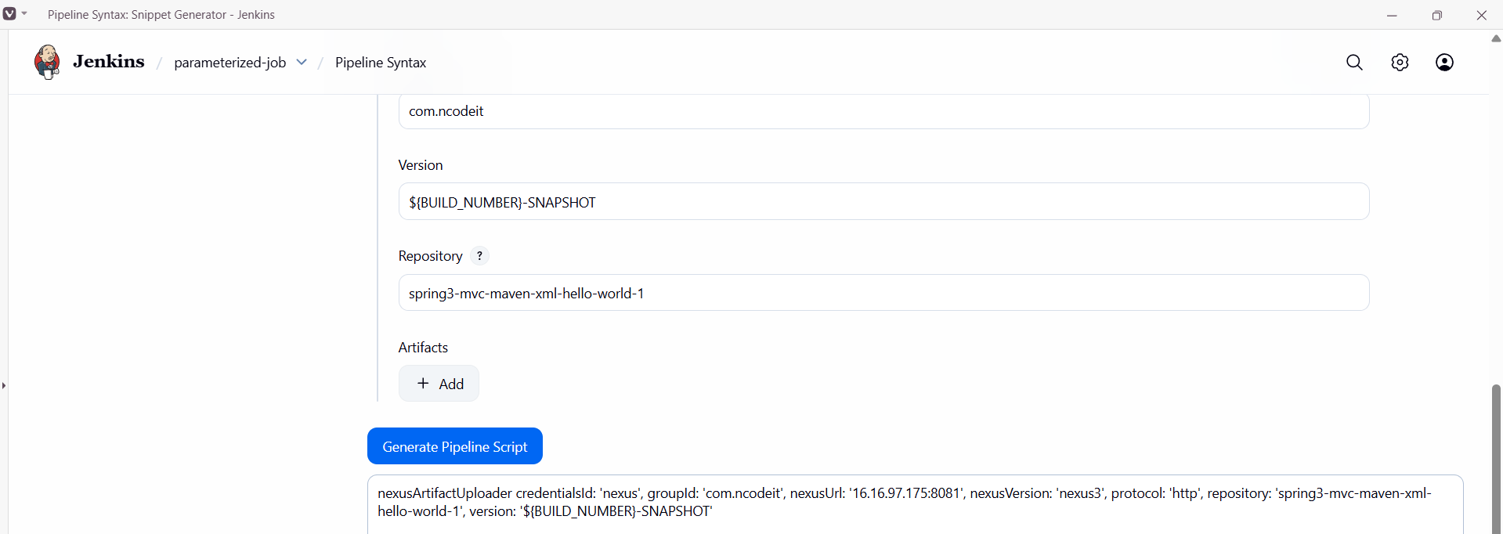
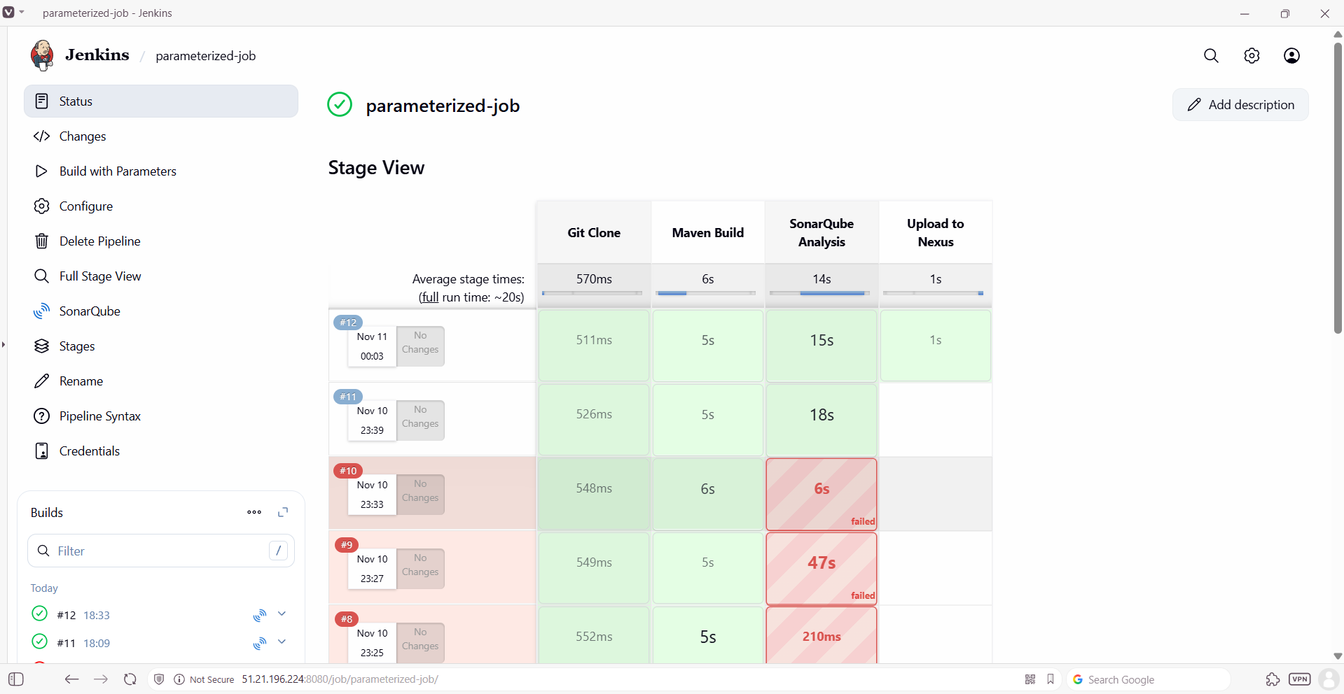
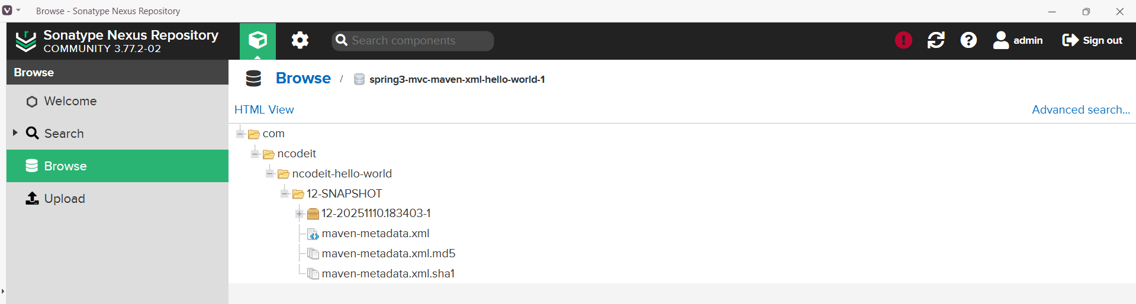

Deploy on Tomcat
Step 1: Goto Pipeline syntaxselect Deploy war to a containerEnter detailsgenerate pipeline scriptUpdate the script & Build the job.
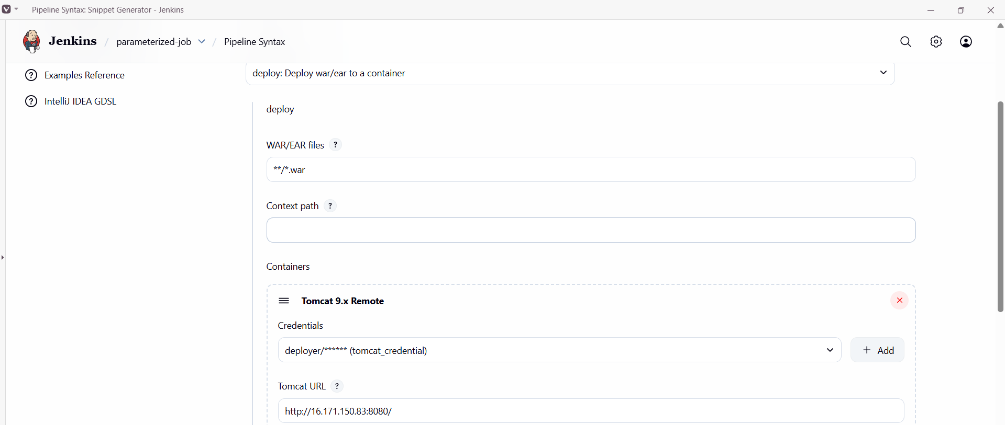
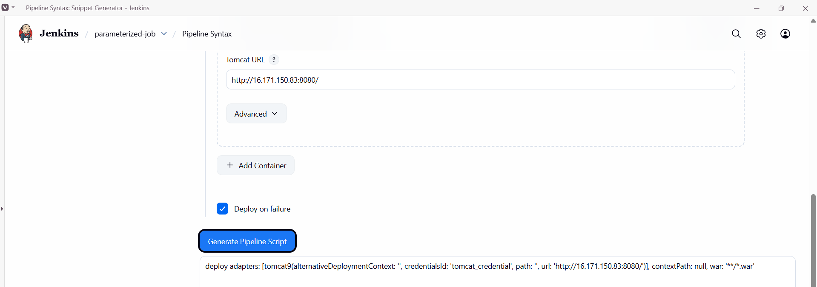

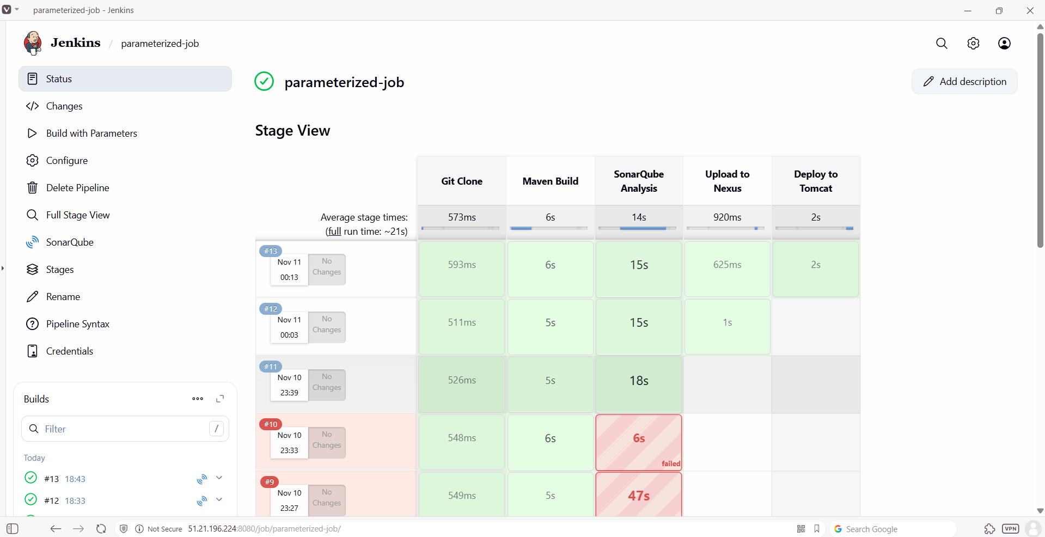

Full script
pipeline {
agent any

environment {
MVN_HOME = tool 'MVN_HOME' // Maven tool configured in Jenkins
// If Sonar scanner is configured as a Jenkins tool, replace with: SONAR_SCANNER_HOME = tool('SONAR_SCANNER')
SONAR_SCANNER_HOME = '/opt/sonar_scanner' // path to sonar-scanner on the node
}

parameters {
string(name: 'BRANCH_NAME', defaultValue: 'master', description: 'Git branch to clone (e.g. master)')
string(name: 'SONAR_INSTALLATION', defaultValue: 'MySonarQubeServer', description: 'SonarQube installation name in Jenkins')
// Nexus credentialsId 'nexus' and Tomcat credentialsId 'tomcat_credential' must exist in Jenkins Credentials
}

stages {
stage('Git Clone') {
steps {
echo "Cloning branch: ${params.BRANCH_NAME}"
script {
checkout([
$class: 'GitSCM',
branches: [[name: "refs/heads/${params.BRANCH_NAME}"]],
doGenerateSubmoduleConfigurations: false,
extensions: [],
userRemoteConfigs: [[
url: 'https://github.com/gowtham4s/spring3-mvc-maven-xml-hello-world-1.git'
]]
])
}
}
}

stage('Maven Build') {
steps {
echo "Building project using Maven..."
sh "${MVN_HOME}/bin/mvn clean package"
}
}

stage('SonarQube Analysis') {
steps {
echo "Running SonarQube analysis using installation: ${params.SONAR_INSTALLATION}"
script {
withSonarQubeEnv(params.SONAR_INSTALLATION) {
echo "SONAR_HOST_URL = ${env.SONAR_HOST_URL}"
sh """
${SONAR_SCANNER_HOME}/bin/sonar-scanner \
-Dsonar.projectKey=ncodeit-hello-world \
-Dsonar.sources=src \
-Dsonar.java.binaries=target \
-Dsonar.host.url=${SONAR_HOST_URL}
"""
}
}
}
}

stage('Upload to Nexus') {
steps {
script {
// find the first WAR file in target/ (fail if none)
def warFile = sh(script: "ls target/*.war 2>/dev/null | head -n1 || true", returnStdout: true).trim()
if (!warFile) {
error "No WAR file found in target/ to upload to Nexus"
}
echo "Found WAR: ${warFile}"

// prepare version using BUILD_NUMBER
def nexusVersion = "${env.BUILD_NUMBER}-SNAPSHOT"

nexusArtifactUploader(
credentialsId: 'nexus',
groupId: 'com.ncodeit',
nexusUrl: '16.16.97.175:8081',
nexusVersion: 'nexus3',
protocol: 'http',
repository: 'spring3-mvc-maven-xml-hello-world-1',
version: nexusVersion,
artifacts: [
[artifactId: 'ncodeit-hello-world', classifier: '', file: warFile, type: 'war']
]
)

echo "Uploaded ${warFile} to Nexus repository 'spring3-mvc-maven-xml-hello-world-1' as version ${nexusVersion}"
}
}
}

stage('Deploy to Tomcat') {
steps {
script {
// Deploy all WARs matched by pattern (adjust path if necessary)
deploy adapters: [tomcat9(
alternativeDeploymentContext: '',
credentialsId: 'tomcat_credential',
path: '',
url: 'http://16.171.150.83:8080/'
)],
contextPath: null,
war: '**/*.war'
}
}
}
}
}

